**DAILY ONLINE ACTIVITIES SUMMARY**

|  |  |  |  |  |  |  |
| --- | --- | --- | --- | --- | --- | --- |
| **Date:** | **19/06/2020** | | | **Name:** | **Ravi kr** | |
| **Sem & Sec** | **8th- B** | | | **USN:** | **4AL16CS076** | |
| **Certification Course Summary** | | | | | | |
| **Course** | **Learn Php and mysql developments by building projects.** | | | | | |
| **platform** | | **Eduonix** | **Duration** | | | **3 hours** |
| **Coding Challenges** | | | | | | |
| **Problem Statement:**  **For each query, return Cat A if cat catches the mouse first, Cat B if cat A catches the mouse first, or Mouse C if the mouse escapes.** | | | | | | |
| **Status: Executed** | | | | | | |
| **Uploaded the report in Github** | | | **Yes** | | | |
| **If yes Repository name** | | | https://github.com/alvas-education-foundation/ravi_kr | | | |
| **Uploaded the report in slack** | | | **Yes** | | | |

Online Test:

Certification:

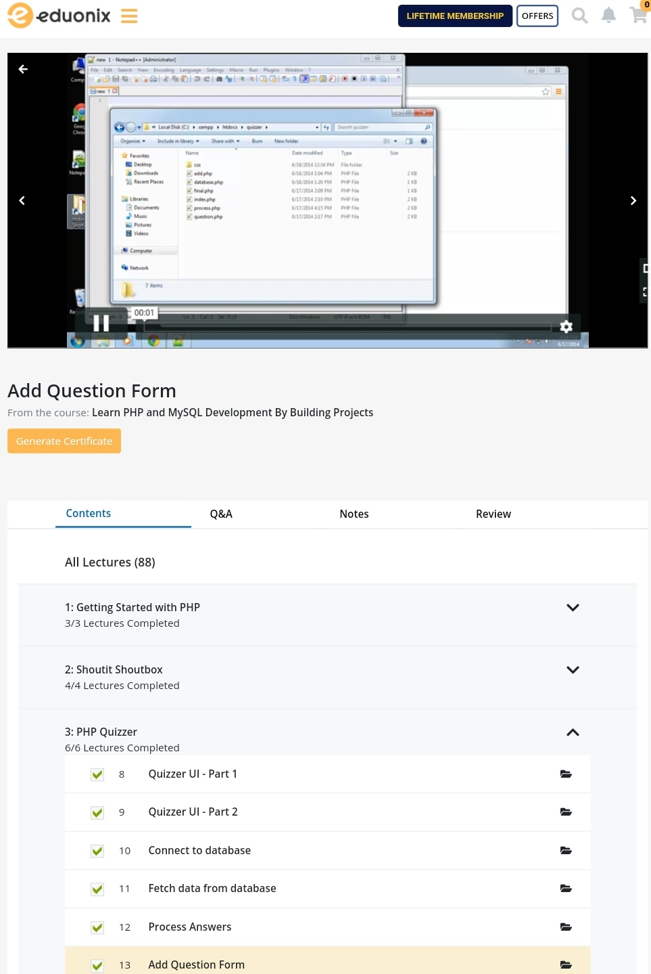

Coding Challenges Details:

