**DAILY ONLINE ACTIVITIES SUMMARY**

|  |  |  |  |  |  |  |
| --- | --- | --- | --- | --- | --- | --- |
| **Date:** | **4/07/2020** | | | **Name:** | **Ravi k r** | |
| **Sem & Sec** | **8th- B** | | | **USN:** | **4AL16CS076** | |
| **Certification Course Summary** | | | | | | |
| **Course** | **Building Scalable Java Microservices with Spring Boot and Spring Cloud** | | | | | |
| **platform** | | **coursera** | **Duration** | | | **10 hours** |
| **Coding Challenges** | | | | | | |
| **Problem Statement:**  **The java program throws clause in exception handling with default messages?** | | | | | | |
| **Status: Executed** | | | | | | |
| **Uploaded the report in Github** | | | **Yes** | | | |
| **If yes Repository name** | | | https://github.com/alvas-education-foundation/Ravi_kr | | | |
| **Uploaded the report in slack** | | | **Yes** | | | |

Certification:

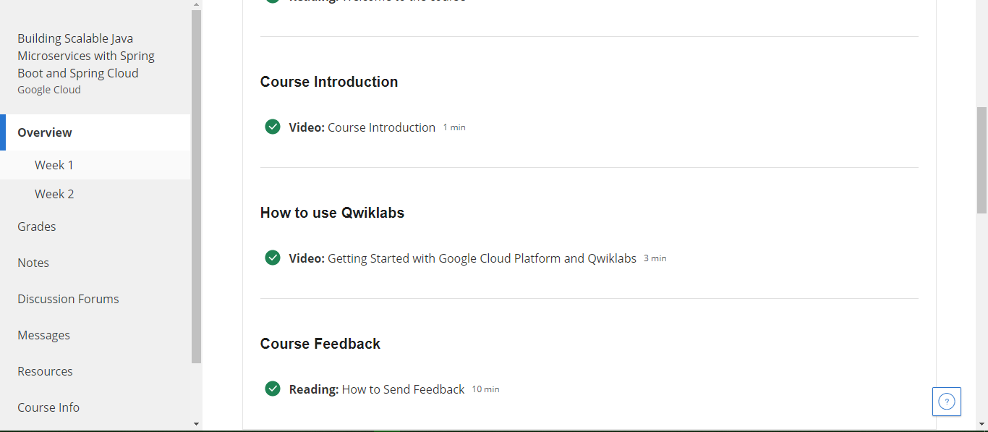

Coding Challenges Details:

import java.lang.*;

public class Demonstration_1010 {

public static void main(String Args[]) throws Exception{

int[] array = new int[3];

try{

for (int i=0;i<4;++i)

{

array[i] = i;

}

System.out.println(array);

}

catch(ArrayIndexOutOfBoundsException e){

System.out.println("filIn: " + e.fillInStackTrace());

System.out.println("cause: " + e.getCause());

System.out.println("local: " + e.getLocalizedMessage());

System.out.println("messa: " + e.getMessage());

System.out.println("trace: " + e.getStackTrace());

System.out.println();

System.out.println();

System.out.print("trace: ");

e.printStackTrace();

System.out.println();

System.out.print("string: ");

e.toString();

System.out.println();

System.out.println();

//printed just to inform that we have entered the catch block

System.out.println("Oops, we went too far, better go back to 0!");

throw (Exception) new Exception().initCause(e);

}

finally{

System.out.println(array);

// method call to continue program

}

}

}