**DAILY ONLINE ACTIVITIES SUMMARY**

|  |  |  |  |  |  |  |  |  |
| --- | --- | --- | --- | --- | --- | --- | --- | --- |
| **Date:** | 08-07-2020 | | | | | **Name:** | D Richard Franklin | |
| **Sem & Sec** | Fourth sem section A | | | | | **USN:** | 4AL18CS020 | |
| **Descriptive Test Summary** | | | | | | | | |
| **Subject** | | Design and Analysis of Algorithms | | | | | | |
| **Time Limit** | | 45 minutes | | **Score** | | | - | |
| **Certification Course Summary** | | | | | | | | |
| **Course** | 1. **Spark basics and streaming** | | | | | | | |
| **Certificate Provider** | | | greatlearning | | **Duration** | | | 3 hr |
| **Coding Challenges** | | | | | | | | |
| **Problem Statement:**  1: Given the participants' score sheet for your University Sports Day, you are required to find the runner-up score. You are given scores. Store them in a list and find the score of the runner-up. | | | | | | | | |
| **Status:** completed | | | | | | | | |
| **Uploaded the report in Github** | | | | | yes | | | |
| **If yes Repository name** | | | | | <https://github.com/alvas-education-foundation/Richard_Franklin> | | | |
| **Uploaded the report in slack** | | | | | yes | | | |

**Descriptive Test Details:**

The test was from module 1 of DAA. There were 3 questions given to us to write within 45 minutes. We had to scan the answers that we have written in A4 sheets and make it as a pdf and submit it in Google classroom.

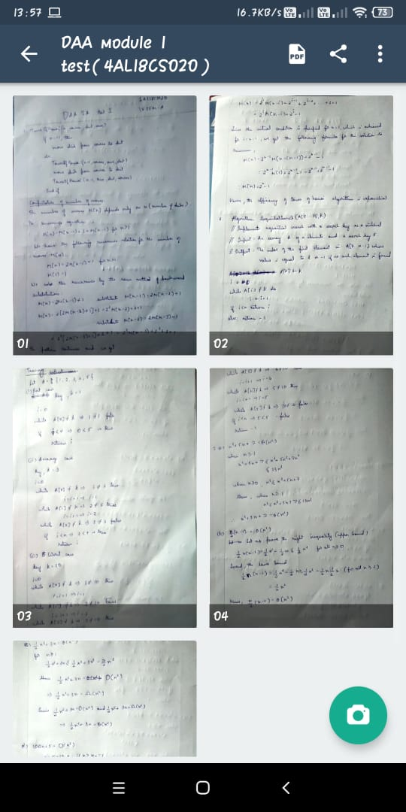

**Online Course Details:**

1. Name of course: **Spark basics and streaming**

Certificate provider: greatlearning

The total course is about getting familiar with big data analysis and how spark can be implemented in it. Today I went through pyspark and pyspark clustering along with spark – Mllib.

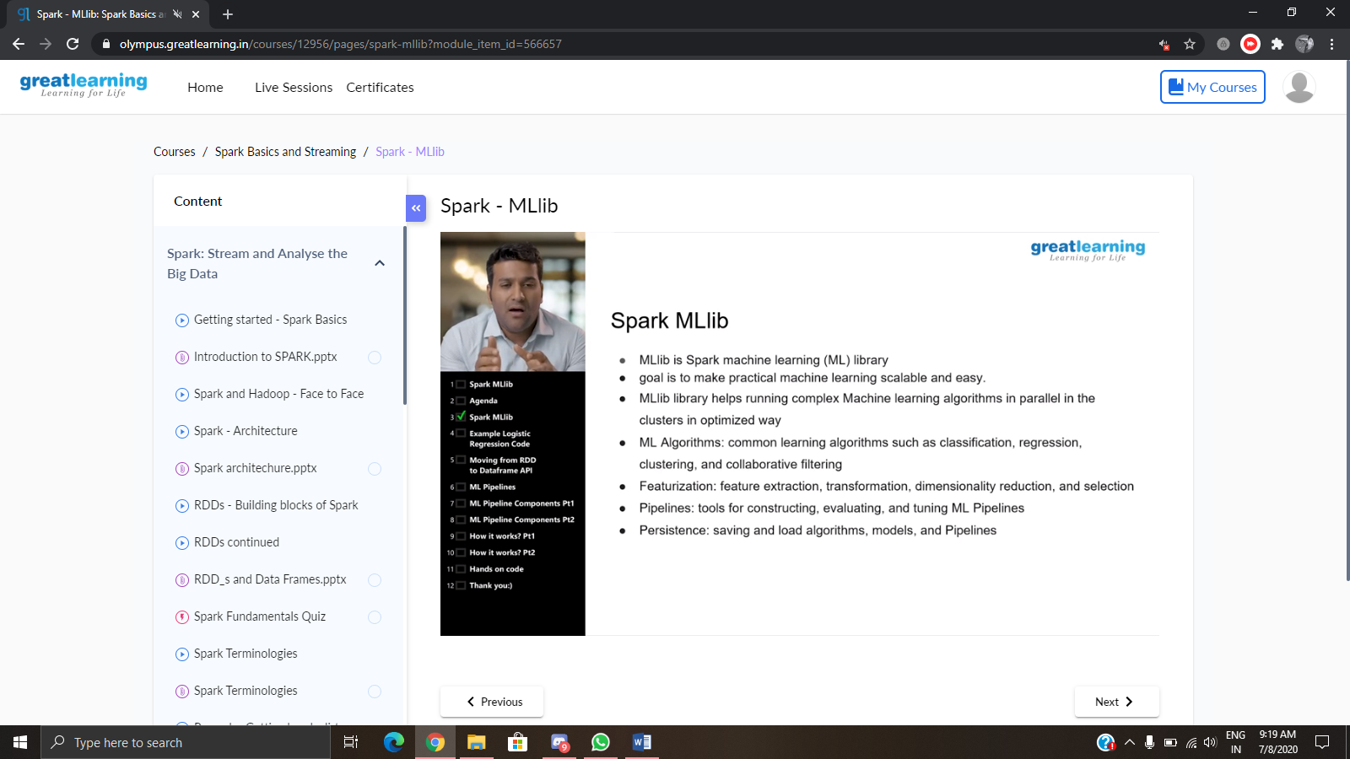

**Online coding:**

Problem 1: (using Python) Given the participants' score sheet for your University Sports Day, you are required to find the runner-up score. You are given scores. Store them in a list and find the score of the runner-up.

