**DAILY ONLINE ACTIVITIES SUMMARY**

|  |  |  |  |  |  |  |  |  |
| --- | --- | --- | --- | --- | --- | --- | --- | --- |
| **Date:** | **28-06-2020** | | | | | **Name:** | **Sanath shetty** | |
| **Sem & Sec** | **8th sem B sec** | | | | | **USN:** | **4AL16CS094** | |
| **Online Test Summary** | | | | | | | | |
| **Subject** | | **-** | | | | | | |
| **Max. Marks** | | **-** | | **Score** | | | **-** | |
| **Certification Course Summary** | | | | | | | | |
| **Course** | **Hadoop and Big data for absolute beginners** | | | | | | | |
| **Certificate Provider** | | | **Eduonix** | | **Duration** | | | **4 hours** |
| **Coding Challenges** | | | | | | | | |
| **Problem Statement: 1) Python Program To Display Powers of 2 Using Anonymous Function** | | | | | | | | |
| **Status: completed** | | | | | | | | |
| **Uploaded the report in Github** | | | | | **yes** | | | |
| **If yes Repository name** | | | | | **alvas-education-foundation/Sanath-Shetty** | | | |
| **Uploaded the report in slack** | | | | | **yes** | | | |

Online Test Details: (Attach the snapshot and briefly write the report for the same)

Certification Course Details: (Attach the snapshot and briefly write the report for the same)

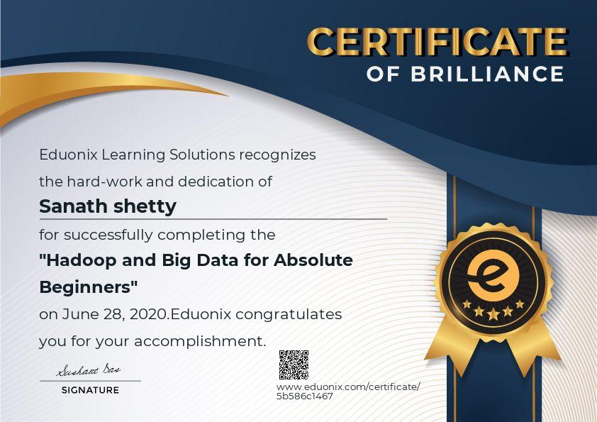

Coding Challenges Details: (Attach the snapshot and briefly write the report for the same)

Coding was given n it was uploaded for github and slack

PROGRAM1

terms = 10

result = list(map(lambda x: 2 ** x, range(terms)))

print("The total terms are:",terms)

for i in range(terms):

print("2 raised to power",i,"is",result[i])

|  |
| --- |
|  |