**DAILY ONLINE ACTIVITIES SUMMARY**

|  |  |  |  |  |  |  |  |  |
| --- | --- | --- | --- | --- | --- | --- | --- | --- |
| **Date:** | **28-05-2020** | | | | | **Name:** | **Sanath shetty** | |
| **Sem & Sec** | **8th sem B sec** | | | | | **USN:** | **4AL16CS094** | |
| **Online Test Summary** | | | | | | | | |
| **Subject** | | **SMS** | | | | | | |
| **Max. Marks** | | **60** | | **Score** | | | **48** | |
| **Certification Course Summary(Internship)** | | | | | | | | |
| **Course** | **Export dashboard screenshot option in the dashboard view** | | | | | | | |
| **Certificate Provider** | | | **Gain-insights** | | **Duration** | | | **8 hours** |
| **Coding Challenges** | | | | | | | | |
| |  | | --- | | **Problem Statement:** Python program to convert Celsius to fahrenheit | | | | | | | | | |
| **Status: completed** | | | | | | | | |
| **Uploaded the report in Github** | | | | | **yes** | | | |
| **If yes Repository name** | | | | | **alvas-education-foundation/Sanath-Shetty** | | | |
| **Uploaded the report in slack** | | | | | **yes** | | | |

Online Test Details: (Attach the snapshot and briefly write the report for the same)

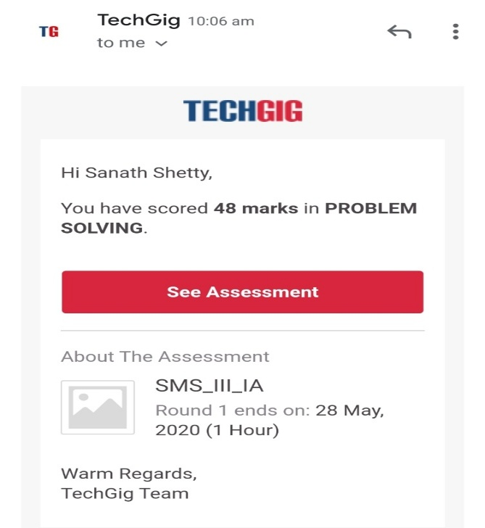

Certification Course Details: (Attach the snapshot and briefly write the report for the same)

Coding Challenges Details: (Attach the snapshot and briefly write the report for the same)

Coding was given n it was uploaded for github and slack

PROGRAM1

**Celsius=37.5**

**Fahreheit = (celsius*1.8)+32**

**Print(‘%0.IfdegreeCelsiusisequalto%0.IfdegreeFahrenheit’%(Celsius,Fahrenheit))**