**DAILY ONLINE ACTIVITIES SUMMARY**

|  |  |  |  |  |  |  |  |  |
| --- | --- | --- | --- | --- | --- | --- | --- | --- |
| **Date:** | **08-06-2020** | | | | | **Name:** | **Sanath shetty** | |
| **Sem & Sec** | **8th sem B sec** | | | | | **USN:** | **4AL16CS094** | |
| **Online Test Summary** | | | | | | | | |
| **Subject** | | **SMS** | | | | | | |
| **Max. Marks** | | **60** | | **Score** | | | **60** | |
| **Certification Course Summary(Internship)** | | | | | | | | |
| **Course** | **Bug fix in the import and export solutions functionality** | | | | | | | |
| **Certificate Provider** | | | **Gain-insights** | | **Duration** | | | **8 hours** |
| **Coding Challenges** | | | | | | | | |
| **Problem Statement: generate all unique partition of integer** | | | | | | | | |
| **Status: completed** | | | | | | | | |
| **Uploaded the report in Github** | | | | | **yes** | | | |
| **If yes Repository name** | | | | | **alvas-education-foundation/Sanath-Shetty** | | | |
| **Uploaded the report in slack** | | | | | **yes** | | | |

Online Test Details: (Attach the snapshot and briefly write the report for the same)

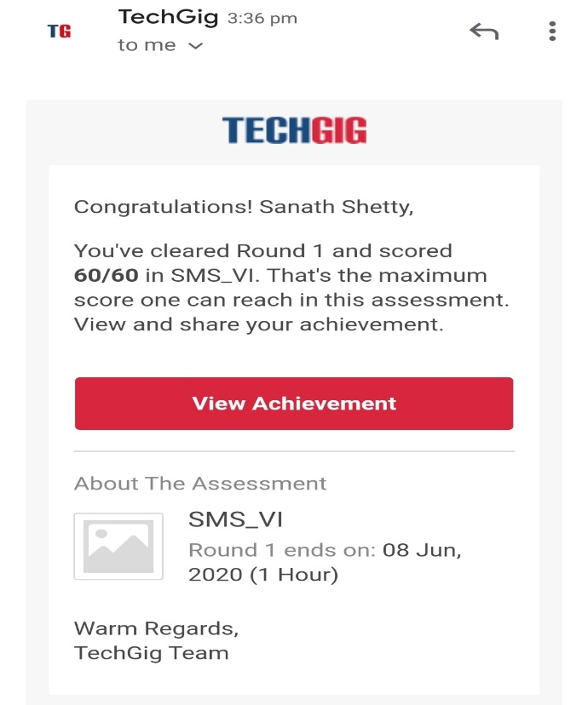

Certification Course Details: (Attach the snapshot and briefly write the report for the same)

Coding Challenges Details: (Attach the snapshot and briefly write the report for the same)

Coding was given n it was uploaded for github and slack

PROGRAM1

def printArray(p, n):

for i in range(0, n):

print(p[i], end = " ")

print()

def printAllUniqueParts(n):

p = [0] * n # An array to store a partition

k = 0 # Index of last element in a partition

p[k] = n # Initialize first partition

# as number itself

while True:

printArray(p, k + 1)

rem_val = 0

while k >= 0 and p[k] == 1:

rem_val += p[k]

k -= 1

if k < 0:

print()

return

p[k] -= 1

rem_val += 1

while rem_val > p[k]:

p[k + 1] = p[k]

rem_val = rem_val - p[k]

k += 1

p[k + 1] = rem_val

k += 1

print('All Unique Partitions of 2')

printAllUniqueParts(2)

print('All Unique Partitions of 3')

printAllUniqueParts(3)

print('All Unique Partitions of 4')

printAllUniqueParts(4)

|  |
| --- |
|  |