DAILY ONLINE ACTIVITIES SUMMARY

|  |  |  |  |  |  |  |  |
| --- | --- | --- | --- | --- | --- | --- | --- |
| **Date:** | 21/05/2020 | | | | **Name:** | Sheeri | |
| **Sem & Sec** | 8 - B sec | | | | **USN:** | 4AL16CS095 | |
| Online Test Summary | | | | | | | |
| **Subject** | | SMS 2 | | | | | |
| **Max. Marks** | | 60 | | **Score** | | 60 | |
| Certification Course Summary | | | | | | | |
| **Course** | **AWS Cloud Practitioner Essentials** | | | | | | |
| **Certificate Provider** | | | AWS | **Duration** | | | 30 minutes |
| Coding Challenges | | | | | | | |
| **Problem Statement:** C Program to Reverse a Linked List in groups of given size. | | | | | | | |
| **Status:** Completed. | | | | | | | |
| **Uploaded the report in Github** | | | | Yes | | | |
| **If yes Repository name** | | | | Sheerishetty | | | |
| **Uploaded the report in slack** | | | | Yes. | | | |

Online Test Details: (Attach the snapshot and briefly write the report for the same)

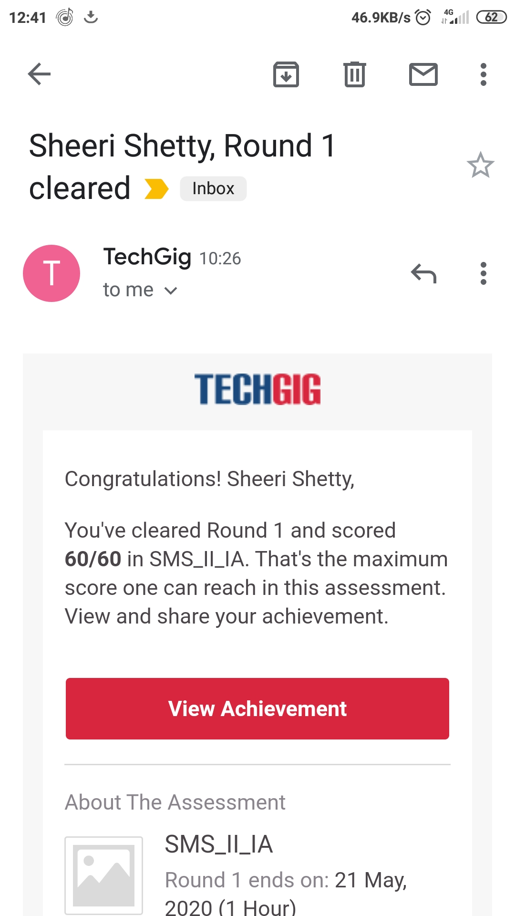

Certification Course Details: (Attach the snapshot and briefly write the report for the same)

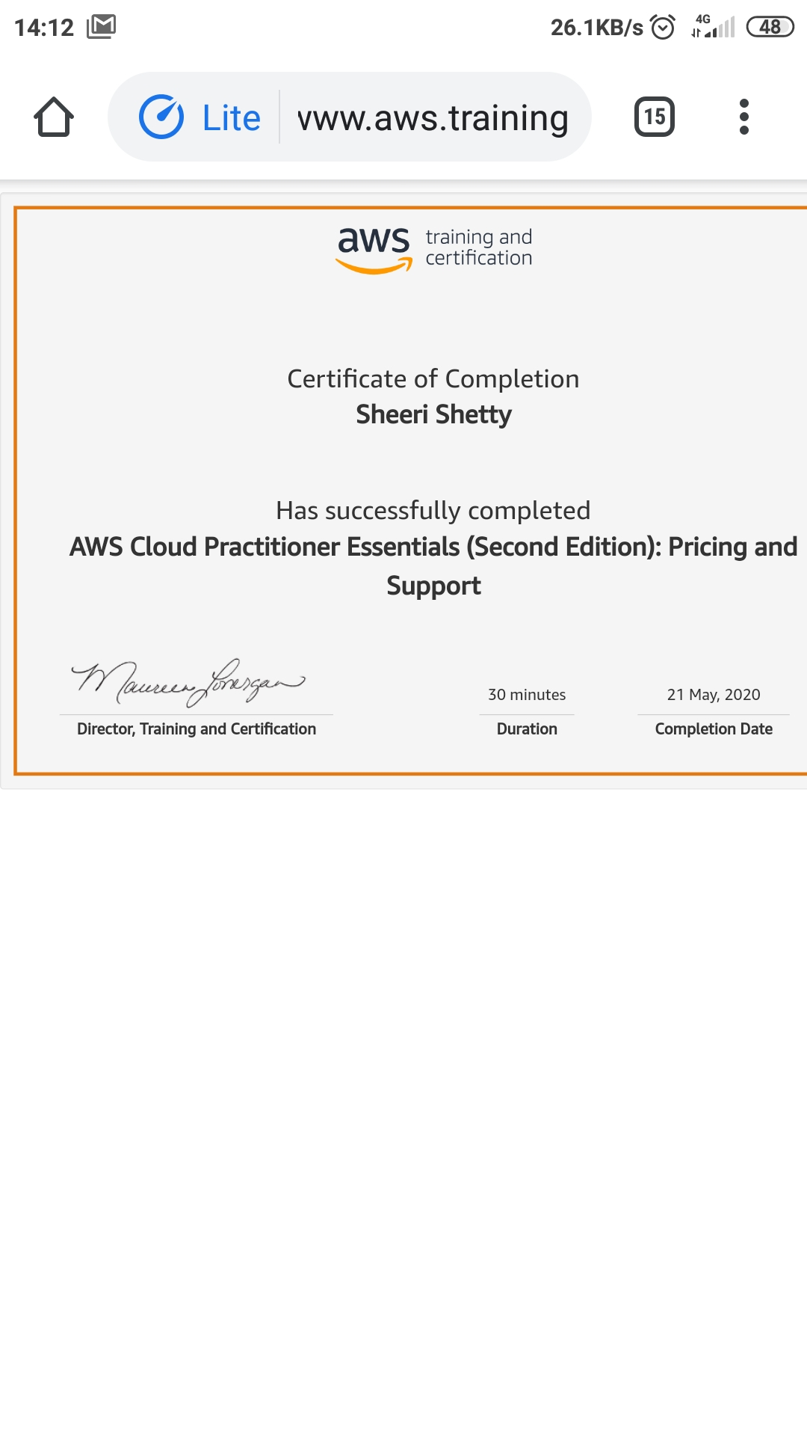

Coding Challenges Details:

Write a C Program to Reverse a Linked List in groups of given size.

