**DAILY ONLINE ACTIVITIES SUMMARY**

|  |  |  |  |  |  |  |  |  |
| --- | --- | --- | --- | --- | --- | --- | --- | --- |
| **Date:** | **06/07/2020** | | | | | **Name:** | **Supriksha** | |
| **Sem & Sec** | **8th B** | | | | | **USN:** | **4AL16CS096** | |
| **Online Test Summary** | | | | | | | | |
| **Subject** | | **-** | | | | | | |
| **Max. Marks** | | **-** | | **Score** | | | **-** | |
| **Certification Course Summary** | | | | | | | | |
| **Course** | **AWS Serverless development** | | | | | | | |
| **Certificate Provider** | | | **AWS** | | **Duration** | | | **4.5hr** |
| **Coding Challenges** | | | | | | | | |
| **Problem Statement:**  **Python Program to Count the Number of Blank Spaces in a Text**  **File.** | | | | | | | | |
| **Status: Solved** | | | | | | | | |
| **Uploaded the report in Github** | | | | | **Yes** | | | |
| **If yes Repository name** | | | | | **Supriksha** | | | |
| **Uploaded the report in slack** | | | | | **Yes** | | | |

Certification Course Details:

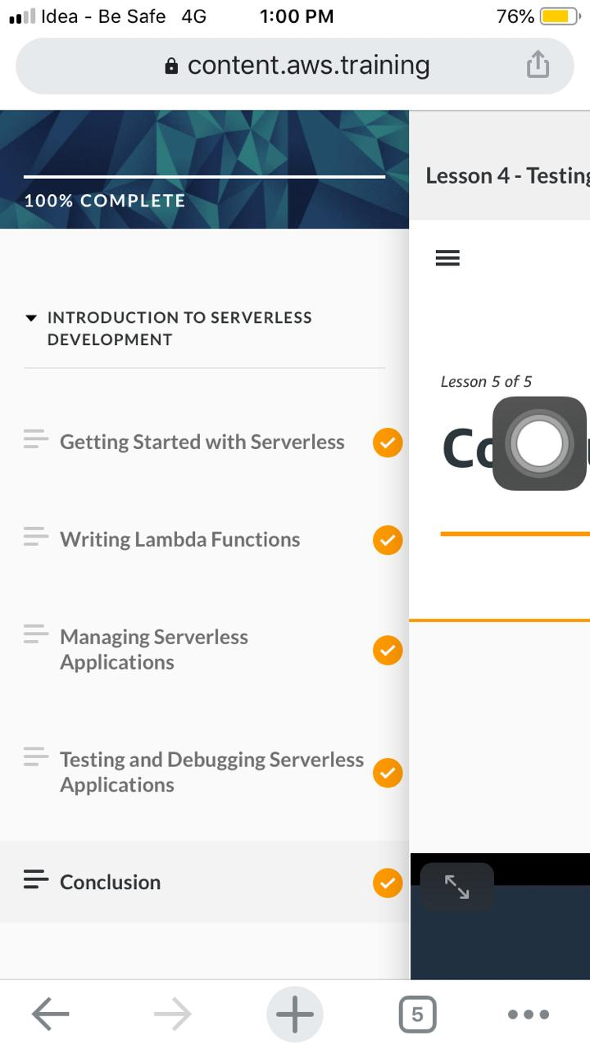

*Coding Challenges Details:*

fname = input("Enter file name: ")

k = 0

with open(fname, 'r') as f:

for line in f:

words = line.split()

for i in words:

for letter in i:

if(letter.isspace):

k=k+1

print("Occurrences of blank spaces:")

print(k)