DAILY ONLINE ACTIVITIES SUMMARY

|  |  |  |  |  |  |  |  |
| --- | --- | --- | --- | --- | --- | --- | --- |
| **Date:** | **1stJuly 2020** | | | | **Name:** | **Supriksha Shetty** | |
| **Sem & Sec** | **8thSemester ‘B’ Section** | | | | **USN:** | **4AL16CS096** | |
| Online Test Summary | | | | | | | |
| **Subject** | |  | | | | | |
| **Max. Marks** | |  | | **Score** | |  | |
| Certification Course Summary | | | | | | | |
| **Course** | **MACHINE LEARNING TERMINOLOGY** | | | | | | |
| **Certificate Provider** | | | **AWS** | **Duration** | | | **3 hour** |
| Coding Challenges | | | | | | | |
| **Problem Statement: 1**. Python program to swap elements at given positions using Swap function | | | | | | | |
| **Status:** completed | | | | | | | |
| **Uploaded the report in Github** | | | | **yes** | | | |
| **If yes Repository name** | | | | **Supriksha** | | | |
| **Uploaded the report in slack** | | | | **yes** | | | |

Certification Course Details: (Attach the snapshot and briefly write the report for thesame)

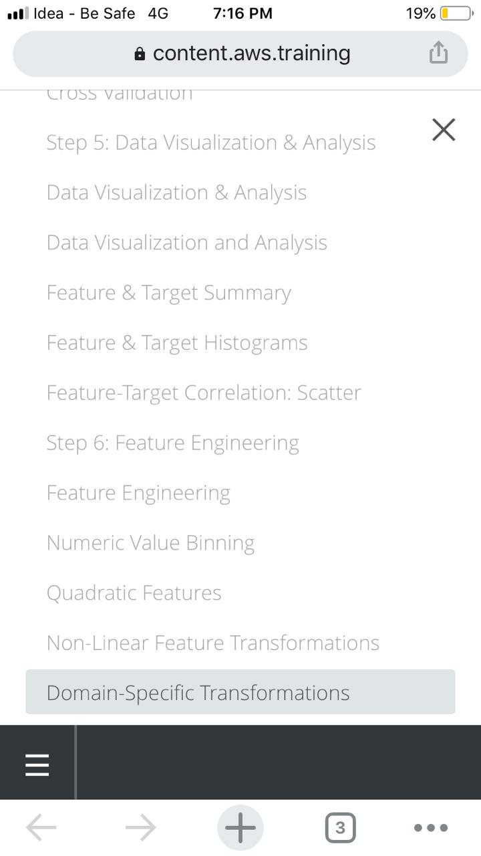

Coding Challenges Details: (Attach the snapshot and briefly write the report for thesame)

def swapPositions(list, pos1, pos2):

list[pos1], list[pos2] = list[pos2], list[pos1]

return list

# Driver function

List = [23, 65, 19, 90]

pos1, pos2 = 1, 3

print(swapPositions(List, pos1-1, pos2-1))