**DAILY ONLINE ACTIVITIES SUMMARY**

|  |  |  |  |  |  |  |  |
| --- | --- | --- | --- | --- | --- | --- | --- |
| **Date:** | **10-06-2020** | | | | **Name:** | **Suprimsha Shetty** | |
| **Sem & Sec** | **8th sem B sec** | | | | **USN:** | **4AL16CS096** | |
| **Online Test Summary** | | | | | | | |
| **Subject** | | **-** | | | | | |
| **Max. Marks** | | **-** | | **Score** | | **-** | |
| **Certification Course Summary** | | | | | | | |
| **Course** | **Java programming** | | | | | | |
| **Certificate Provider** | | | **AWS Lambda foundation** | **Duration** | | | **10-2.30** |
| **Coding Challenges** | | | | | | | |
| **Problem Statement-** : 1) Python program takes a number and reverses it | | | | | | | |
| **Status: completed** | | | | | | | |
| **Uploaded the report in Github** | | | | **yes** | | | |
| **If yes Repository name** | | | | **Supriksha** | | | |
| **Uploaded the report in slack** | | | | **yes** | | | |

Online Test Details: (Attach the snapshot and briefly write the report for the same)

Certification Course Details: (Attach the snapshot and briefly write the report for the same)

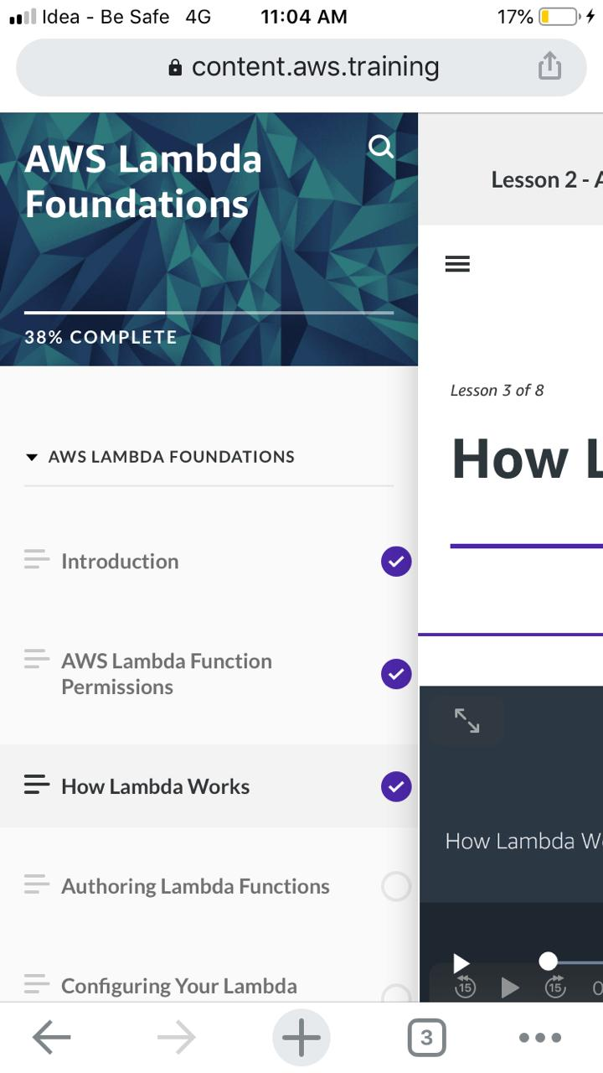

Coding Challenges Details: (Attach the snapshot and briefly write the report for the same)

Coding was given and it was uploaded for github and slack

Program no:1

n=int(input("Enter number: "))

rev=0

**while**(n>0):

dig=n%10

rev=rev*10+dig

n=n//10

**print**("Reverse of the number:",rev)