**DAILY ONLINE ACTIVITIES SUMMARY**

|  |  |  |  |  |  |  |  |
| --- | --- | --- | --- | --- | --- | --- | --- |
| **Date:** | **23-06-2020** | | | | **Name:** | **Supriksha Shetty** | |
| **Sem & Sec** | **8th sem B sec** | | | | **USN:** | **4AL16CS096** | |
| **Online Test Summary** | | | | | | | |
| **Subject** | | **-** | | | | | |
| **Max. Marks** | | **-** | | **Score** | | **-** | |
| **Certification Course Summary** | | | | | | | |
| **Course** | **Aws security fundamentals** | | | | | | |
| **Certificate Provider** | | | **Aws** | **Duration** | | | **2hr** |
| **Coding Challenges** | | | | | | | |
| **Problem Statement-Problem Statement-** : **# Program to make a simple calculator** | | | | | | | |
| **Status: completed** | | | | | | | |
| **Uploaded the report in Github** | | | | **yes** | | | |
| **If yes Repository name** | | | | **Supriksha** | | | |
| **Uploaded the report in slack** | | | | **yes** | | | |

Online Test Details: (Attach the snapshot and briefly write the report for the same)

Certification Course Details: (Attach the snapshot and briefly write the report for the same) 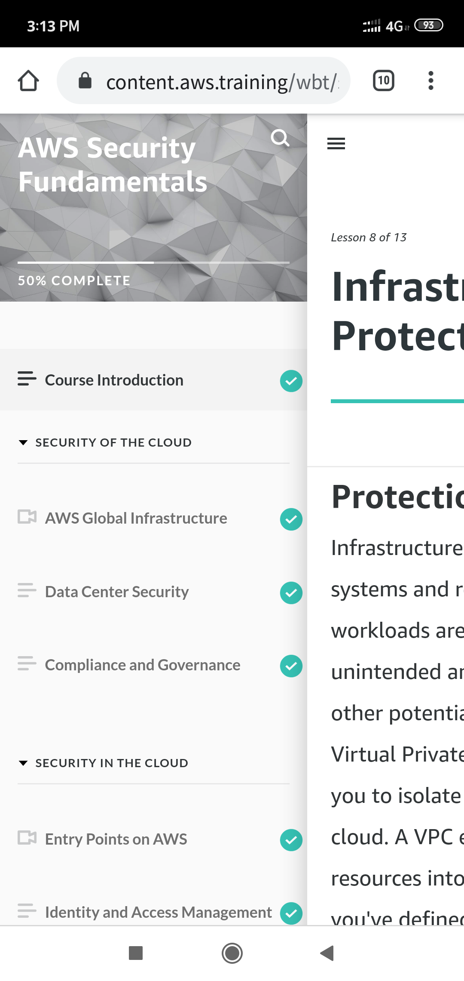

Coding Challenges Details: (Attach the snapshot and briefly write the report for the same)

Coding was given and it was uploaded for github and slack

**def add(x, y):**

**return x + y**

**def subtract(x, y):**

**return x - y**

**def multiply(x, y):**

**return x * y**

**def divide(x, y):**

**return x / y**

**print("Select operation.")**

**print("1.Add")**

**print("2.Subtract")**

**print("3.Multiply")**

**print("4.Divide")**

**while True:**

**choice = input("Enter choice(1/2/3/4): ")**

**if choice in ('1', '2', '3', '4'):**

**num1 = float(input("Enter first number: "))**

**num2 = float(input("Enter second number: "))**

**if choice == '1':**

**print(num1, "+", num2, "=", add(num1, num2))**

**elif choice == '2':**

**print(num1, "-", num2, "=", subtract(num1, num2))**

**elif choice == '3':**

**print(num1, "*", num2, "=", multiply(num1, num2))**

**elif choice == '4':**

**print(num1, "/", num2, "=", divide(num1, num2))**

**break**

**else:**

**print("Invalid Input")**