**DAILY ONLINE ACTIVITIES SUMMARY**

|  |  |  |  |  |  |  |  |
| --- | --- | --- | --- | --- | --- | --- | --- |
| **Date:** | **04-06-2020** | | | | **Name:** | **Supriksha Shetty** | |
| **Sem & Sec** | **8th sem B sec** | | | | **USN:** | **4AL16CS096** | |
| **Online Test Summary** | | | | | | | |
| **Subject** | | **SMS** | | | | | |
| **Max. Marks** | | **60** | | **Score** | | **60** | |
| **Certification Course Summary** | | | | | | | |
| **Course** | **Advanced analytics** | | | | | | |
| **Certificate Provider** | | | **AWS** | **Duration** | | | **2.5hrs** |
| **Coding Challenges** | | | | | | | |
| **Problem Statement-** :  **Program to find HCF of two numbers** | | | | | | | |
| **Status: completed** | | | | | | | |
| **Uploaded the report in Github** | | | | **yes** | | | |
| **If yes Repository name** | | | | **Supriksha** | | | |
| **Uploaded the report in slack** | | | | **yes** | | | |

Online Test Details: (Attach the snapshot and briefly write the report for the same)

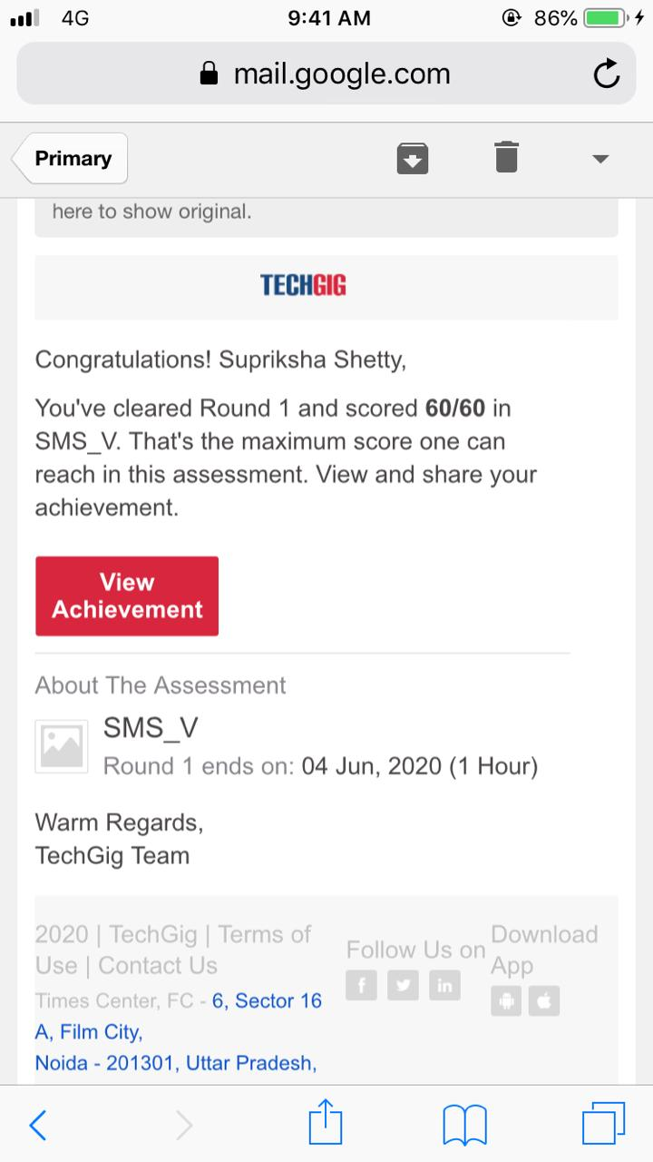

Certification Course Details: (Attach the snapshot and briefly write the report for the same)

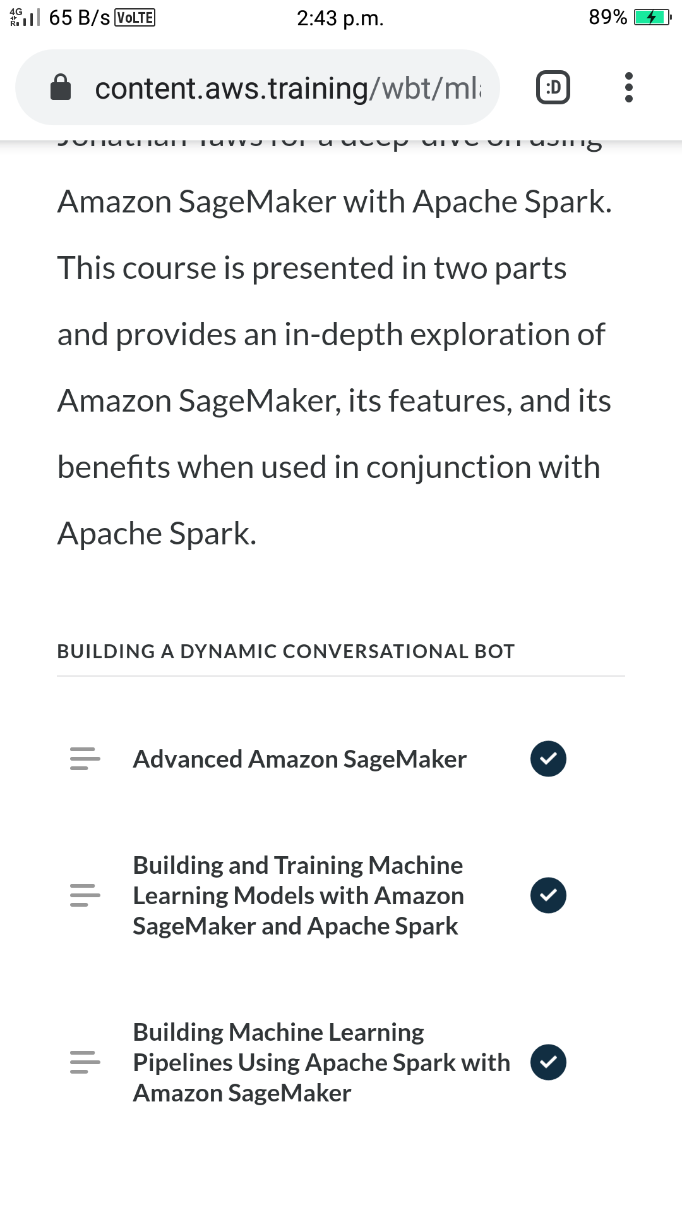

Coding Challenges Details: (Attach the snapshot and briefly write the report for the same)

Coding was given and it was uploaded for github and slack

**Python program to find H.C.F of two numbers**

**defcompute_hcf(x,y):**

**ifx>y:**

**smaller=y else:**

**smaller=x foriinrange(1,smaller+1):**

**if((x%i==0)and(y%i==0)):**

**hcf=i return hcf**

**num1=54**

**num2=24**

**print("TheH.C.F.is",compute_hcf(num1,num2))**