**DAILY ONLINE ACTIVITIES SUMMARY**

|  |  |  |  |  |  |  |  |
| --- | --- | --- | --- | --- | --- | --- | --- |
| **Date:** | **21/05/2020** | | | | **Name:** | **Tushit Shukla** | |
| **Sem & Sec** | **4 sem & B sec** | | | | **USN:** | **4AL18CS093** | |
| **Online Test Summary** | | | | | | | |
| **Subject** | | **Micro controller and micro processor IA Test** | | | | | |
| **Max. Marks** | | **30** | | **Score** | | **20** | |
| **Certification Course Summary** | | | | | | | |
| **Course** | 1. [Introduction to Cyber security](https://olympus.greatlearning.in/courses/12628) | | | | | | |
| **Certificate Provider** | | | **Great Learning** | **Duration** | | | **1s hr(spent by me on that day to learn)** |
| **Coding Challenges** | | | | | | | |
| **Problem Statement:1** Hint: Create the SLL, and then Reverse the Link in SLL until Head becomes NULL. Each Time Reversing the Link, Head must be moved to next immediate node.  **2** Write a C program to construct a singly linked list by removing duplicate elements in the sorted linked list Description: Take a sorted list and traverse the list. Compare the current node element with next adjacent node. If it is same then delete second element, if not retain. Finally print the resulting list. Sample output: Given list {1,2,2,3,3,3,4} Resulting list{1,2,3,4}  . | | | | | | | |
| **Status: Completed** | | | | | | | |
| **Uploaded the report in Github** | | | | **Yes** | | | |
| **If yes Repository name** | | | | <https://github.com/tushitshukla29/lockdown-program> | | | |
| **Uploaded the report in slack** | | | | **Yes** | | | |

**Online Test Details**

Micro controller and micro processorTEST Details:

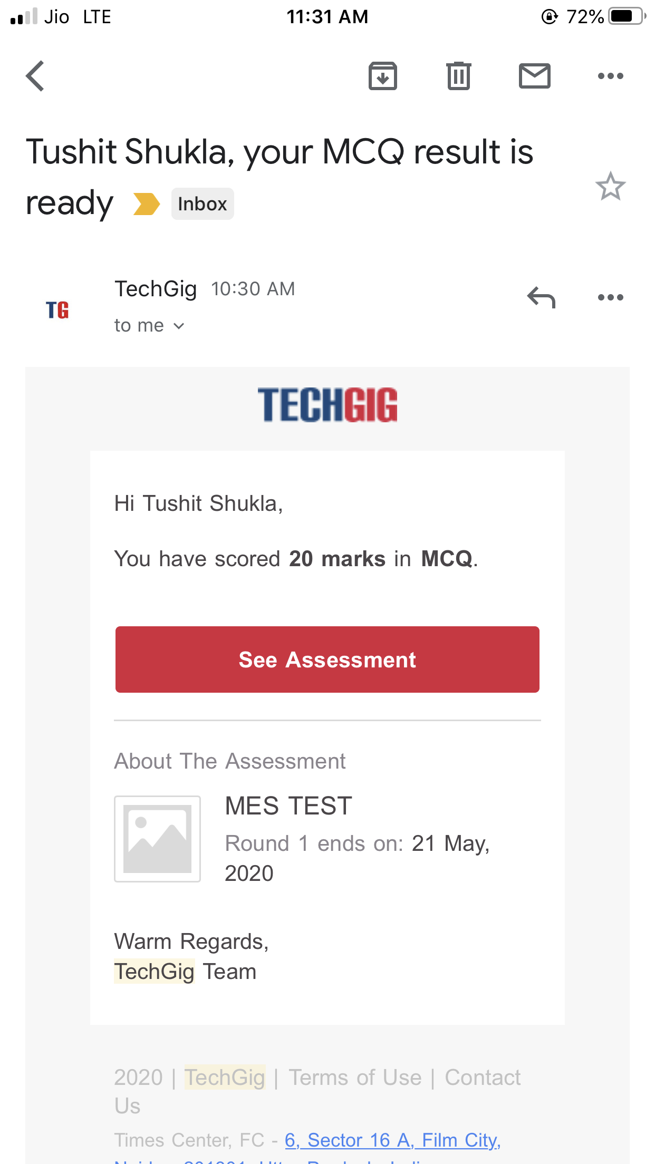

**Online Certification Details**: Introduction to Cryptography

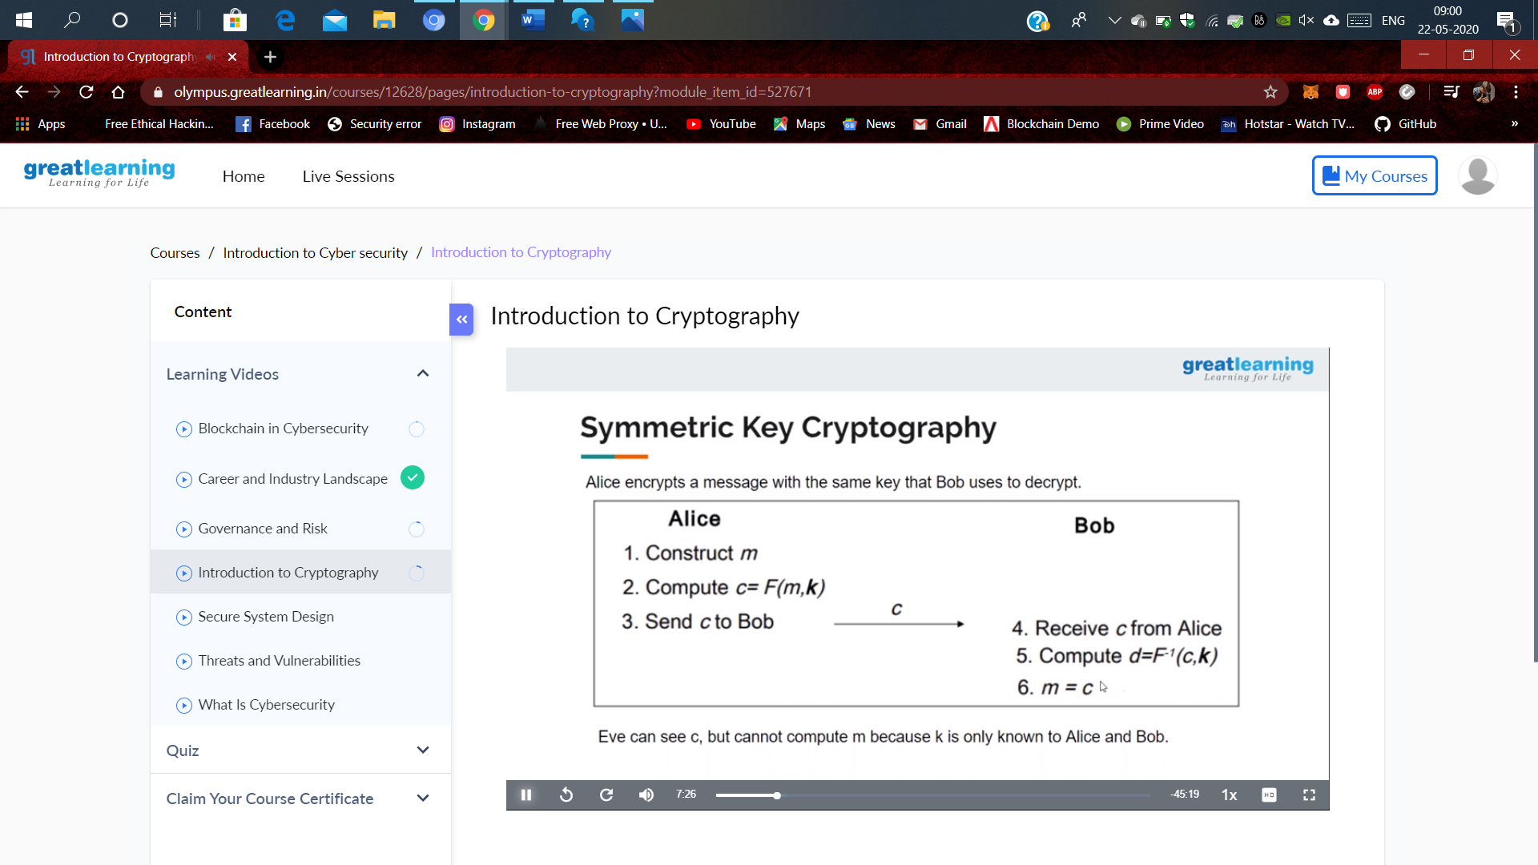

**Coding Challenge Detail :** I have written programs and uploaded it to my Github repository.

Link as follows: 1.<https://github.com/tushitshukla29/lockdown-program/blob/master/duplicate%20linklist>

1. <https://github.com/tushitshukla29/lockdown-program/blob/master/duplicate%20linklist>