**DAILY ONLINE ACTIVITIES SUMMARY**

|  |  |  |  |  |  |  |  |
| --- | --- | --- | --- | --- | --- | --- | --- |
| **Date:** | **22/05/2020** | | | | **Name:** | **Tushit Shukla** | |
| **Sem & Sec** | **4 sem & B sec** | | | | **USN:** | **4AL18CS093** | |
| **Online Test Summary** | | | | | | | |
| **Subject** | | **Operating System IA Test** | | | | | |
| **Max. Marks** | | **30** | | **Score** | | **23** | |
| **Certification Course Summary** | | | | | | | |
| **Course** | 1. [Introduction to Cyber security](https://olympus.greatlearning.in/courses/12628) | | | | | | |
| **Certificate Provider** | | | **Great Learning** | **Duration** | | | **1s hr(spent by me on that day to learn)** |
| **Coding Challenges** | | | | | | | |
| **Problem Statement:**  1. Hint: First Create a Singly Linked List Stack with the node corresponding to First Element is the base of the stack; and its link field must be always Null. When you push First Element, It is the First and it is Base of the stack. Its Link must be Null. top pointer pointing to First. (top = First) When you push any element, (No need of checking Stack full case because SLL is dynamic) Create a new node called temp using malloc function and insert the a number into Data field, and Link field must be pointing to top; and move the pointer top to point to temp. When you pop, First check for stack Empty. if First == NULL, then Stack Empty. If it is not empty, The pointer temp must be pointing to top. Move the pointer top to top->link. delete temp. When you display the stack element, First Check for Stack Empty as in pop operation. If it is not empty, Display all the elements of current stack starting from top to First. | | | | | | | |
| **Status: Completed** | | | | | | | |
| **Uploaded the report in Github** | | | | **Yes** | | | |
| **If yes Repository name** | | | | <https://github.com/tushitshukla29/lockdown-program> | | | |
| **Uploaded the report in slack** | | | | **Yes** | | | |

**Online Test Details**

Operating SystemTEST Details:

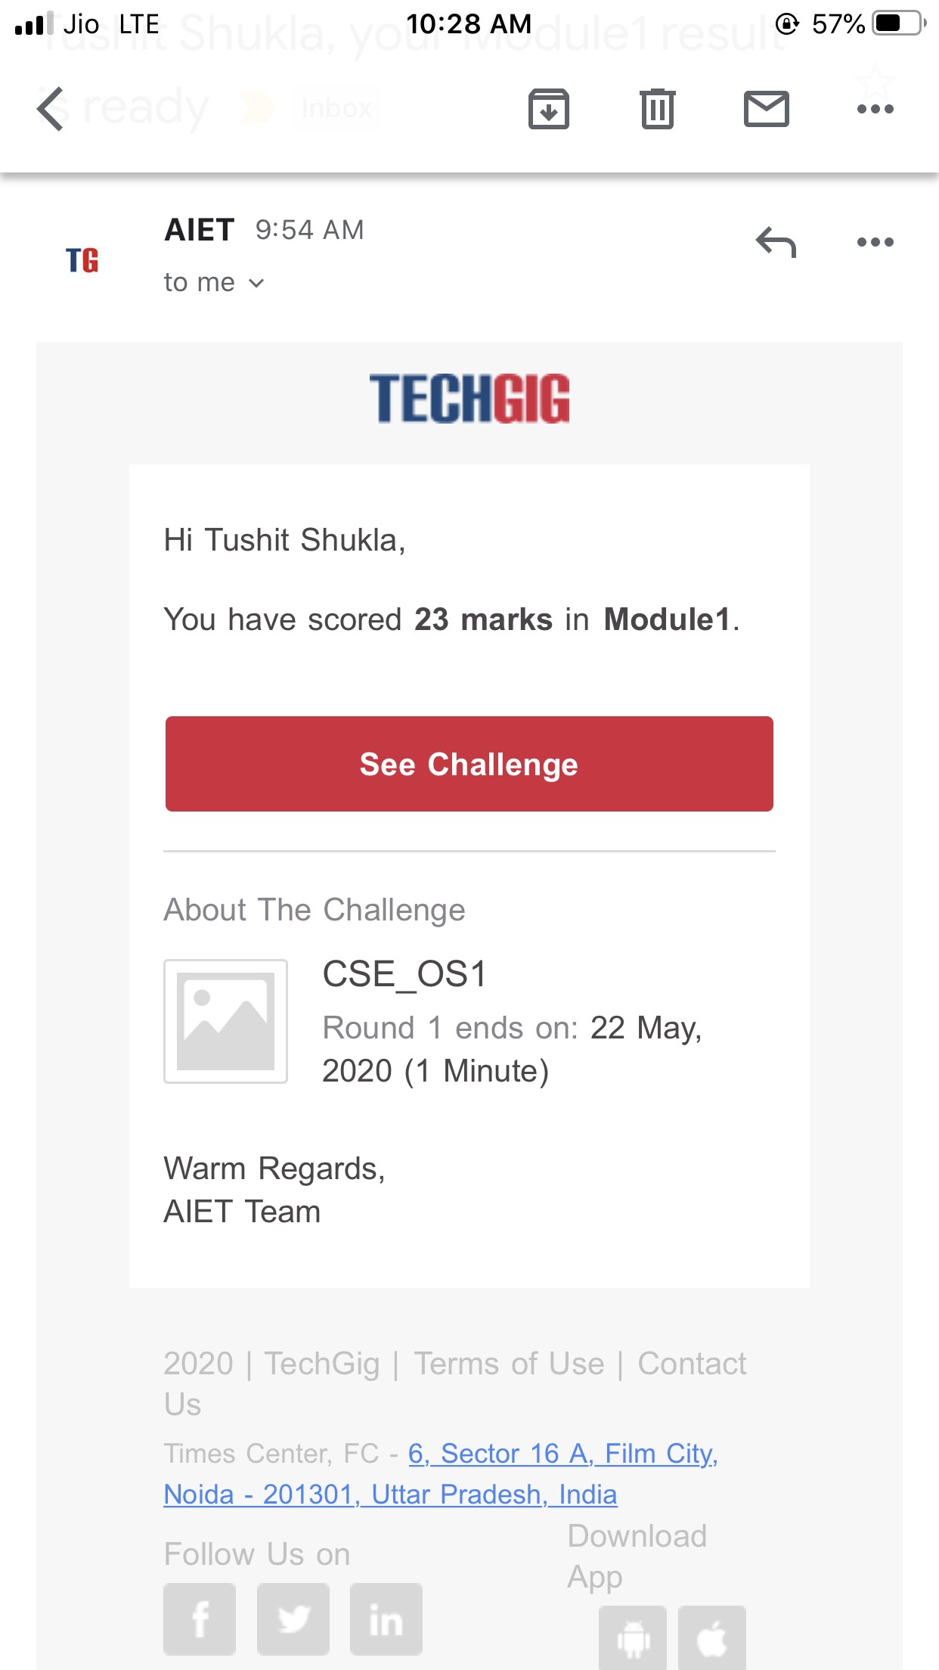

**Online Certification Details**:

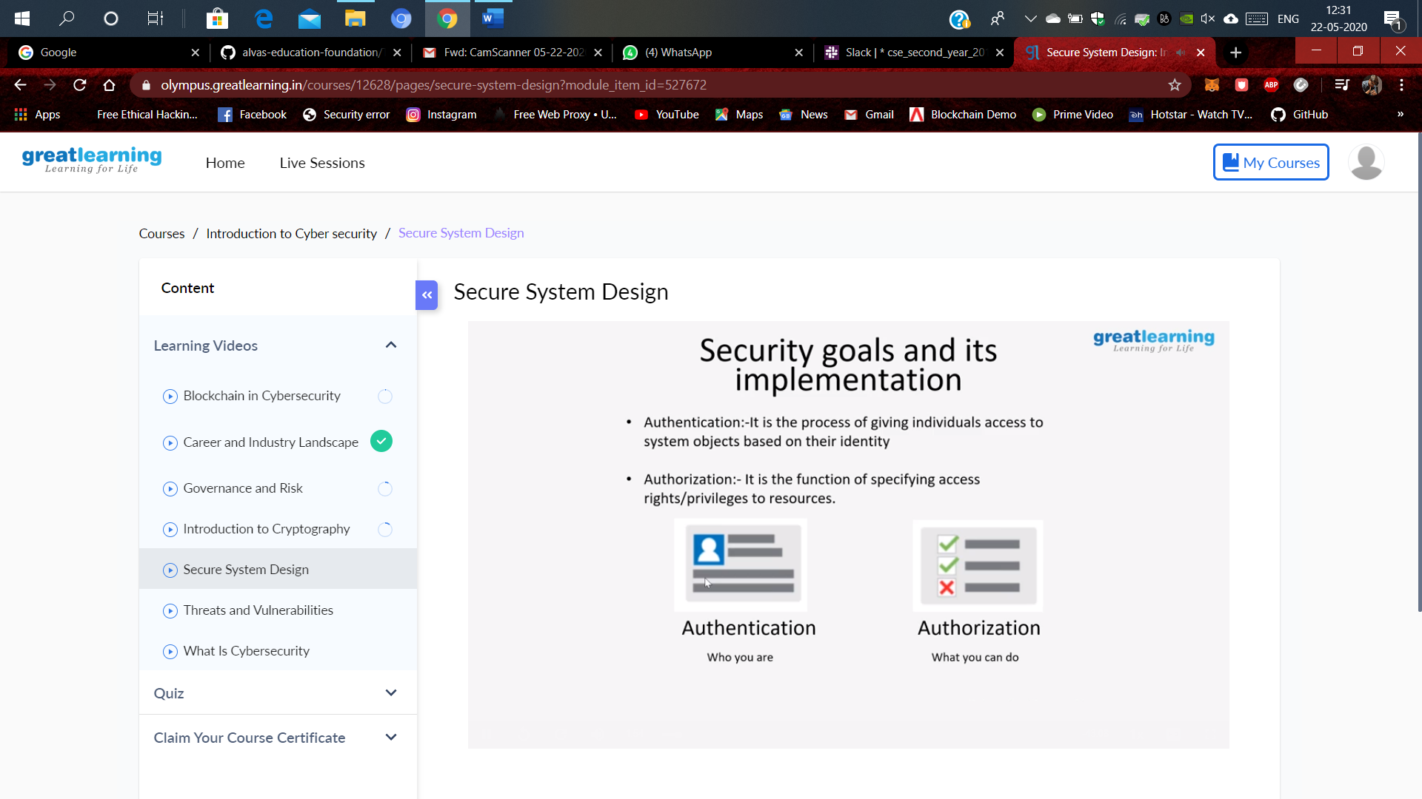

**Coding Challenge Detail :** I have written programs and uploaded it to my Github repository.

Link as follows: 1. <https://github.com/tushitshukla29/lockdown-program/blob/master/sll%20stack>