**DAILY ONLINE ACTIVITIES SUMMARY**

|  |  |  |  |  |  |  |  |
| --- | --- | --- | --- | --- | --- | --- | --- |
| **Date:** | **1/06/20** | | | | **Name:** | **Vandana E V** | |
| **Sem& Sec** | **8th semA sec** | | | | **USN:** | **4AL15CS103** | |
| **Online Test Summary** | | | | | | | |
| **Subject** | | **SMS** | | | | | |
| **Max. Marks** | | **60** | | **Score** | | **30** | |
| **Certification Course Summary** | | | | | | | |
| **Course** | **Python for machine learning** | | | | | | |
| **Certificate Provider** | | | **Great Learning Academy** | **Duration** | | | **5 hrs** |
| **Coding Challenges** | | | | | | | |
| **Problem Statement: 1)** | | | | | | | |
| **Status: Completed** | | | | | | | |
| **Uploaded the report in Github** | | | | **Yes** | | | |
| **If yes Repository name** | | | | **Vandana** | | | |
| **Uploaded the report in slack** | | | | **Yes** | | | |

Online Test Details:

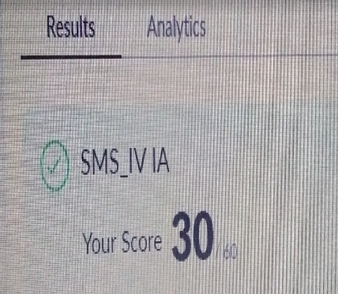

Online Course:

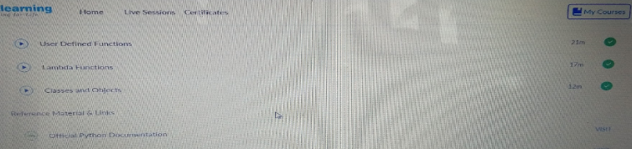

Coding Challenges Details:

intmain()

{

int Rows, i, j;

printf("Please Enter the Number of Rows: ");

scanf("%d", &Rows);

printf("\nPrinting Right Angled Triangle \n \n");

for ( i = 1 ; i<= Rows; i++ )

{

for ( j = 1 ; j <= i; j++ )

{

printf("* ");

}

printf("\n");

}

return 0;

}

intmain()

{

int Rows, i, j;

printf("Please Enter the Number of Rows: ");

scanf("%d", &Rows);

printf("\nPrinting Right Angled Triangle \n \n");

for ( i = 1 ; i<= Rows; i++ )

{

for ( j = 1 ; j <= i; j++ )

{

printf("* ");

}

printf("\n");

}

return 0;

}