**DAILY ONLINE ACTIVITIES SUMMARY**

|  |  |  |  |  |  |  |  |
| --- | --- | --- | --- | --- | --- | --- | --- |
| **Date:** | **13/06/2020** | | | | **Name:** | **Vandana E V** | |
| **Sem & Sec** | **8th A** | | | | **USN:** | **4AL15CS103** | |
| Online Test Summary | | | | | | | |
| **Subject** | | **IOT** | | | | | |
| **Max. Marks** | | **30** | | **Score** | | **30** | |
| Certification Course Summary | | | | | | | |
| **Course** | **Introduction to Cyber security** | | | | | | |
| **Certificate Provider** | | | **Great Learning Academy** | **Duration** | | | **7 hrs** |
| Coding Challenges | | | | | | | |
| **Problem Statement:Write a C program to calculate electricity** | | | | | | | |
| **Status: Solved** | | | | | | | |
| **Uploaded the report in Github** | | | | **YES** | | | |
| **If yes Repository name** | | | | **Vandana** | | | |
| **Uploaded the report in slack** | | | | **YES** | | | |

**Online Test:**

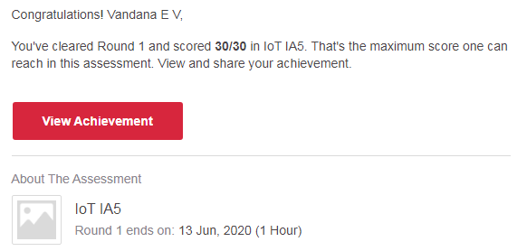

**Certification Course Details:**



# CODE:

Program no:1

//Write a C Program to calculate Electricity Bill

#include <stdio.h>

int main()

{

int unit;

float amt, total_amt;

printf("Enter total units consumed: ");

scanf("%d", &unit);

if(unit <= 100)

{

amt = unit * 10;

}

else if(unit <= 200)

{

amt = 1000 + ((unit-100) * 15);

}

else if(unit <= 300)

{

amt = 2500 + ((unit-200) * 20);

}

else

{

amt = 4500 + ((unit-300) * 25);

}

total_amt = amt;

printf("Electricity Bill = Rs. %d", total_amt);

return 0;

}