**DAILY ONLINE ACTIVITIES SUMMARY**

|  |  |  |  |  |  |  |  |  |
| --- | --- | --- | --- | --- | --- | --- | --- | --- |
| **Date:** | **20-05-2020** | | | | | **Name:** | **Vandana E V** | |
| **Sem & Sec** | **8th 'A'** | | | | | **USN:** | **4AL15CS103** | |
| **Online Test Summary** | | | | | | | | |
| **Subject** | | **Internet of things** | | | | | | |
| **Max. Marks** | | **30** | | **Score** | | | **19** | |
| **Certification Course Summary** | | | | | | | | |
| **Course** | **Ethical Hacking** | | | | | | | |
| **Certificate Provider** | | | **Great learning** | | **Duration** | | | **6hrs** |
| **Coding Challenges** | | | | | | | | |
| **Problem Statement:Finding a frequency of each character in a string and to point the even and odd for series** | | | | | | | | |
| **Status:Solved** | | | | | | | | |
| **Uploaded the report in Github** | | | | | **Yes** | | | |
| **If yes Repository name** | | | | | **Vandana** | | | |
| **Uploaded the report in slack** | | | | | **Yes** | | | |

Online Test Details: (Attach the snapshot and briefly write the report for the same)

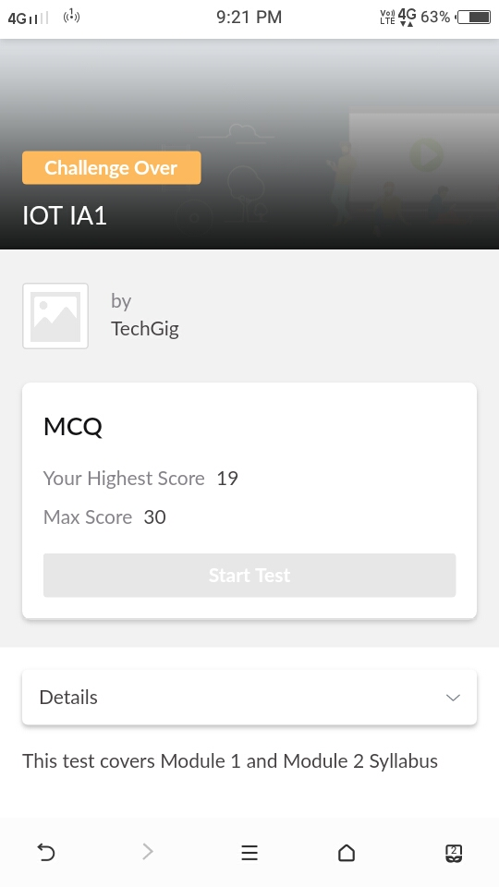

Certification Course Details: (Attach the snapshot and briefly write the report for the same)

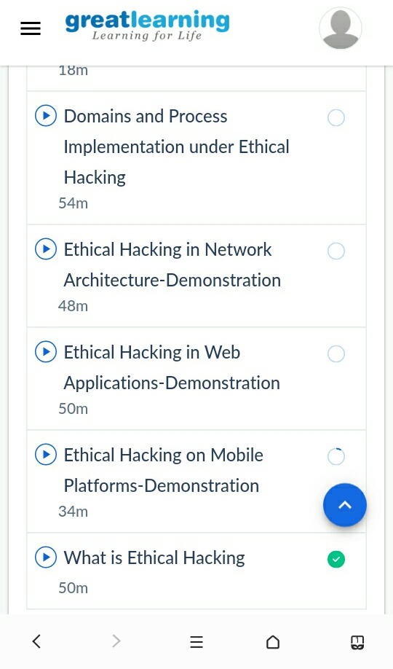

Coding Challenges Details: (Attach the snapshot and briefly write the report for the same)

package shortestpalindromeexample.java;

import java.util.Scanner;

public class ShortestPalindromeDemo {

public static String shortestPalindrome(String str) {

int x=0;

int y=str.length()-1;

while(y>=0){

if(str.charAt(x)==str.charAt(y)){

x++;

}

y--;

}

if(x==str.length())

return str;

String suffix = str.substring(x);

String prefix = new StringBuilder(suffix).reverse().toString();

String mid = shortestPalindrome(str.substring(0, x));

return prefix+mid+suffix;

}

public static void main(String[] args)

{

Scanner in = new Scanner(System.in);

System.out.println("Enter a String to find out shortest palindrome");

String str=in.nextLine();

System.out.println("Shortest palindrome of "+str+" is "+shortestPalindrome(str));}