**DAILY ONLINE ACTIVITIES SUMMARY**

|  |  |  |  |  |  |  |  |
| --- | --- | --- | --- | --- | --- | --- | --- |
| **Date:** | **15-06-2020** | | | | **Name:** | **Veekshith Shetty** | |
| **Sem & Sec** | **8th sem B sec** | | | | **USN:** | **4AL16CS097** | |
| **Online Test Summary** | | | | | | | |
| **Subject** | | **SMS** | | | | | |
| **Max. Marks** | | **60** | | **Score** | | **No mail received** | |
| **Certification Course Summary** | | | | | | | |
| **Course** | Exam Readiness:AWS certified security speciality | | | | | | |
| **Certificate Provider** | | | **Aws** | **Duration** | | | **2hr** |
| **Coding Challenges** | | | | | | | |
| **Problem Statement- # Python implementation to reverse bits of a number** | | | | | | | |
| **Status: completed** | | | | | | | |
| **Uploaded the report in Github** | | | | **yes** | | | |
| **If yes Repository name** | | | | Veekshith-Shetty | | | |
| **Uploaded the report in slack** | | | | **yes** | | | |

Online Test Details: (Attach the snapshot and briefly write the report for the same)

Certification Course Details: (Attach the snapshot and briefly write the report for the same)

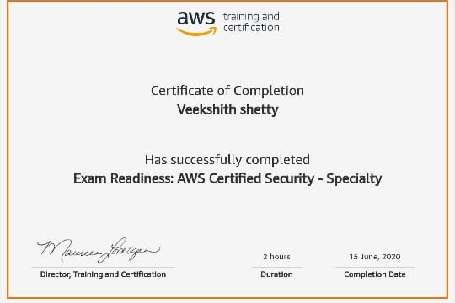

Coding Challenges Details: (Attach the snapshot and briefly write the report for the same)

Coding was given and it was uploaded for github and slack

**# Python implementation to reverse bits of a number**

**def reverseBits(n) :**

**rev = 0**

**# traversing bits of 'n' from the right**

**while (n > 0) :**

**# bitwise left shift 'rev' by 1**

**rev = rev << 1**

**# if current bit is '1'**

**if (n & 1 == 1) :**

**rev = rev ^ 1**

**# bitwise right shift 'n' by 1**

**n = n >> 1**

**return rev**

**n = 11**

**print(reverseBits(n))**