**DAILY ONLINE ACTIVITIES SUMMARY**

|  |  |  |  |  |  |  |  |
| --- | --- | --- | --- | --- | --- | --- | --- |
| **Date:** | **28/06/2020** | | | | **Name:** | **Veekshith Shetty** | |
| **Sem & Sec** | **8 B** | | | | **USN:** | **4AL16CS097** | |
| **Online Test Summary** | | | | | | | |
| **Subject** | | **-** | | | | | |
| **Max. Marks** | | **-** | | **Score** | | **-** | |
| **Certification Course Summary** | | | | | | | |
| **Course** | **Architecting serverless solution on AWS** | | | | | | |
| **Certificate Provider** | | | **AWS** | **Duration** | | | **3 hr** |
| **Coding Challenges** | | | | | | | |
| **Problem Statement:**  **1) Python Program To Display Powers of 2 Using Anonymous Function** | | | | | | | |
| **Status:completed** | | | | | | | |
| **Uploaded the report in Github** | | | | **Yes** | | | |
| **If yes Repository name** | | | | **Veekshith-Shetty** | | | |
| **Uploaded the report in slack** | | | | **Yes** | | | |

ONLINE TEST

**CERTIFICATION**

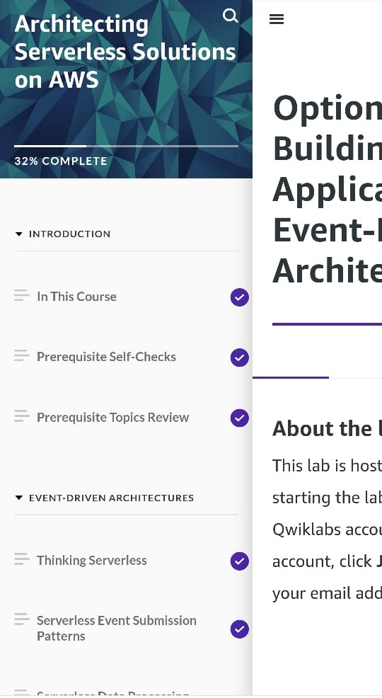

CODING CHALLENGE:

PROGRAM 1 :

1)

terms = 10

result = list(map(lambda x: 2 ** x, range(terms)))

print("The total terms are:",terms)

for i in range(terms):

print("2 raised to power",i,"is",result[i])