**DAILY ONLINE ACTIVITIES SUMMARY**

|  |  |  |  |  |  |  |  |
| --- | --- | --- | --- | --- | --- | --- | --- |
| **Date:** | **29-06-2020** | | | | **Name:** | **Veekshith shetty** | |
| **Sem & Sec** | **8th sem B sec** | | | | **USN:** | **4AL16CS097** | |
| **Online Test Summary** | | | | | | | |
| **Subject** | | **SMS** | | | | | |
| **Max. Marks** | | **30** | | **Score** | | **No mail received** | |
| **Certification Course Summary** | | | | | | | |
| **Course** | **Architecting serverless solution for AWS** | | | | | | |
| **Certificate Provider** | | | **Aws** | **Duration** | | | **3hr** |
| **Coding Challenges** | | | | | | | |
| **Problem Statement-** #Python program to swap elements at given positions using Swap function | | | | | | | |
| **Status: completed** | | | | | | | |
| **Uploaded the report in Github** | | | | **yes** | | | |
| **If yes Repository name** | | | | **Veekshith-Shetty** | | | |
| **Uploaded the report in slack** | | | | **yes** | | | |

Online Test Details: (Attach the snapshot and briefly write the report for the same)

Certification Course Details: (Attach the snapshot and briefly write the report for the same)

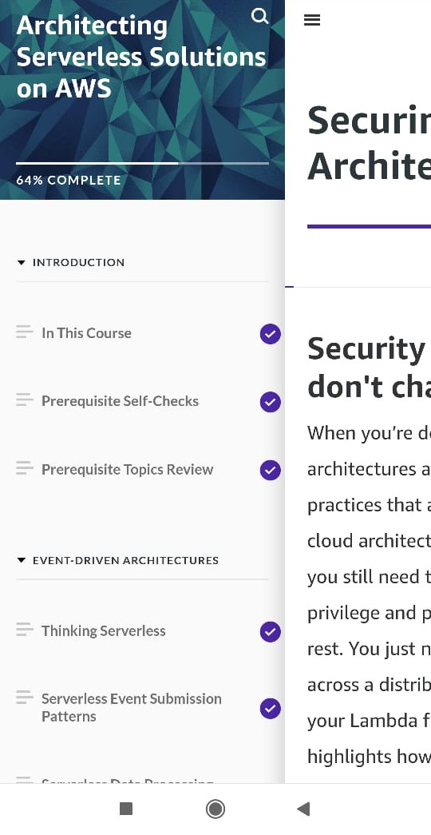

Coding Challenges Details: (Attach the snapshot and briefly write the report for the same)

Coding was given and it was uploaded for github and slack

def swapPositions(list, pos1, pos2):

list[pos1], list[pos2] = list[pos2], list[pos1]

return list

# Driver function

List = [23, 65, 19, 90]

pos1, pos2 = 1, 3

print(swapPositions(List, pos1-1, pos2-1))