**DAILY ONLINE ACTIVITIES SUMMARY**

|  |  |  |  |  |  |  |  |
| --- | --- | --- | --- | --- | --- | --- | --- |
| **Date:** | **06-06-2020** | | | | **Name:** | **Veekshith Shetty** | |
| **Sem & Sec** | **8th sem B sec** | | | | **USN:** | **4AL16CS097** | |
| **Online Test Summary** | | | | | | | |
| **Subject** | | **IOT** | | | | | |
| **Max. Marks** | | **30** | | **Score** | | **30** | |
| **Certification Course Summary** | | | | | | | |
| **Course** | **AWS certified Machine Learning speciality** | | | | | | |
| **Certificate Provider** | | | **Aws** | **Duration** | | | **4hrs 30 min** |
| **Coding Challenges** | | | | | | | |
| **Problem Statement-** :  **1)** Python program for **given a two list. Create a third list by picking an odd-index element from the first list and even index elements from second.** | | | | | | | |
| **Status: completed** | | | | | | | |
| **Uploaded the report in Github** | | | | **yes** | | | |
| **If yes Repository name** | | | | **Supriksha** | | | |
| **Uploaded the report in slack** | | | | **yes** | | | |

Online Test Details: (Attach the snapshot and briefly write the report for the same)

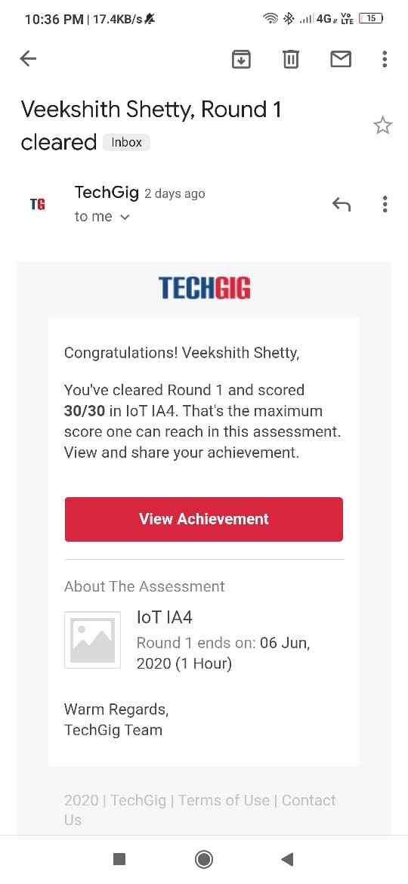

Certification Course Details: (Attach the snapshot and briefly write the report for the same)

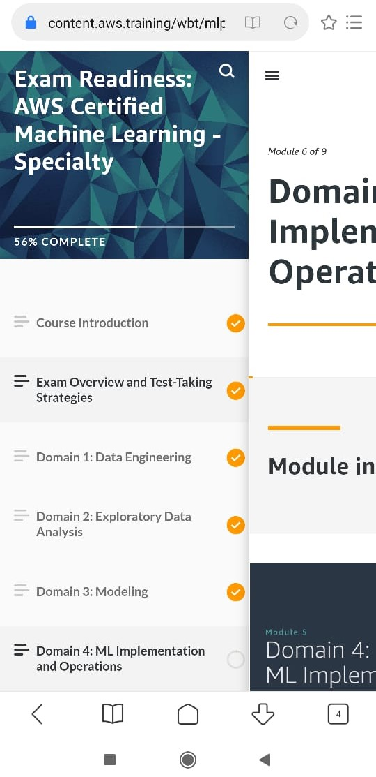

Saw videos on machine learning

Coding Challenges Details: (Attach the snapshot and briefly write the report for the same)

Coding was given and it was uploaded for github and slack

listOne = [3, 6, 9, 12, 15, 18, 21]

listTwo = [4, 8, 12, 16, 20, 24, 28]

listThree = list()

oddElements = listOne[1::2]

print("Element at odd-index positions from list one")

print(oddElements)

EvenElement = listTwo[0::2]

print("Element at even-index positions from list two")

print(EvenElement)

print("Printing Final third list")

listThree.extend(oddElements)

listThree.extend(EvenElement)

print(listThree)