**DAILY ONLINE ACTIVITIES SUMMARY**

|  |  |  |  |  |  |  |  |  |
| --- | --- | --- | --- | --- | --- | --- | --- | --- |
| **Date:** | **15-07-2020** | | | | | **Name:** | **Vekkshith shetty** | |
| **Sem & Sec** | **8th sem B sec** | | | | | **USN:** | **4AL16CS097** | |
| **Online Test Summary** | | | | | | | | |
| **Subject** | | **-** | | | | | | |
| **Max. Marks** | | **-** | | **Score** | | | **-** | |
| **Certification Course Summary(Internship)** | | | | | | | | |
| **Course** | **Alexa for developers** | | | | | | | |
| **Certificate Provider** | | | **aws** | | **Duration** | | | **3 hrs** |
| **Coding Challenges** | | | | | | | | |
| **Problem Statement: Python Program to Display Calendar** | | | | | | | | |
| **Status: completed** | | | | | | | | |
| **Uploaded the report in Github** | | | | | **yes** | | | |
| **If yes Repository name** | | | | | **Veekshith-Shetty** | | | |
| **Uploaded the report in slack** | | | | | **yes** | | | |

Online Test Details: (Attach the snapshot and briefly write the report for the same)

Certification Course Details: (Attach the snapshot and briefly write the report for the same)

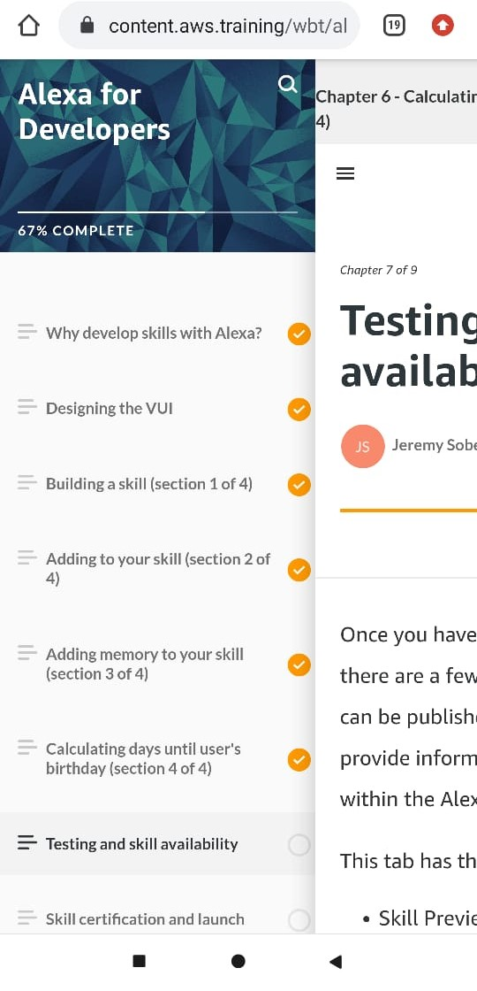

Coding Challenges Details: (Attach the snapshot and briefly write the report for the same)

Coding was given n it was uploaded for github and slack

PROGRAM1

import calendar

yy = 2014 # year

mm = 11 # month

print(calendar.month(yy, mm))

|  |
| --- |
|  |