**DAILY ONLINE ACTIVITIES SUMMARY**

|  |  |  |  |  |  |  |  |  |
| --- | --- | --- | --- | --- | --- | --- | --- | --- |
| **Date:** | **16-07-2020** | | | | | **Name:** | **Veekshith shetty** | |
| **Sem & Sec** | **8th sem B sec** | | | | | **USN:** | **4AL16CS097** | |
| **Online Test Summary** | | | | | | | | |
| **Subject** | | **-** | | | | | | |
| **Max. Marks** | | **-** | | **Score** | | | **-** | |
| **Certification Course Summary(Internship)** | | | | | | | | |
| **Course** | **Data analytics fundamental** | | | | | | | |
| **Certificate Provider** | | | **aws** | | **Duration** | | | **3hr 30 min** |
| **Coding Challenges** | | | | | | | | |
| **Problem Statement: Python Program to Count the Number of Blank Spaces in a Text**  **File** | | | | | | | | |
| **Status: completed** | | | | | | | | |
| **Uploaded the report in Github** | | | | | **yes** | | | |
| **If yes Repository name** | | | | | **Veekshith-Shetty** | | | |
| **Uploaded the report in slack** | | | | | **yes** | | | |

Online Test Details: (Attach the snapshot and briefly write the report for the same)

Certification Course Details: (Attach the snapshot and briefly write the report for the same)

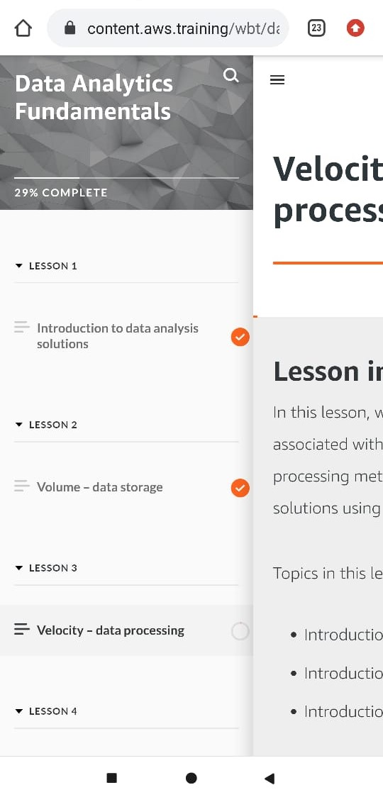

Coding Challenges Details: (Attach the snapshot and briefly write the report for the same)

Coding was given n it was uploaded for github and slack

PROGRAM1

#Python rogram to find the SHA-1 message digest of a file

# importing the hashlib module

import hashlib

def hash_file(filename):

""""This function returns the SHA-1 hash

of the file passed into it"""

# make a hash object

h = hashlib.sha1()

# open file for reading in binary mode

with open(filename,'rb') as file:

chunk = 0

while chunk != b'':

# read only 1024 bytes at a time

chunk = file.read(1024)

h.update(chunk)

# return the hex representation of digest

return h.hexdigest()

message = hash_file("track1.mp3")

print(message)

|  |
| --- |
|  |