**DAILY ONLINE ACTIVITIES SUMMARY**

|  |  |  |  |  |  |  |  |  |
| --- | --- | --- | --- | --- | --- | --- | --- | --- |
| **Date:** | **23-05-2020** | | | | | **Name:** | **Veekshith shetty** | |
| **Sem & Sec** | **8th sem B sec** | | | | | **USN:** | **4AL16CS097** | |
| **Online Test Summary** | | | | | | | | |
| **Subject** | |  | | | | | | |
| **Max. Marks** | |  | | **Score** | | |  | |
| **Certification Course Summary** | | | | | | | | |
| **Course** | **AWS Certification Course** | | | | | | | |
| **Certificate Provider** | | | **AWS** | | **Duration** | | | **100 min** |
| **Coding Challenges** | | | | | | | | |
| |  | | --- | | **Problem Statement : Write a C Program to Display first N Triangular Numbers (Where N is read from the Keyboard)** | | | | | | | | | |
| **Status: completed** | | | | | | | | |
| **Uploaded the report in Github** | | | | | **yes** | | | |
| **If yes Repository name** | | | | | [alvas-education-foundation](https://github.com/alvas-education-foundation)/[**Veekshith-Shetty**](https://github.com/alvas-education-foundation/Veekshith-Shetty) | | | |
| **Uploaded the report in slack** | | | | | **yes** | | | |

Online Test Details: (Attach the snapshot and briefly write the report for the same)

Certification Course Details: (Attach the snapshot and briefly write the report for the same)

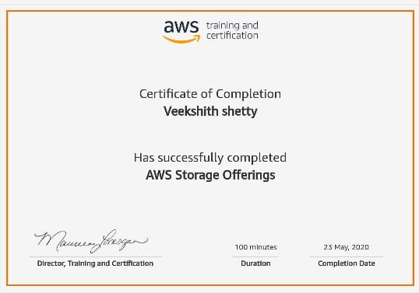

Coding Challenges Details:

Coding was given n it was uploaded for github and slack

PROGRAM1

#include <stdio.h>

void triangular_series(int n)

{

for (int i = 1; i <= n; i++)

printf(" %d ", i*(i+1)/2);

}

int main()

{ int n ;

printf("Enter value for n");

scanf("%d",&n);

triangular_series(n);

return 0;

}