**DAILY ONLINE ACTIVITIES SUMMARY**

|  |  |  |  |  |  |  |  |
| --- | --- | --- | --- | --- | --- | --- | --- |
| **Date:** | **02-07-2020** | | | | **Name:** | **Veekshith Shetty** | |
| **Sem & Sec** | **8th sem B sec** | | | | **USN:** | **4AL16CS097** | |
| **Online Test Summary** | | | | | | | |
| **Subject** | | **SMS** | | | | | |
| **Max. Marks** | | **30** | | **Score** | | **Mail not recived** | |
| **Certification Course Summary** | | | | | | | |
| **Course** | **Iot Edge computing** | | | | | | |
| **Certificate Provider** | | | **AWS** | **Duration** | | | **5hr** |
| **Coding Challenges** | | | | | | | |
| **Problem Statement-** : c++ prog to find sum of digits until the number is a single digits | | | | | | | |
| **Status: completed** | | | | | | | |
| **Uploaded the report in Github** | | | | **yes** | | | |
| **If yes Repository name** | | | | **Veekshith-Shetty** | | | |
| **Uploaded the report in slack** | | | | **yes** | | | |

**Certification Course Details:**

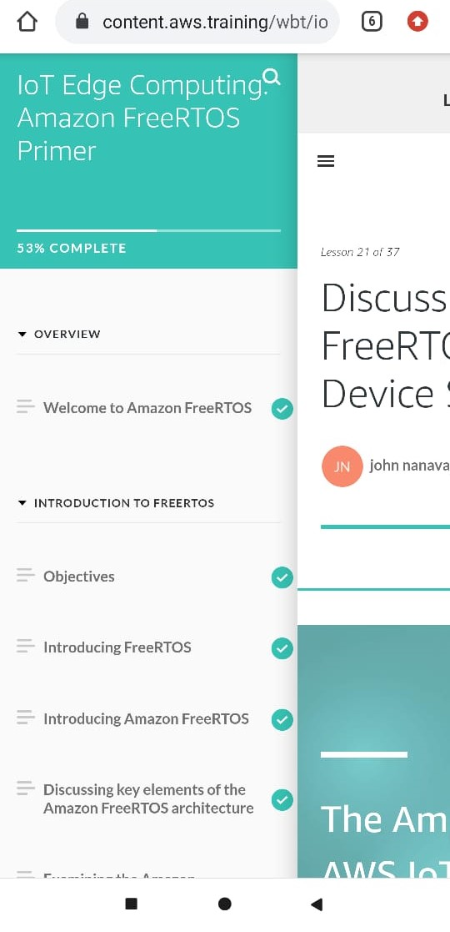

**Coding Challenge details:**

**c++ prog to find sum of digits until the number is a single digits**

#include

using namespacestd;

intmain()

{

intnumber=147; //Any number.intres; if(number) res=number%9==0?9:

number%9;

else res=0;

//print the result cout<<res;

Return 0;

}