**DAILY ONLINE ACTIVITIES SUMMARY**

|  |  |  |  |  |  |  |  |
| --- | --- | --- | --- | --- | --- | --- | --- |
| **Date:** | **20/05/2020** | | | | **Name:** | **Veekshith Shetty** | |
| **Sem & Sec** | **8th- B** | | | | **USN:** | **4AL16CS097** | |
| **Online Test Summary** | | | | | | | |
| **Subject** | | **Internet of Things** | | | | | |
| **Max. Marks** | | **30** | | **Score** | | **22** | |
| **Certification Course Summary** | | | | | | | |
| **Course** | **AWS Cloud Practitioner Essentials** | | | | | | |
| **Certificate Provider** | | | **AWS** | **Duration** | | | **100 minutes** |
| **Coding Challenges** | | | | | | | |
| **Problem Statement:**  **1) Write a C Program to Reverse a Linked List in groups of given size.** | | | | | | | |
| **Status: Executed** | | | | | | | |
| **Uploaded the report in Github** | | | | **Yes** | | | |
| **If yes Repository name** | | | | [**Veekshithshetty**](https://github.com/Veekshithshetty)**/**[codingpart](https://github.com/Veekshithshetty/codingpart) | | | |
| **Uploaded the report in slack** | | | | **Yes** | | | |

Online Test Details:

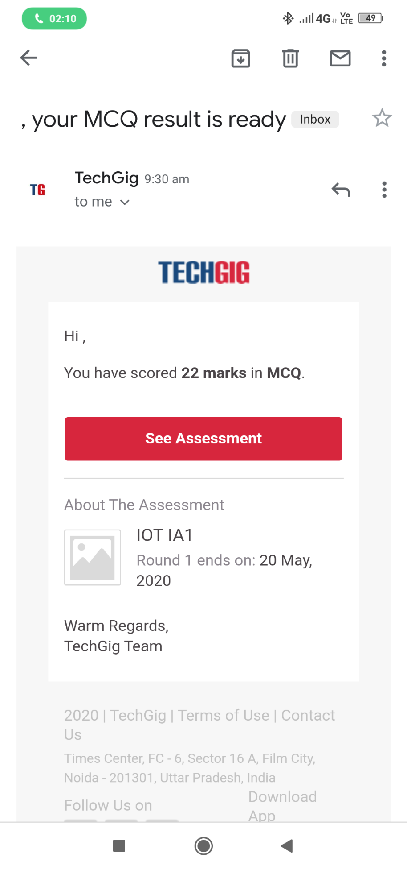

Certification Course Details:

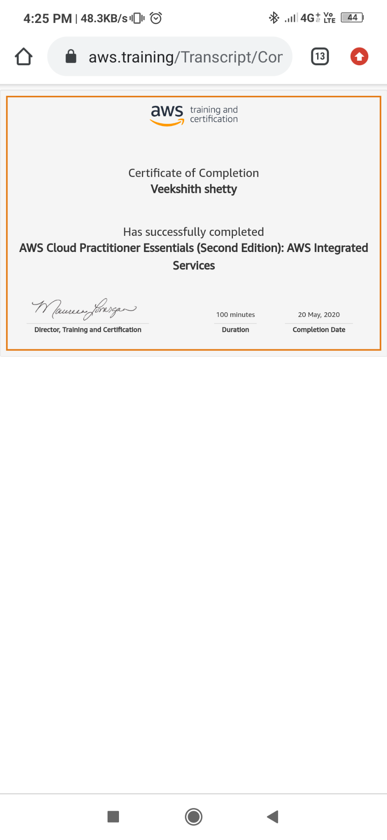

**This is a fundamental level course that is intended for individuals who seek an overall understanding of the AWS cloud, independent of specific technical roles. It provides a detailed overview of cloud concepts, AWS services, security, architecture, pricing, and support. This course also helps us prepare for the AWS Certified Cloud Practitioner Exam.**

Coding Challenges Details:

1) struct Node

{

int data;

struct Node* next;

};

pointer to the new head node. /

struct Node reverse (struct Node head, int k)

{

struct Node current = head;

struct Node next = NULL;

struct Node prev = NULL;

int count = 0;

while (current != NULL && count < k)

{

next = current->next;

current->next = prev;

prev = current;

current = next;

count++;

}

if (next != NULL)

head->next = reverse(next, k);

return prev;

}

void push(struct Node** head_ref, int new_data)

{

struct Node* new_node =

(struct Node*) malloc(sizeof(struct Node));

new_node->data = new_data;

new_node->next = (*head_ref);

(*head_ref) = new_node;

}

void printList(struct Node *node)

{

while (node != NULL)

{

printf("%d ", node->data);

node = node->next;

}

int main(void)

{

struct Node* head = NULL;

push(&head, 8);

push(&head, 7);

push(&head, 6);

push(&head, 5);

push(&head, 4);

push(&head, 3);

push(&head, 2);

push(&head, 1);

printf("\nGiven linked list \n");

printList(head);

head = reverse(head, 2);

printf("\nReversed Linked list \n");

printList(head);

return(0);