**DAILY ONLINE ACTIVITIES SUMMARY**

|  |  |  |  |  |  |  |  |
| --- | --- | --- | --- | --- | --- | --- | --- |
| **Date:** | **22-06-2020** | | | | **Name:** | **Veekshith Shetty** | |
| **Sem & Sec** | **8th sem B sec** | | | | **USN:** | **4AL16CS097** | |
| **Online Test Summary** | | | | | | | |
| **Subject** | | **SMS** | | | | | |
| **Max. Marks** | | **30** | | **Score** | | **No mail received** | |
| **Certification Course Summary** | | | | | | | |
| **Course** | **AWS Foundation series:Telemetry** | | | | | | |
| **Certificate Provider** | | | **Aws** | **Duration** | | | **4&half hr** |
| **Coding Challenges** | | | | | | | |
| **Problem Statement-Problem Statement-** : **# Python program to rotate an array by d elements** | | | | | | | |
| **Status: completed** | | | | | | | |
| **Uploaded the report in Github** | | | | **yes** | | | |
| **If yes Repository name** | | | | **Veekshith-Shetty** | | | |
| **Uploaded the report in slack** | | | | **yes** | | | |

Online Test Details: (Attach the snapshot and briefly write the report for the same)

Certification Course Details: (Attach the snapshot and briefly write the report for the same)

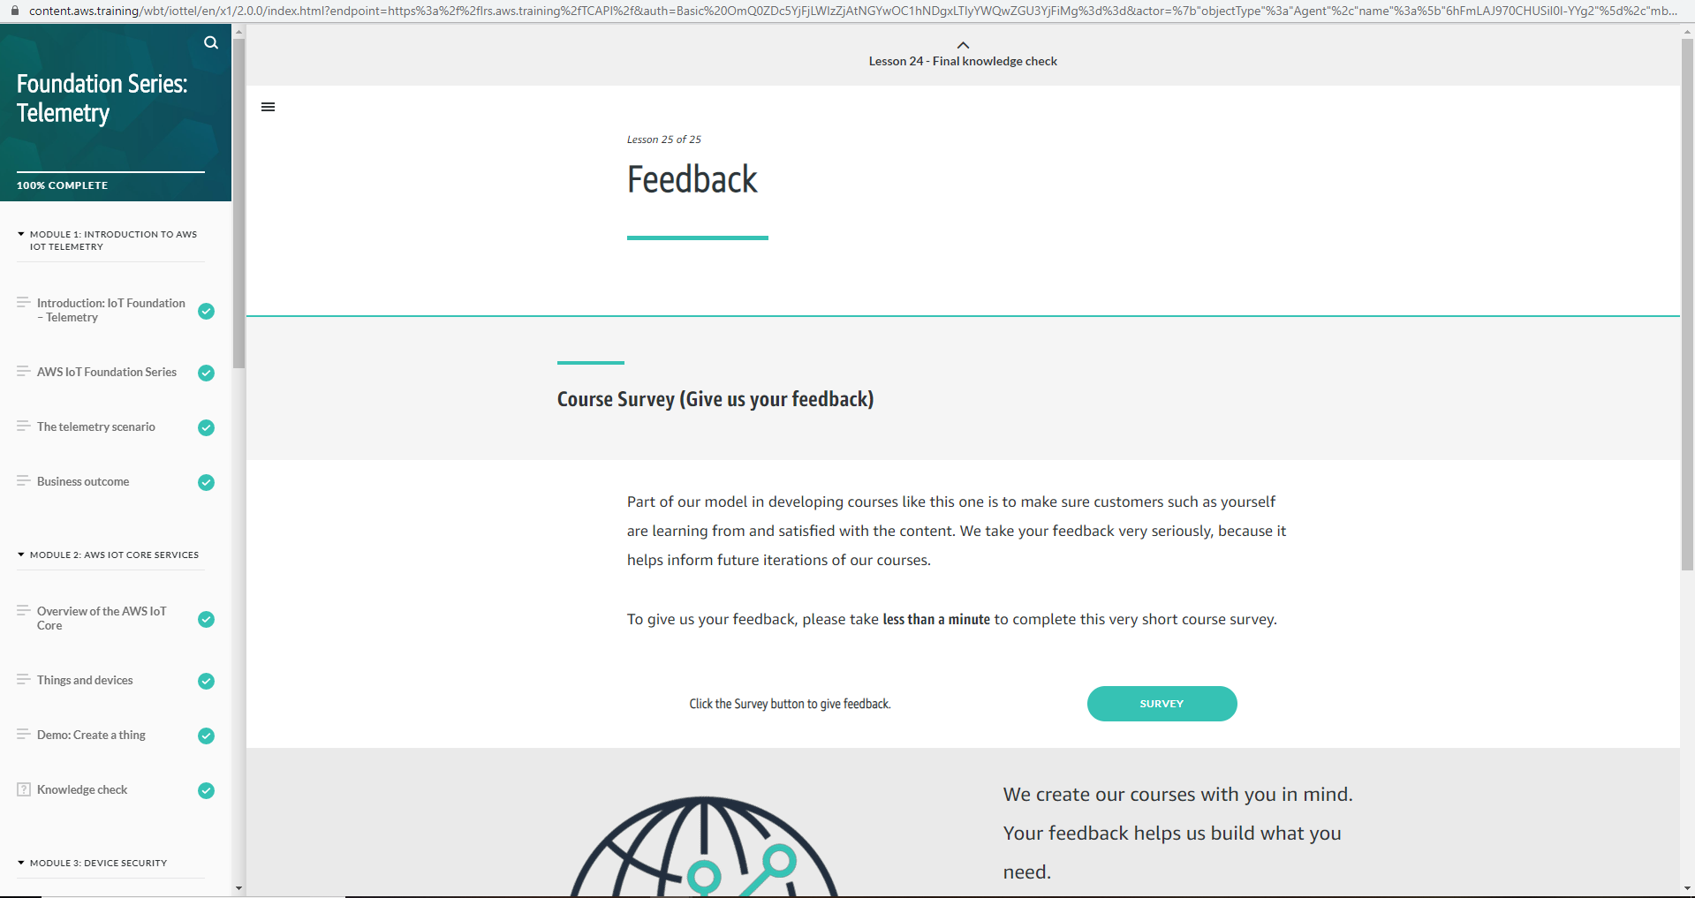

Coding Challenges Details: (Attach the snapshot and briefly write the report for the same)

Coding was given and it was uploaded for github and slack

**def leftRotate(arr, d, n):**

**for i in range(d):**

**leftRotatebyOne(arr, n)**

**def leftRotatebyOne(arr, n):**

**temp = arr[0]**

**for i in range(n-1):**

**arr[i] = arr[i + 1]**

**arr[n-1] = temp**

**def printArray(arr, size):**

**for i in range(size):**

**print ("% d"% arr[i], end =" ")**

**arr = [1, 2, 3, 4, 5, 6, 7]**

**leftRotate(arr, 2, 7)**

**printArray(arr, 7)**