|  |  |  |  |
| --- | --- | --- | --- |
| Date: | 09-06-2020 | Name: | Vidul sambhaji chavan |
| Course: | PCB | USN: | 4AL17EC095 |
| Topic: | Start a new project,netlist and footprint generator. | Semester and section: | 6th sem and B sec |

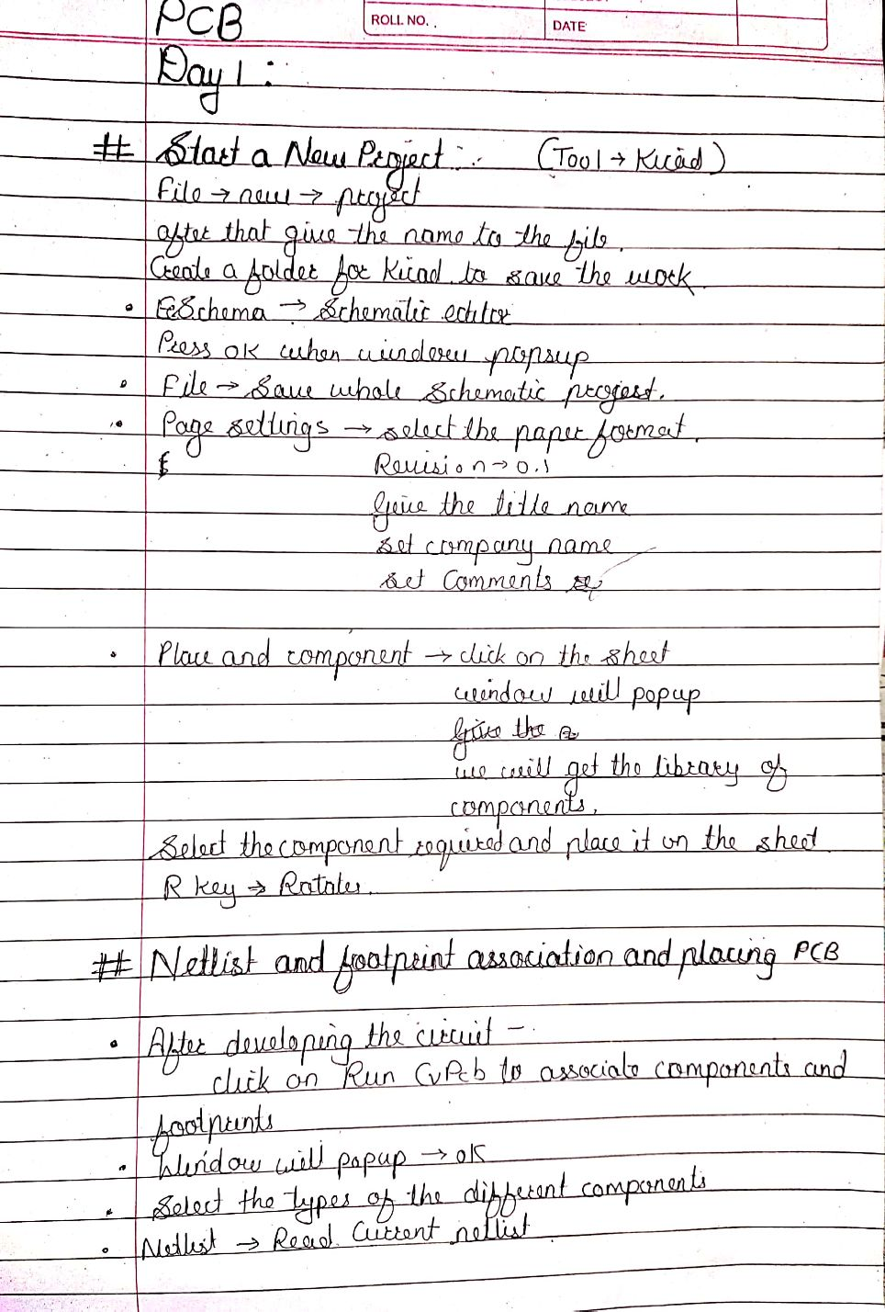

|  |  |  |  |
| --- | --- | --- | --- |
| Date: | 09-06-2020 | Name: | Vidul sambhaji chavan |
| Course: | JAVA | USN: | 4AL17EC095 |
| Topic: | Programming CORE JAVA | Semester and section: | 6th sem and B sec |

