|  |  |  |  |
| --- | --- | --- | --- |
| Date: | 10-06-2020 | Name: | Vidul sambhaji chavan |
| Course: | PCB | USN: | 4AL17EC095 |
| Topic: | Silk screen and copper pour.maintaining holes.create a library and put your own component in that library. | Semester and section: | 6th sem and B sec |

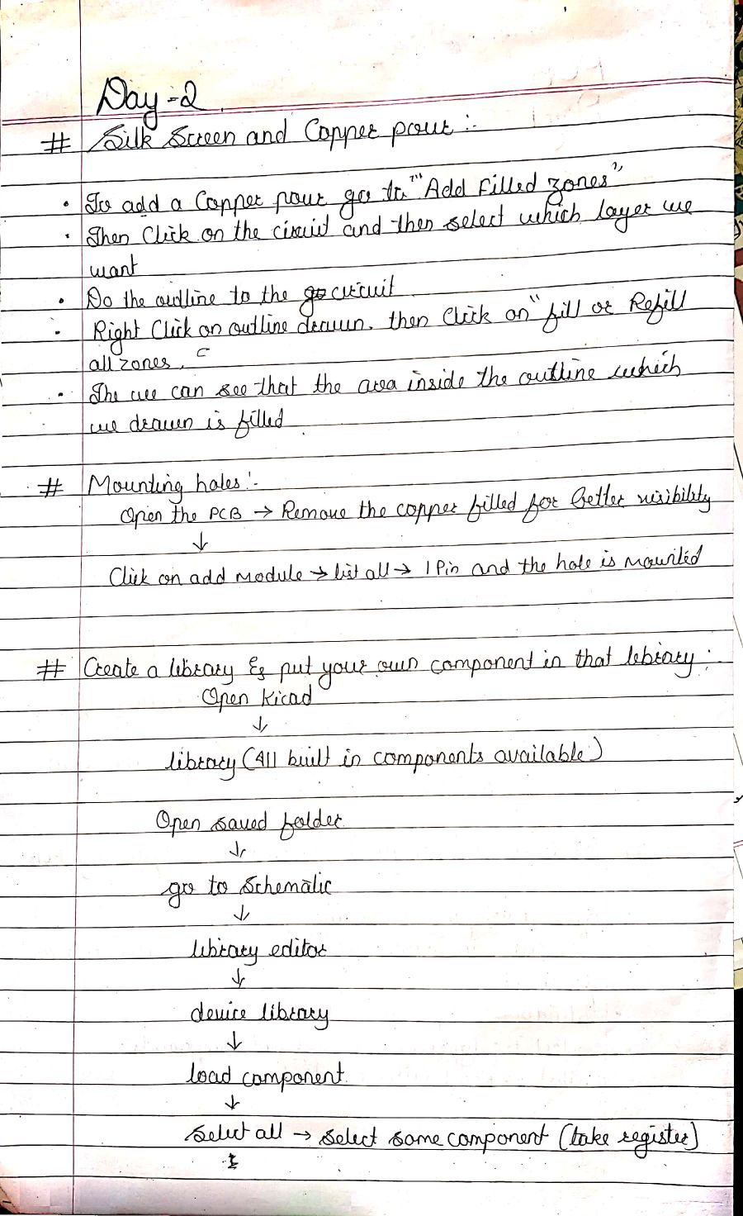

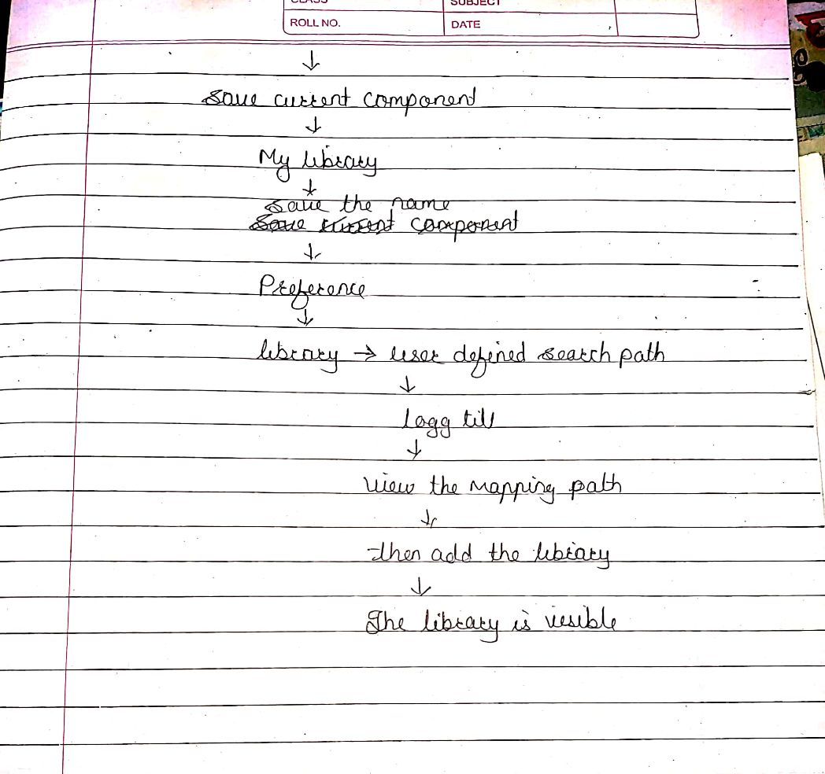

|  |  |  |  |
| --- | --- | --- | --- |
| Date: | 10-06-2020 | Name: | Vidul sambhaji chavan |
| Course: | JAVA | USN: | 4AL17EC095 |
| Topic: | Getting user input.do while.arrays. | Semester and section: | 6th sem and B sec |

