|  |  |  |  |
| --- | --- | --- | --- |
| Date: | 29-05-2020 | Name: | Vidul sambhaji chavan |
| Course: | Logic design | USN: | 4AL17EC095 |
| Topic: | Analysis of clocked sequential circuit | Semester and section: | 6th sem and B sec |

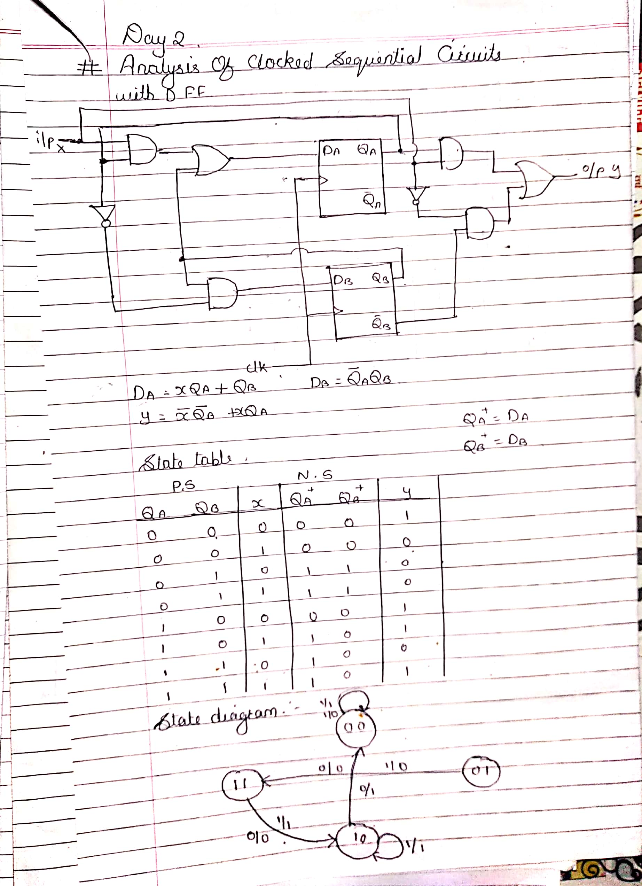

|  |  |  |  |
| --- | --- | --- | --- |
| Date: | 29-05-2020 | Name: | Vidul sambhaji chavan |
| Course: | Python programming | USN: | 4AL17EC095 |
| Topic: | Object oriented programming | Semester and section: | 6th sem and B sec |

