|  |  |  |  |
| --- | --- | --- | --- |
| **Date:** | **30-05-2020** | **Name:** | **Vidul sambhaji chavan** |
| **Course:** | **Logic design** | **USN:** | **4AL17EC095** |
| **Topic:** | **Allpication of programmable logic controllers** | **Semester and section** | **6th sem And B sec** |

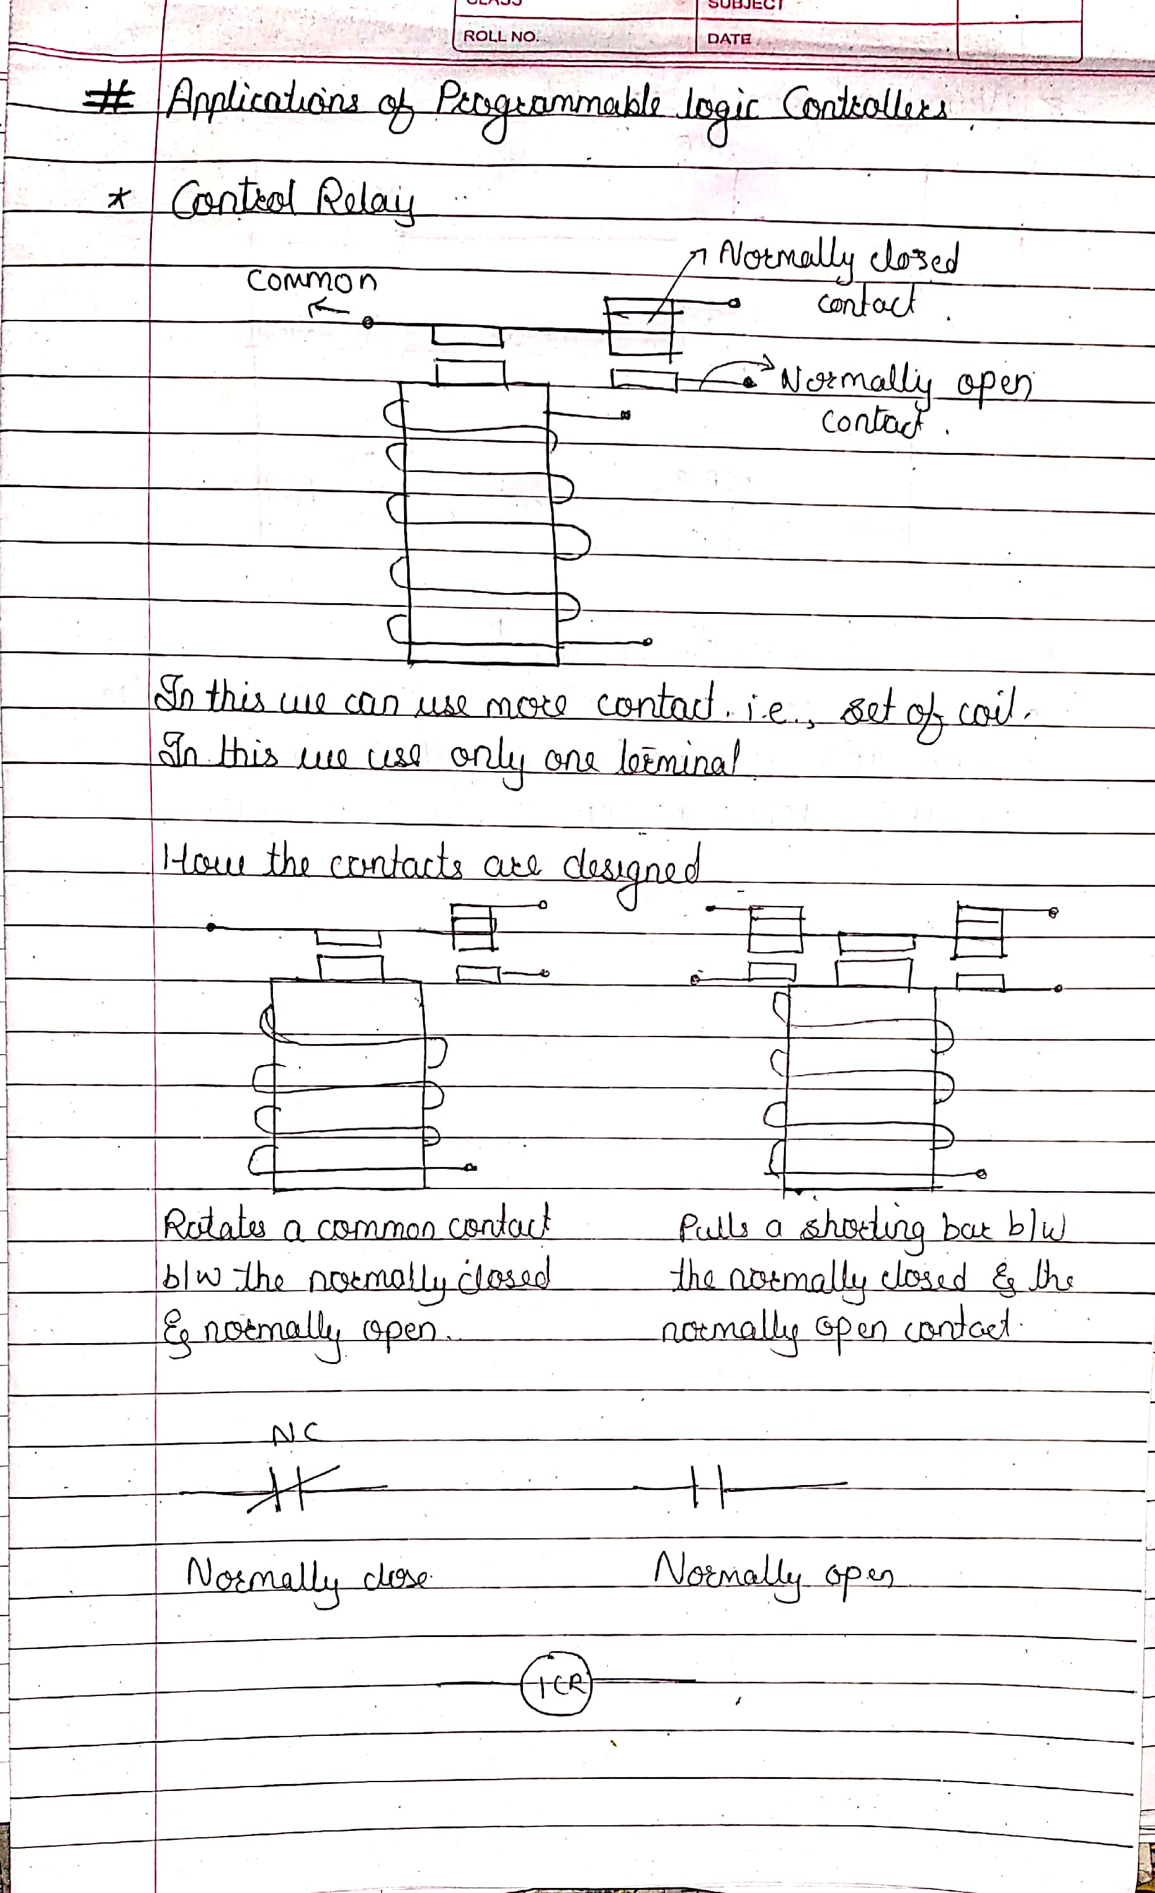

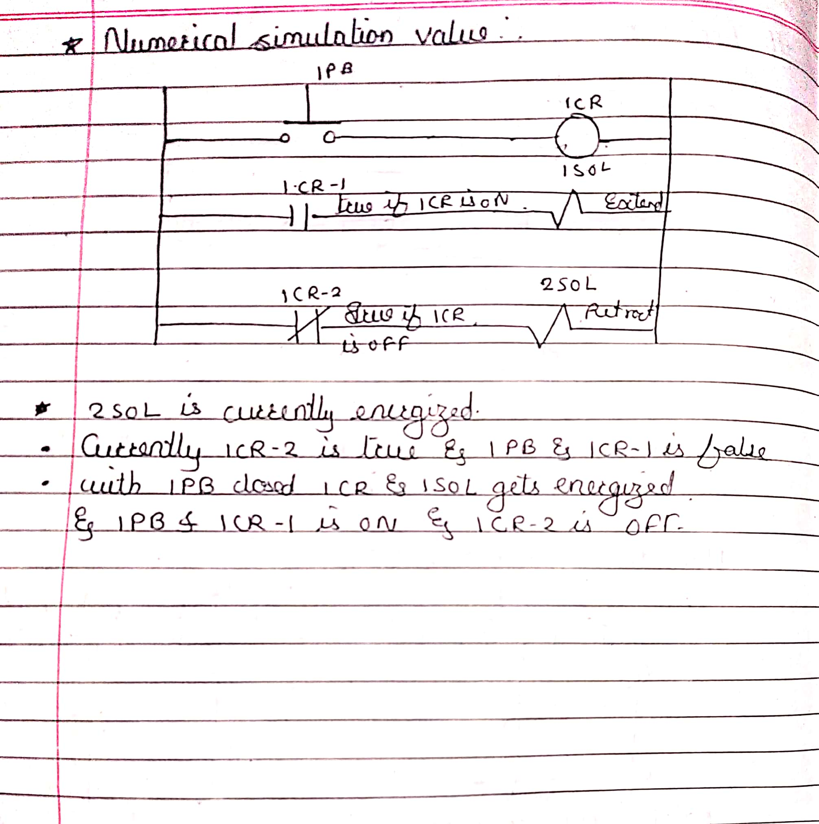

|  |  |  |  |
| --- | --- | --- | --- |
| **Date:** | **30-05-2020** | **Name:** | **Vidul sambhaji chavan** |
| **Course:** | **Python programming** | **USN:** | **4AL17EC095** |
| **Topic:** | **Python for image and video processing using open cv** | **Semester and section** | **6th sem And B sec** |

