|  |  |  |  |
| --- | --- | --- | --- |
| **Date:** | **1-06-2020** | **Name:** | **Vidul sambhaji chavan** |
| **Course:** | **HDL** | **USN:** | **4AL17EC095** |
| **Topic:** | **FPGA basic** | **Semester and section:** | **6th sem and B sec** |

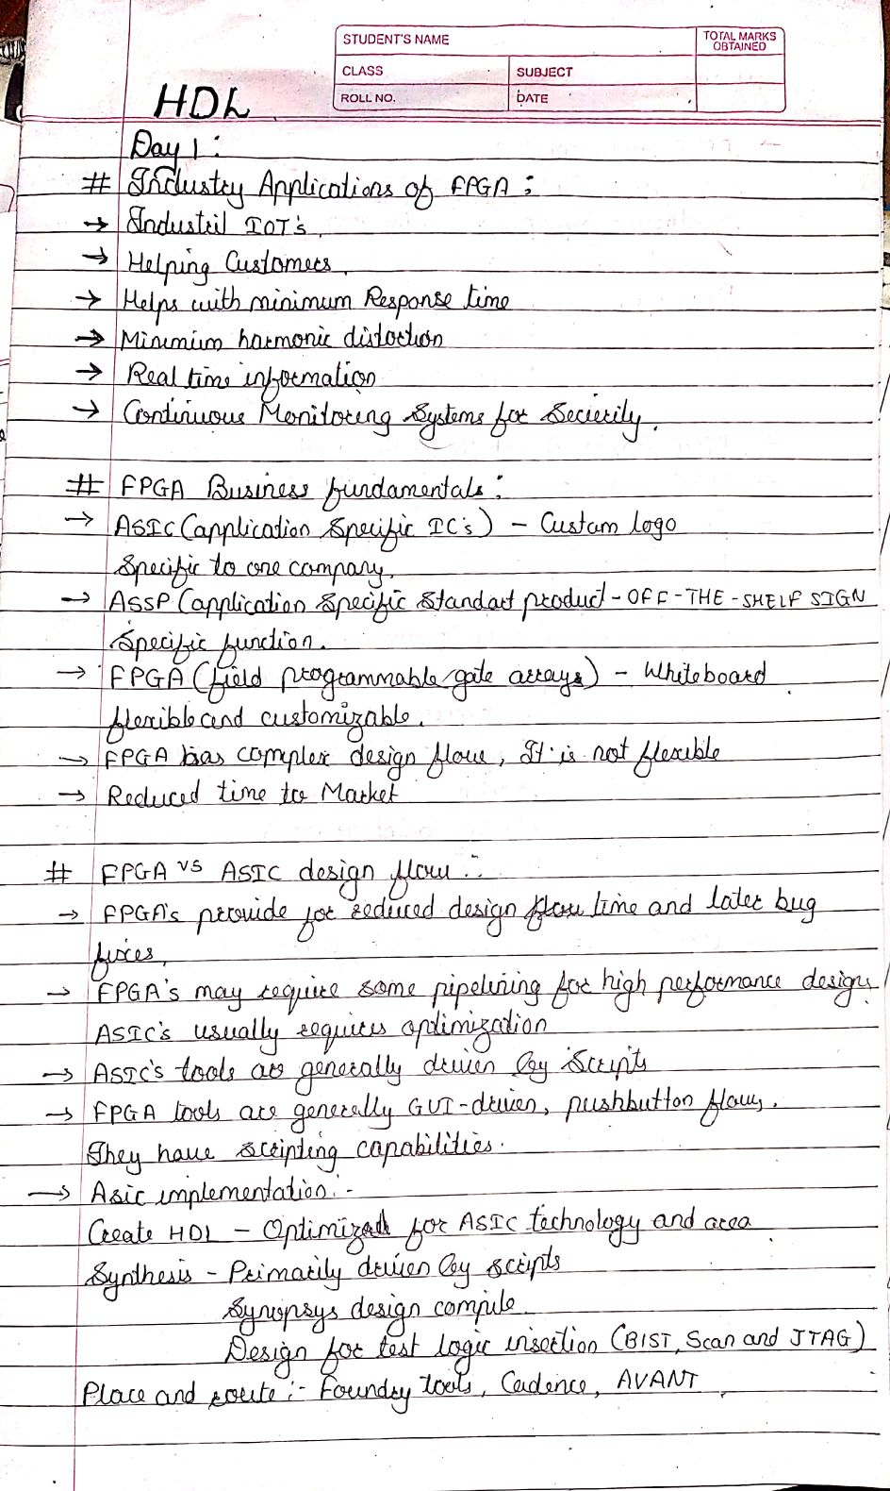

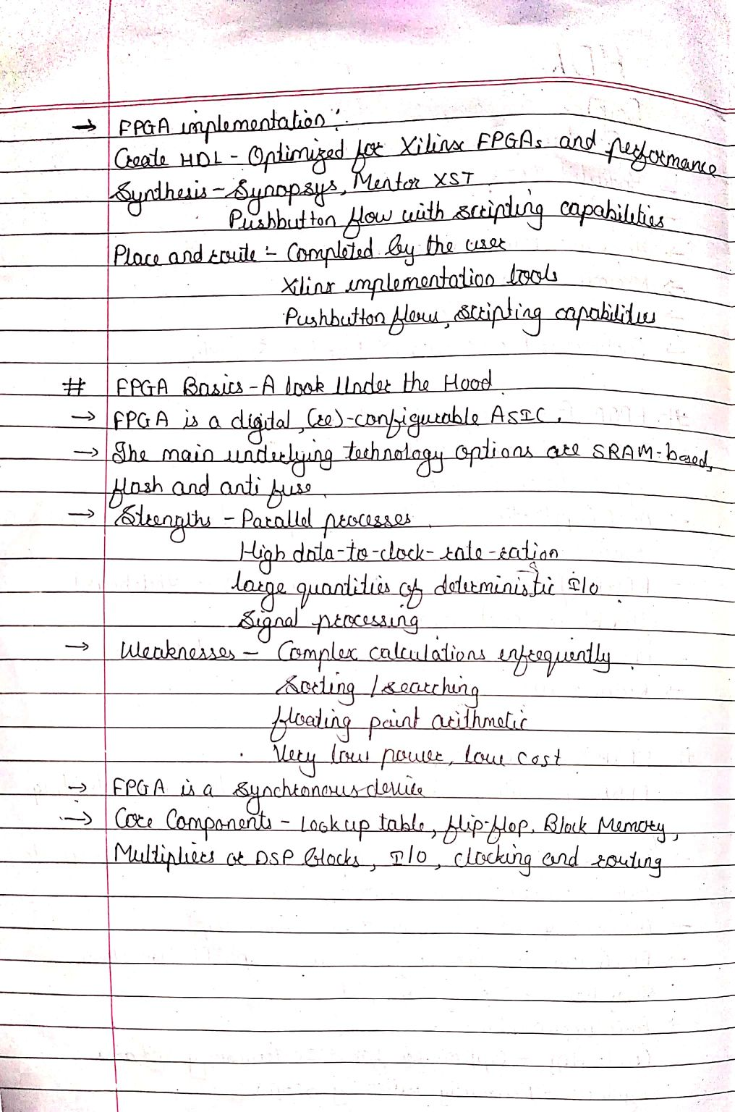

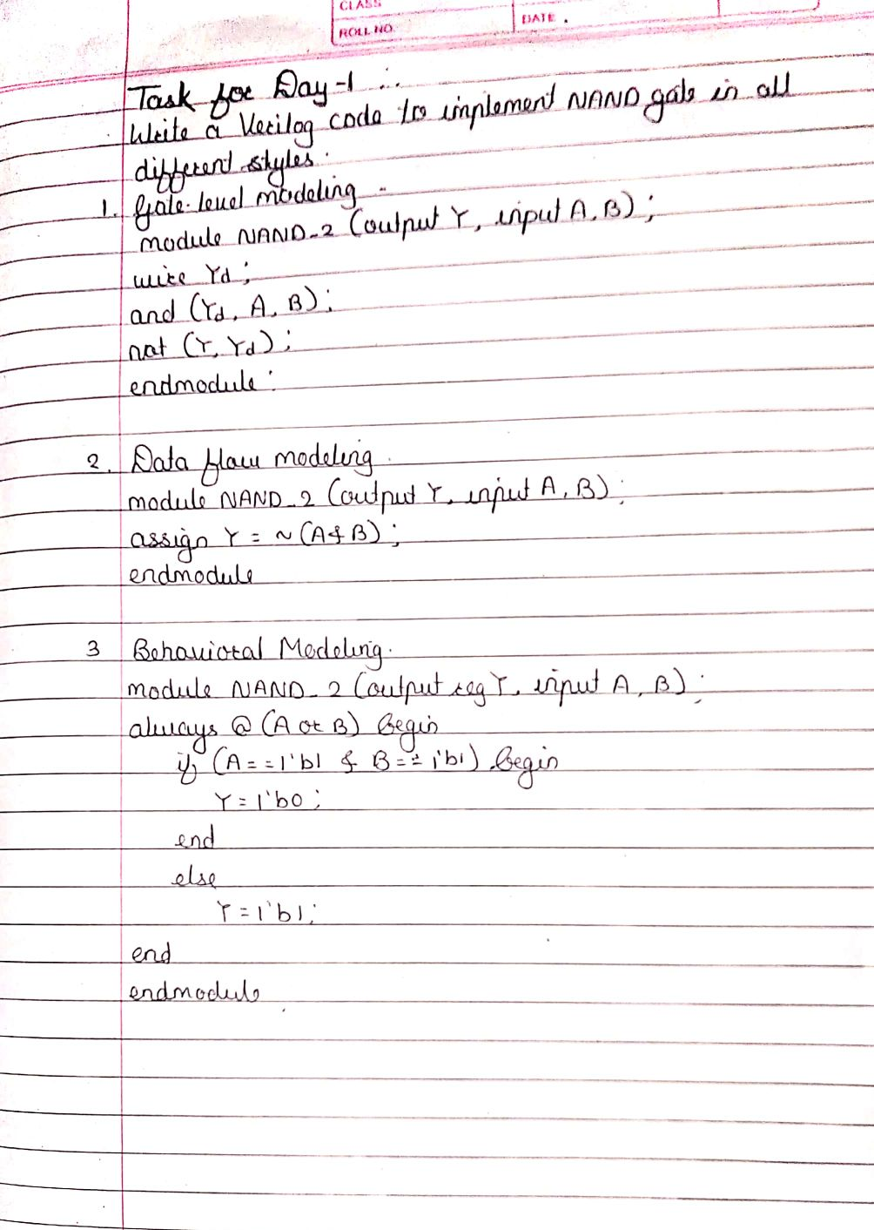

|  |  |  |  |
| --- | --- | --- | --- |
| **Date:** | **1-06-2020** | **Name:** | **Vidul sambhaji chavan** |
| **Course:** | **python** | **USN:** | **4AL17EC095** |
| **Topic:** | **Application 6:build a webcam motion detector** | **Semester and section:** | **6th sem and B sec** |

