|  |  |  |  |
| --- | --- | --- | --- |
| Date: | 02-06-2020 | Name: | Vidul sambhaji chavan |
| Course: | HDL | USN: | 4al17ec095 |
| Topic: | Fpga basics.verilog HDL basics and testbench code | Semester and section: | 6th sem and B sec |

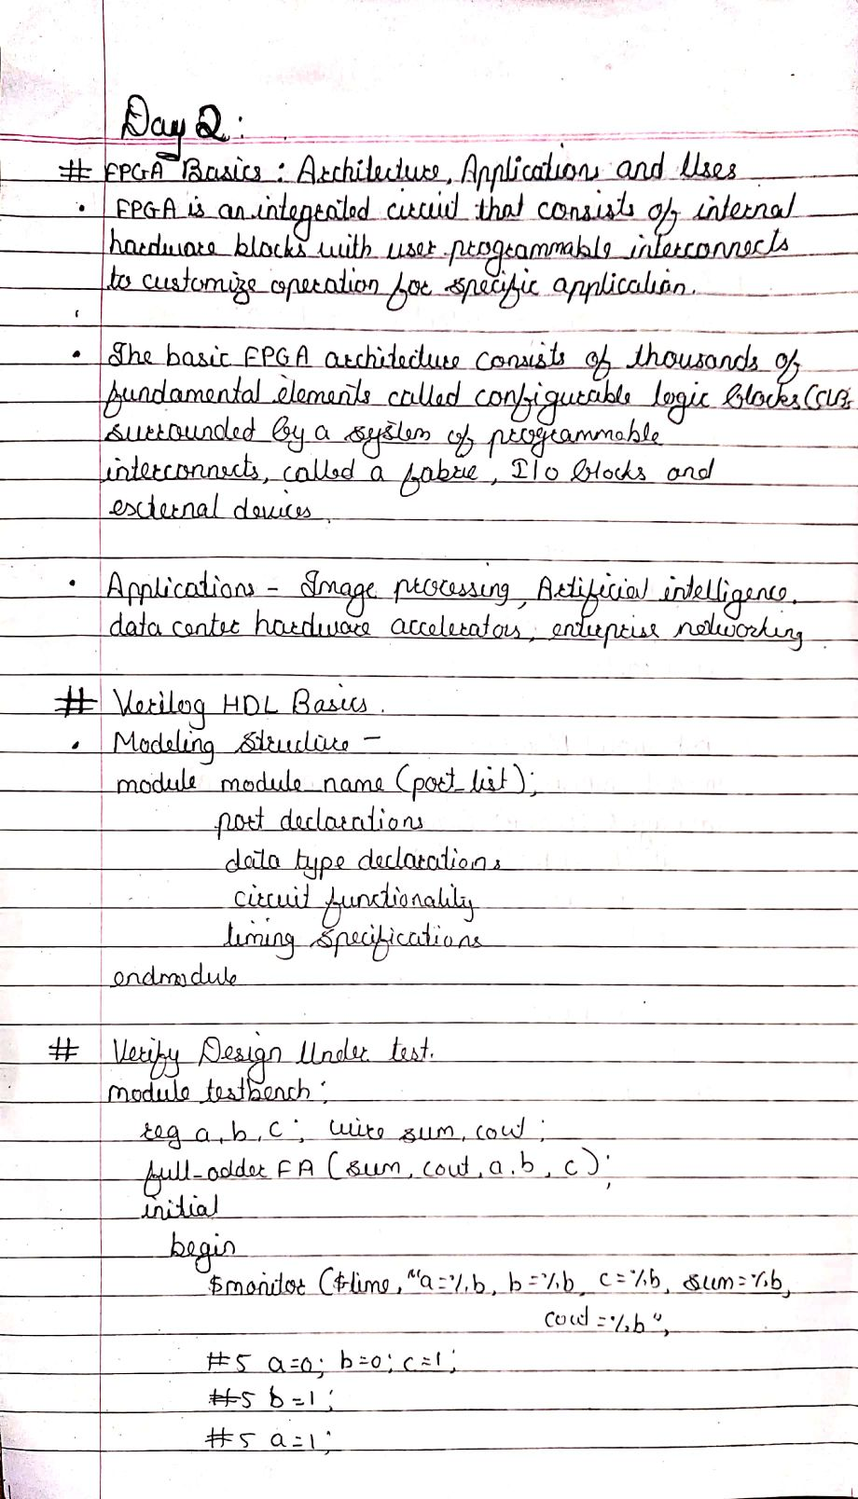

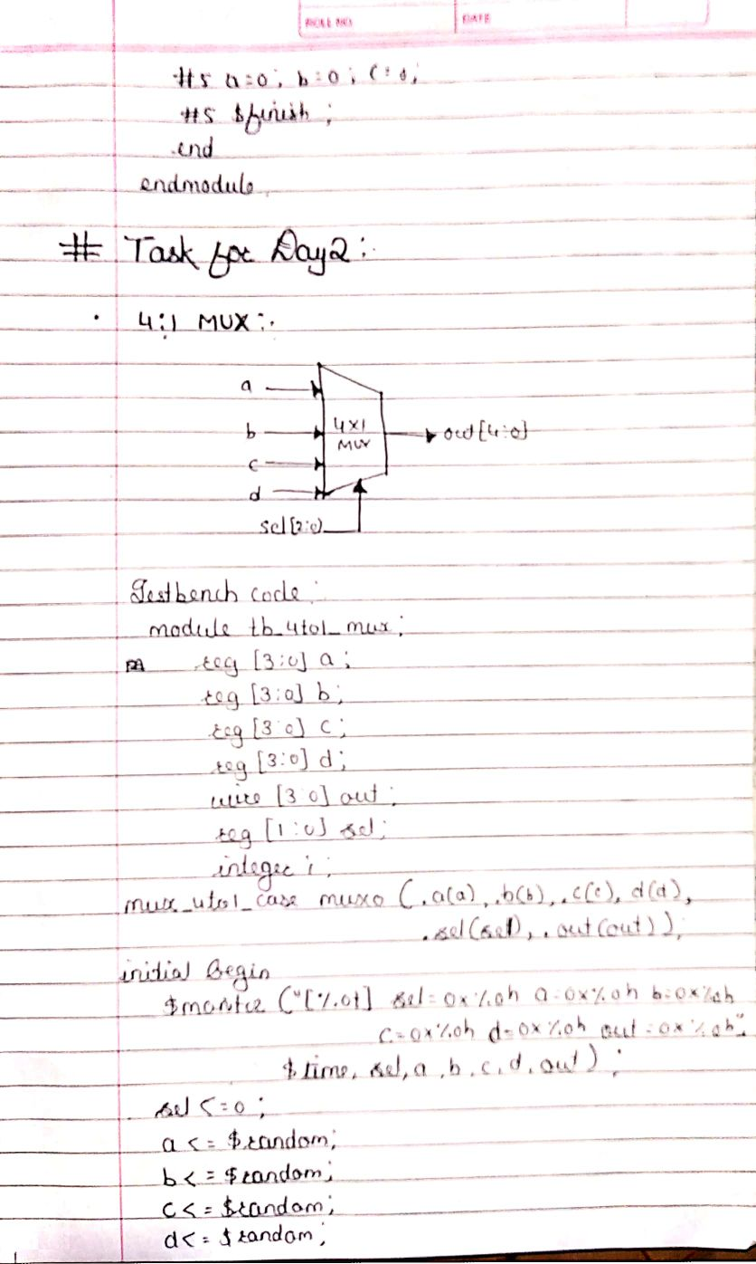

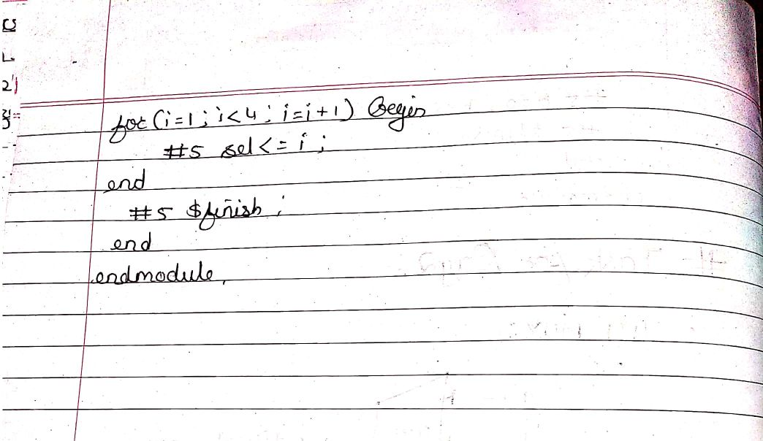

|  |  |  |  |
| --- | --- | --- | --- |
| Date: | 02-06-2020 | Name: | Vidul sambhaji chavan |
| Course: | Python programming | USN: | 4al17ec095 |
| Topic: | Bokeh,webscraping with python beautiful soup. | Semester and section: | 6th sem and B sec |

