|  |  |  |  |
| --- | --- | --- | --- |
| Date: | 04-06-2020 | Name: | Vidul sambhaji chavan |
| Course: | HDL | USN: | 4AL17EC095 |
| Topic: | Hardwase modelling using Verilog,interview questions | Semester and section: | 6th sem and B sec |

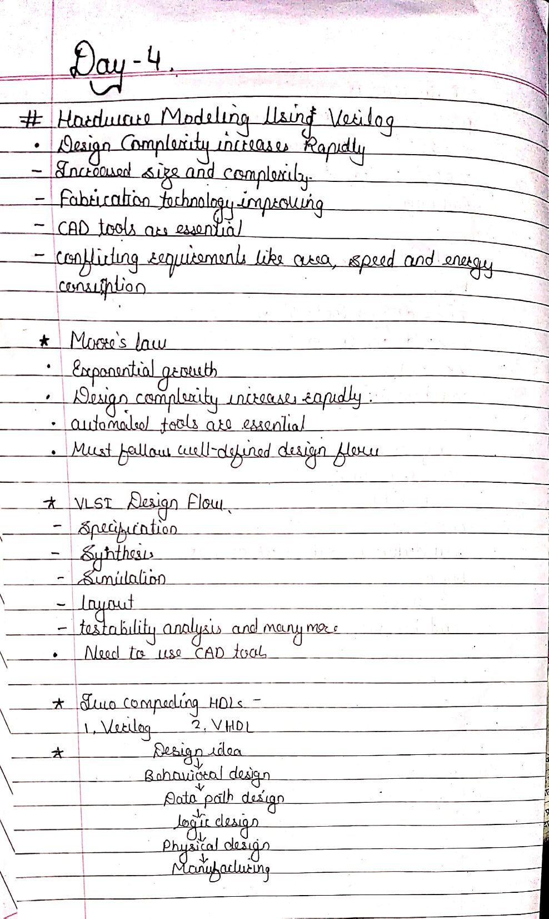

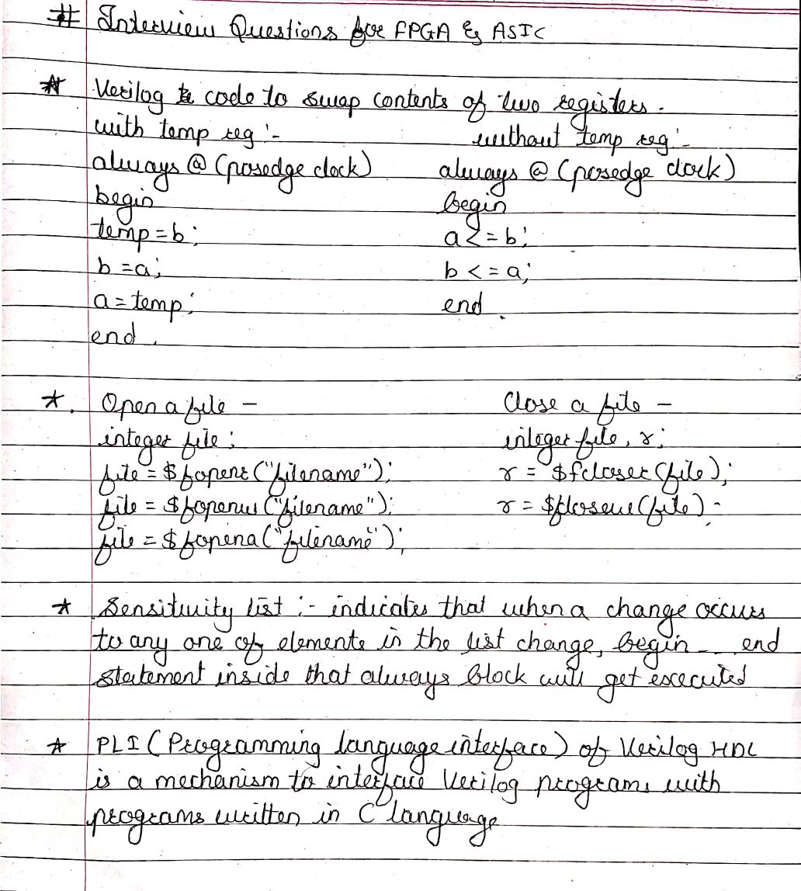

|  |  |  |  |
| --- | --- | --- | --- |
| Date: | 04-06-2020 | Name: | Vidul sambhaji chavan |
| Course: | Python programming | USN: | 4AL17EC095 |
| Topic: | Build a web based financial graph | Semester and section: | 6th sem and B sec |

