|  |  |  |  |
| --- | --- | --- | --- |
| Date: | 05-06-2020 | Name: | Vidul sambhaji chavan |
| Course: | HDL | USN: | 4AL17EC095 |
| Topic: | Verilog tutorial,demo projects,task | Semester and section: | 6th sem and B sec |

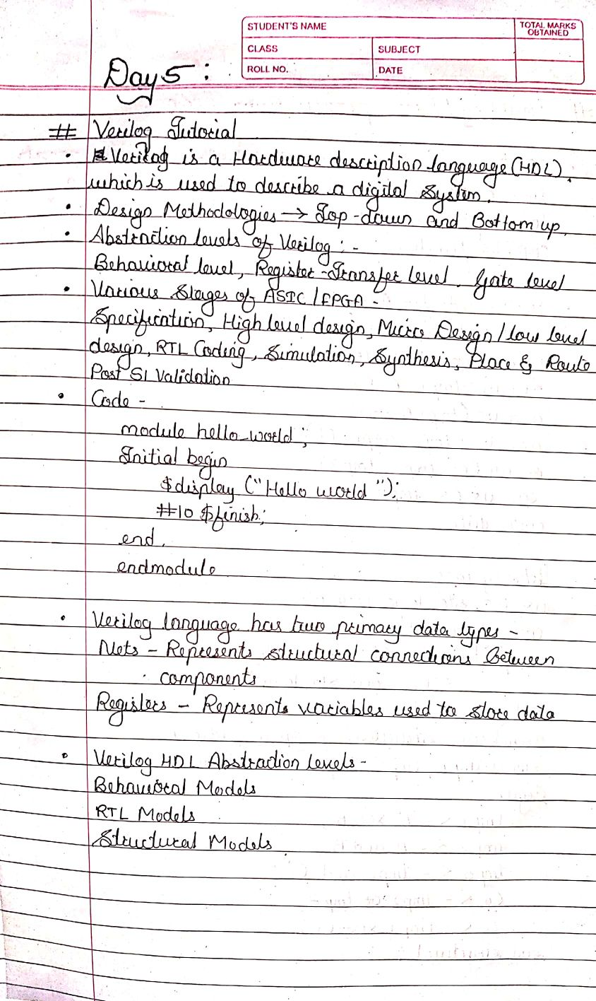

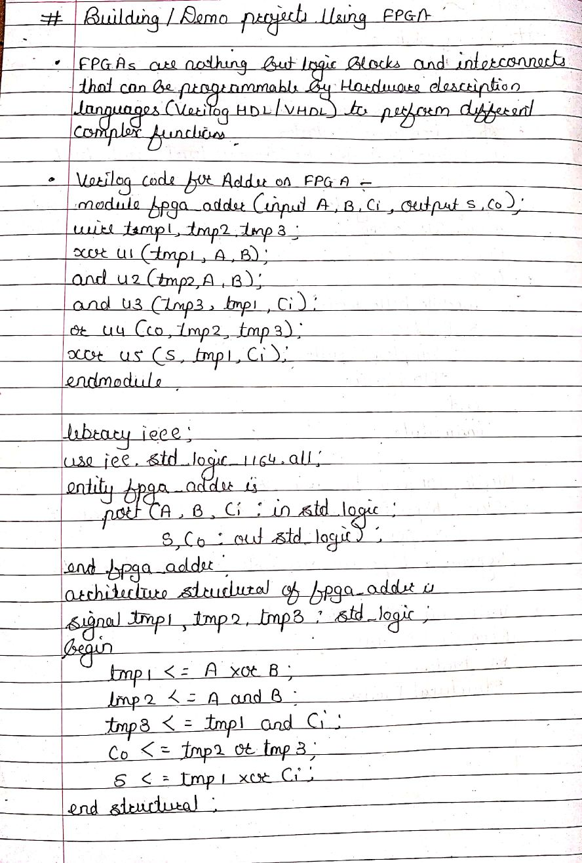

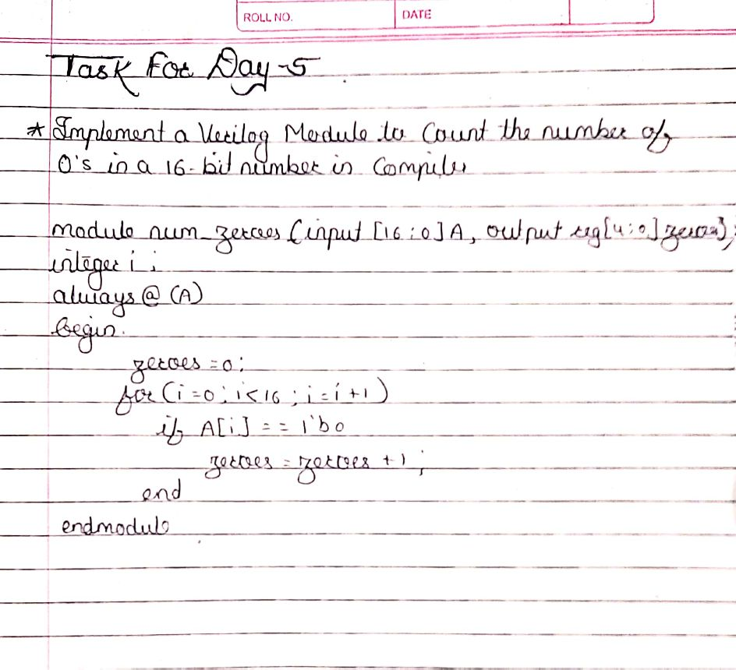

|  |  |  |  |
| --- | --- | --- | --- |
| Date: | 05-06-2020 | Name: | Vidul sambhaji chavan |
| Course: | Python programming | USN: | 4AL17EC095 |
| Topic: | Application 10:build a data collector web app with PostgreSQL and flask. | Semester and section: | 6th sem and B sec |

