|  |  |  |  |
| --- | --- | --- | --- |
| **Date:** | **20-05-2020** | **Name:** | **Vidul Sambhaji chavan** |
| **Course:** | **TCS ION carrer edge** | **USN:** | **4AL17EC095** |
| **Topics:** | **ace corporate interview,learn corporate etiquitte’write effective emails.** | **Semester and section** | **6th sem and B sec** |

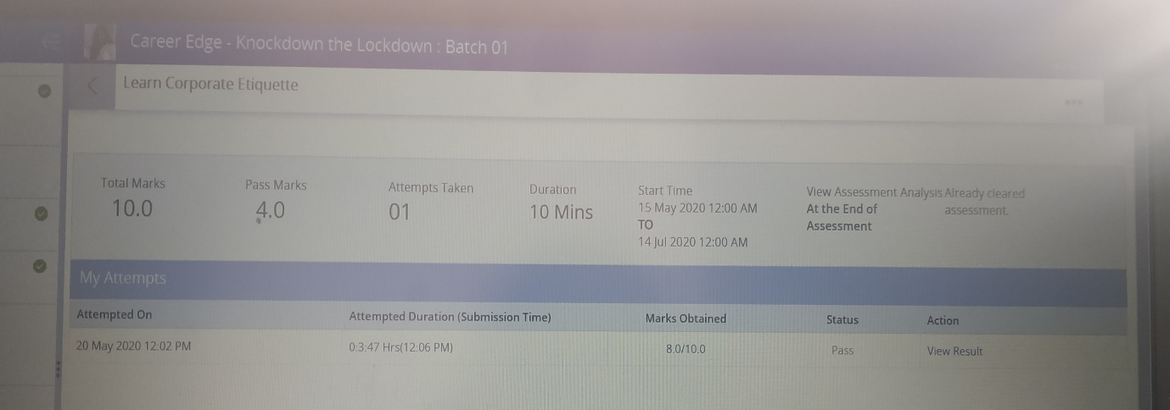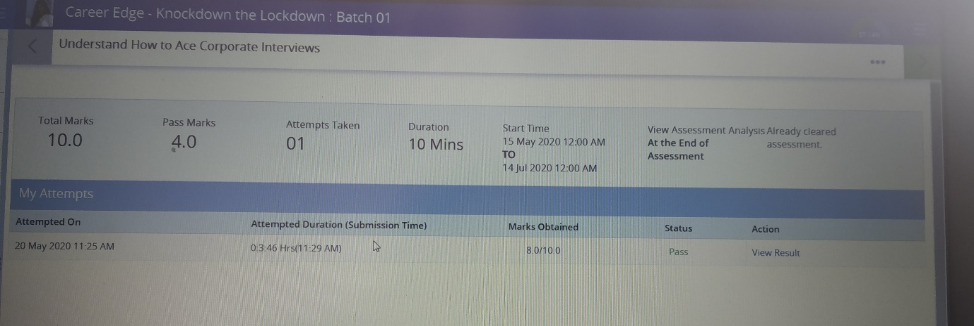

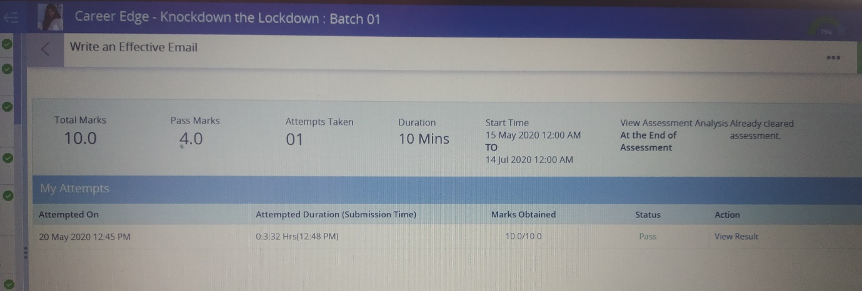

**Ace corporate interviews:**

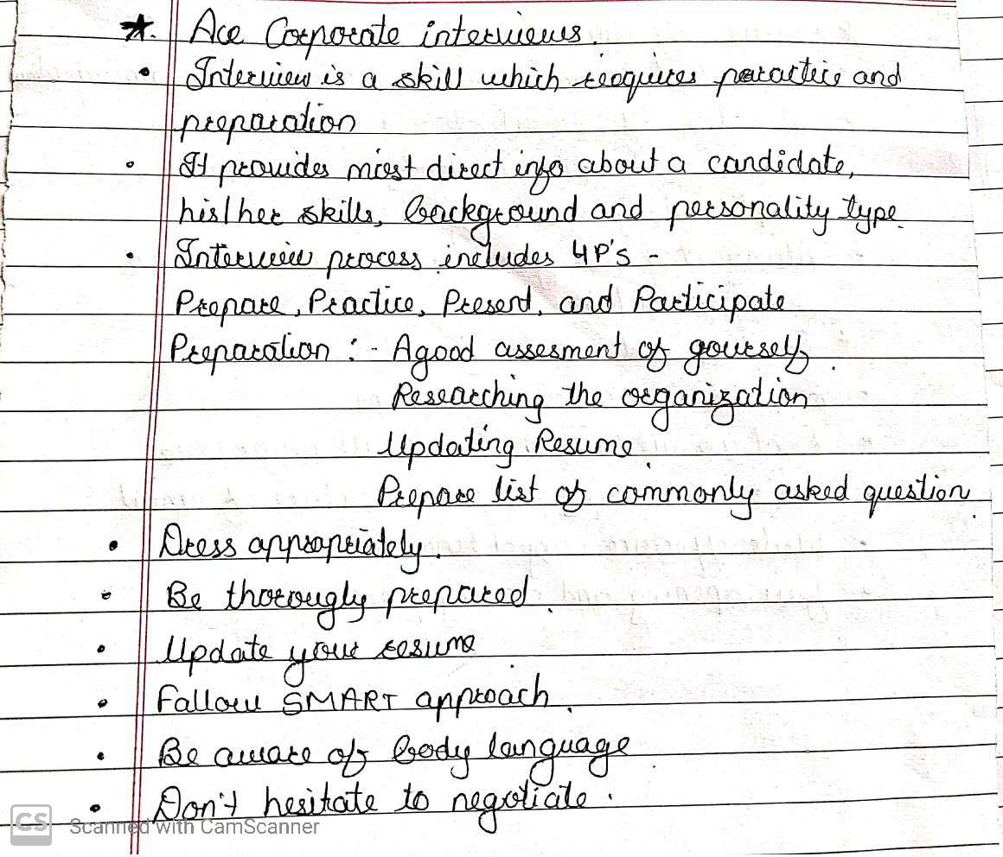

**Learn corporate etiquette:**

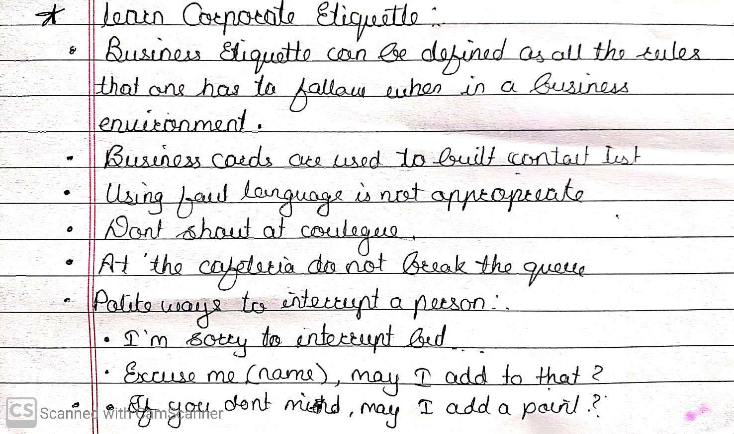

**Write an effective email:** 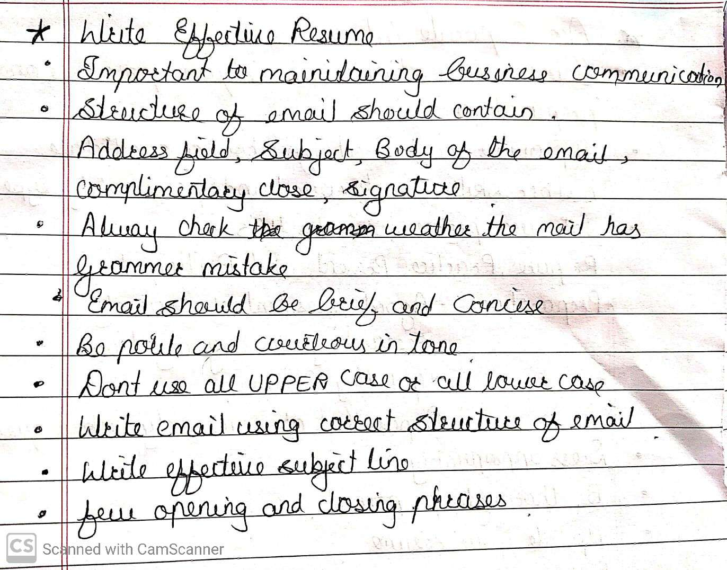

|  |  |  |  |
| --- | --- | --- | --- |
| **Date:** | **20-05-2020** | **Name:** | **Vidul sambhaji chavan** |
| **Course:** | **Python programming** | **USN:** | **4AL17EC095** |
| **Topics:** | **Application1:build an interactive English dictionary** | **Semester and section:** | **6th sem and B sec** |

