|  |  |  |  |
| --- | --- | --- | --- |
| **Date:** | **21-05-2020** | **Name:** | **Vidul sambhaji chavan** |
| **Course:** | **TCS-ION carrer edge** | **USN:** | **4AL17EC095** |
| **Topics:** | **Learn corporate telephone etiduette,,understand accounting fundamentals,gain foundation skills in IT.** | **Semester and sec:** | **6th sem and B sec** |
| **Repositor name:** | **Vidul-chavan** |  |  |

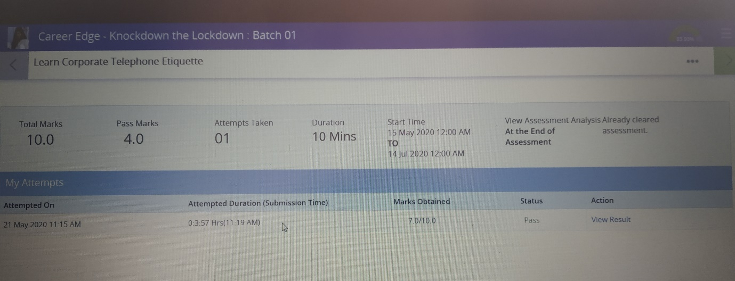

**Learning corporate telephone etiquette:**

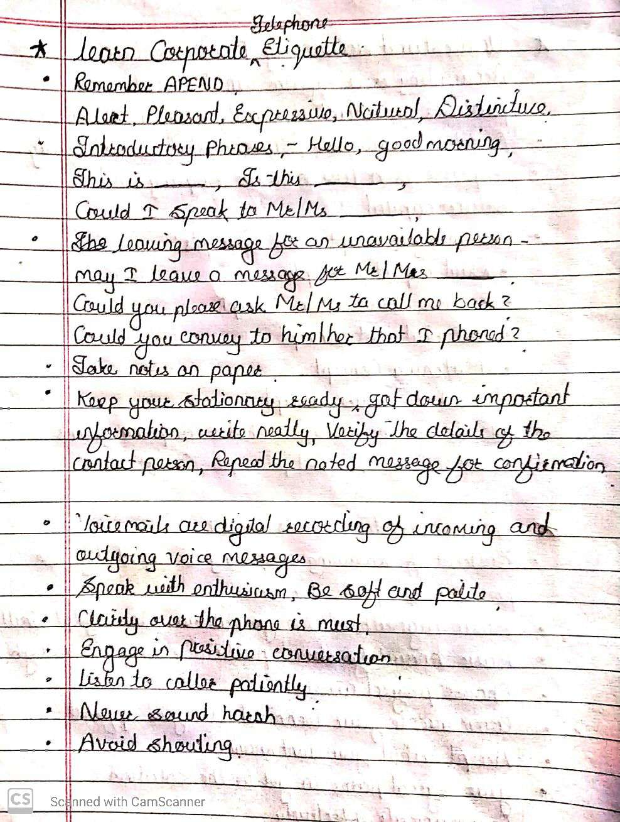

**Understand accounting fundamentals:**

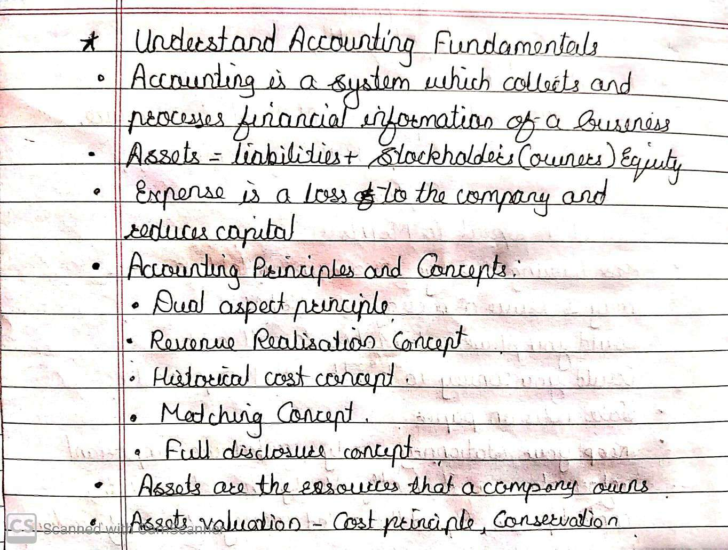

**Gain foundation skills in IT:**

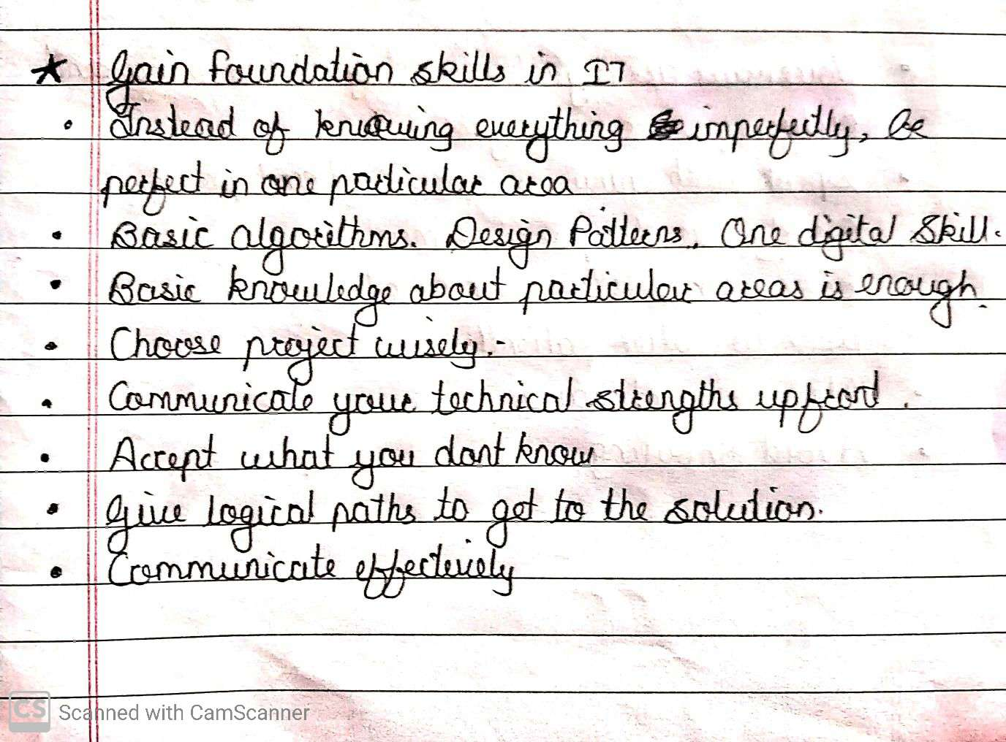

|  |  |  |  |
| --- | --- | --- | --- |
| **Date:** | **21-05-2020** | **Name:** | **Vidul sambhaji chavan** |
| **Course:** | **Python progamming** | **USN:** | **4AL17EC095** |
| **Topics:** | **Project exercise with mysql and python,data analysis with pandas.** | **Semester and section** | **6th sem and B sec** |

