|  |  |  |  |
| --- | --- | --- | --- |
| **Date:** | **22-05-2020** | **Name:** | **Vidul sambhaji chavan** |
| **Course:** | **TCSION carrer adge** | **USN:** | **4AL17EC095** |
| **Topics:** | **Artificial intelligence part1 and part2** | **Semester and section:** | **6th sem and B sec** |

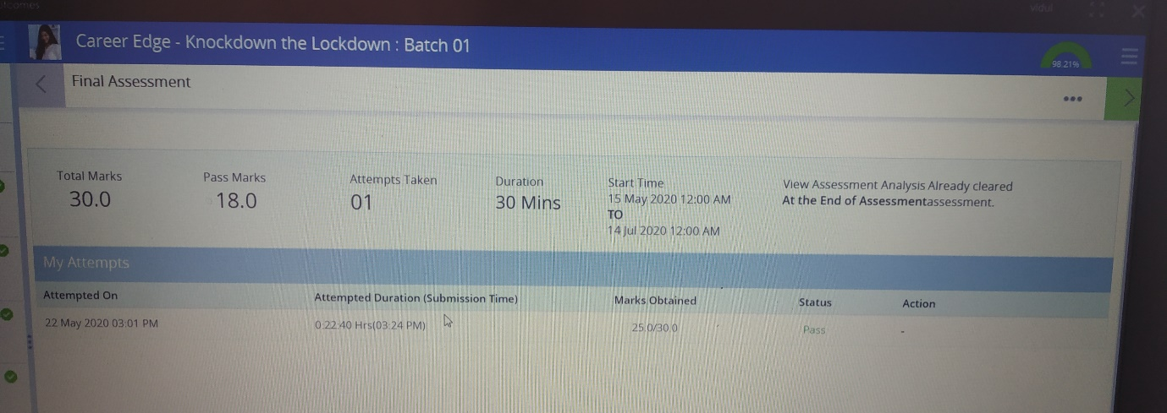

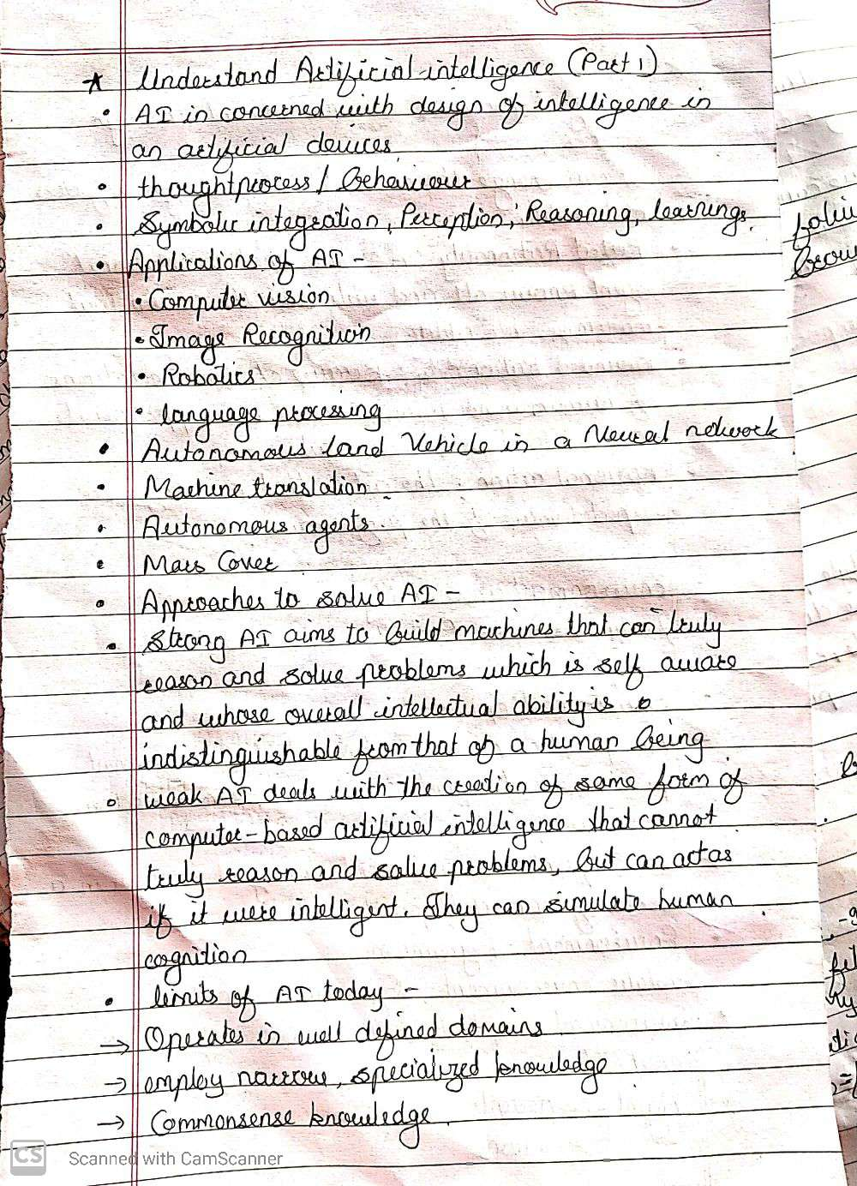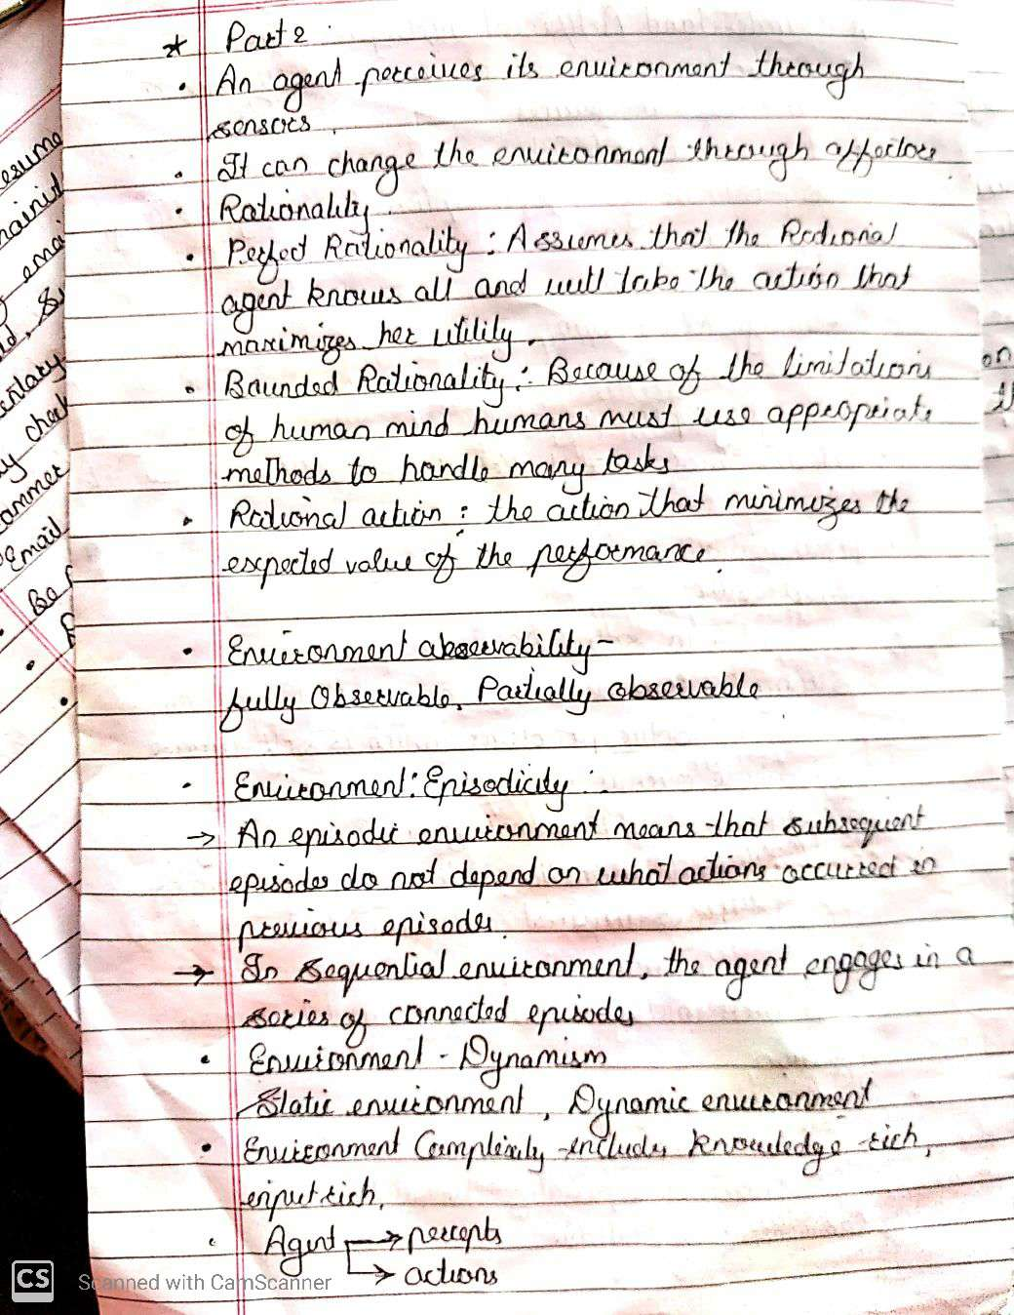

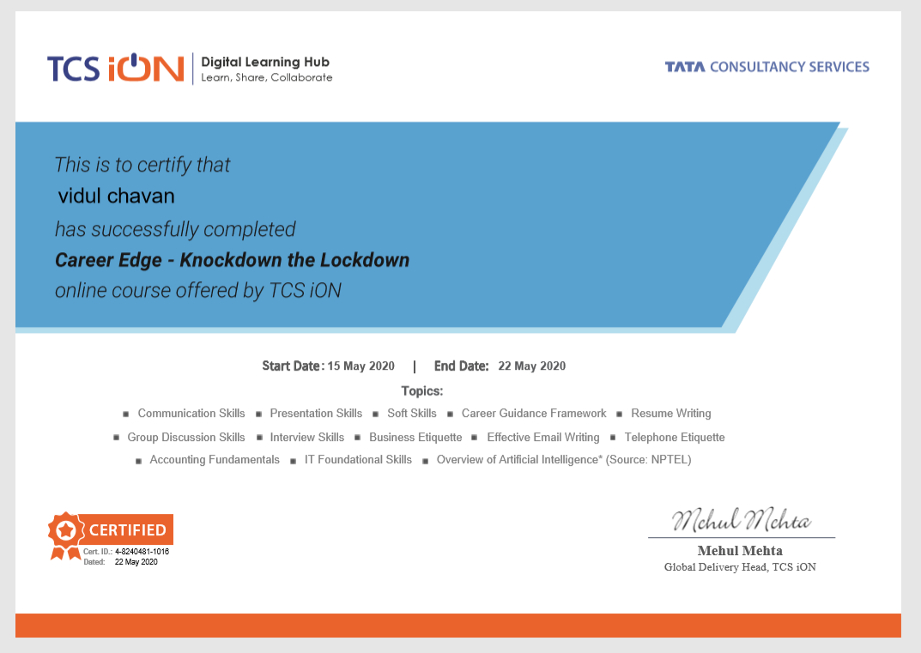

|  |  |  |  |
| --- | --- | --- | --- |
| **Date:** | **22-05-2020** | **Name:** | **Vidul sambhaji chavan** |
| **Course:** | **Python programming** | **USN:** | **4AL17EC095** |
| **Topics:** | **Create webmaps with python and folium** | **Semester and section** | **6th sem and B sec** |

