|  |  |  |  |
| --- | --- | --- | --- |
| **Date** | **26-05-2020** | **Name** | **Vidul Sambhaji Chavan** |
| **Course** | **DSP** | **USN** | **4al17ec095** |
| **Topics** | **Fourier series,fourier transform,Hilbert transform,complex fourier transform,using matlab pythom** | **Semester and section** | **6th sem and B section** |

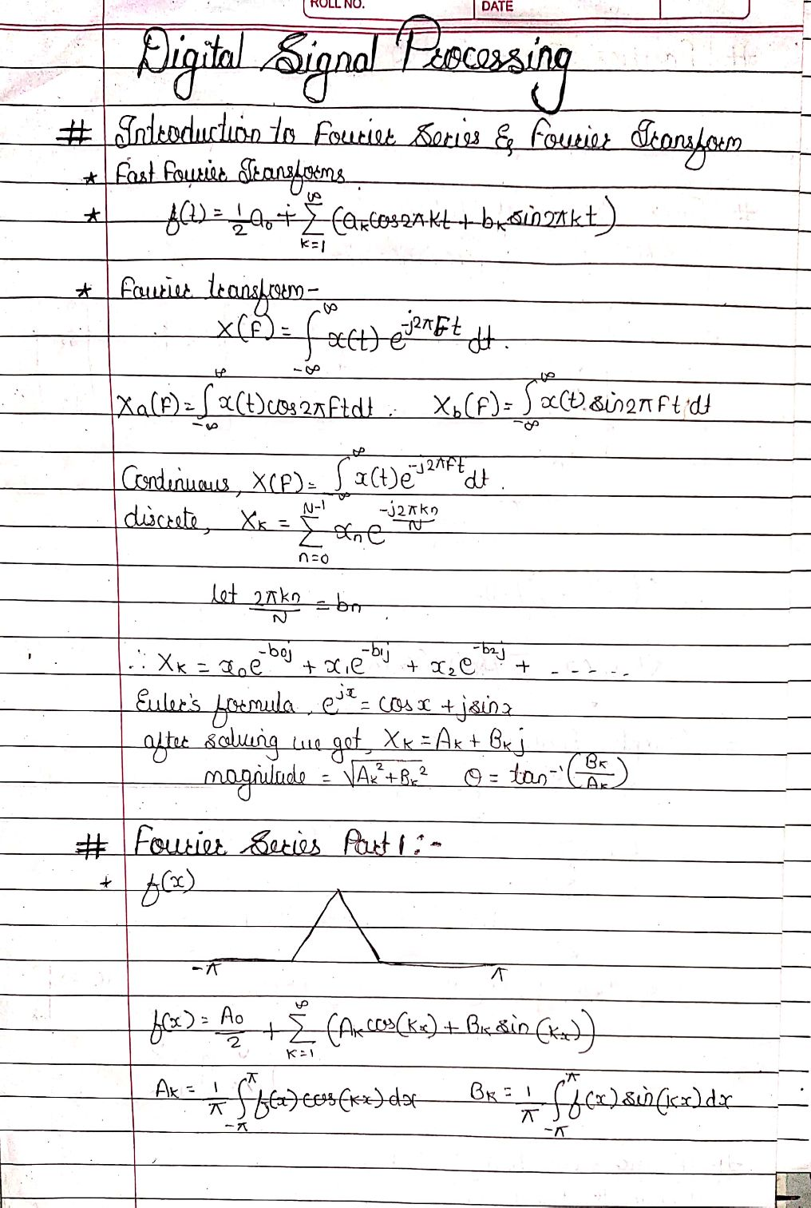

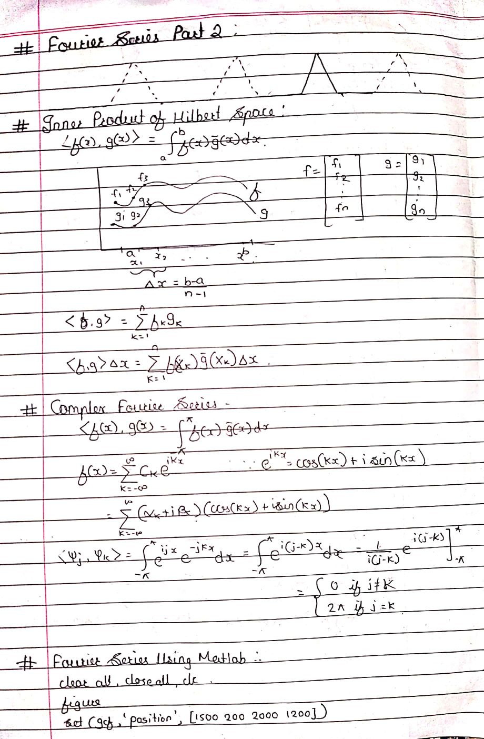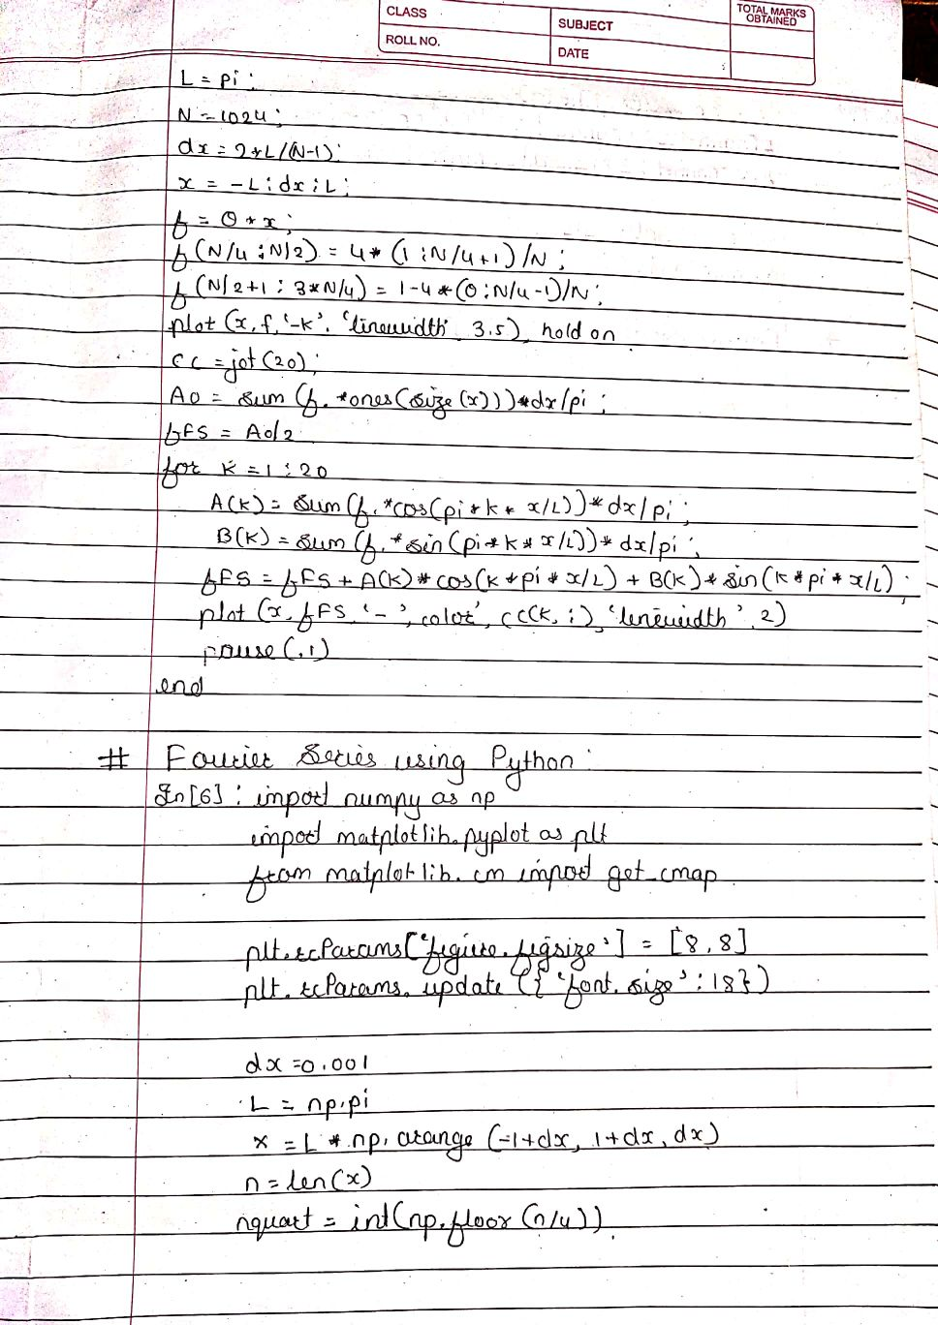

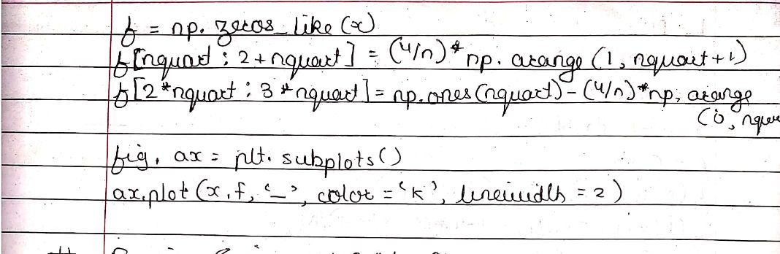

|  |  |  |  |
| --- | --- | --- | --- |
| **Date:** | **25-05-2020** | **name** | **Vidul sambhaji chavan** |
| **Course:** | **Python programming** | **USN:** | **4al17ec095** |
| **Topics:** | **Finding programming error,application3-built a website blocker** | **Semester and section:** | **6th sem and B sec** |

