|  |  |  |  |
| --- | --- | --- | --- |
| **Date:** | **26-05-2020** | **Name:** | **Vidul sambhaji chavan** |
| **Course:** | **DSP** | **USN:** | **4AL17EC095** |
| **Topic:** | **Fourier transform derivatives,laplace tranfrom,z-transform** | **Semester and section:** | **6th sem and B sec** |

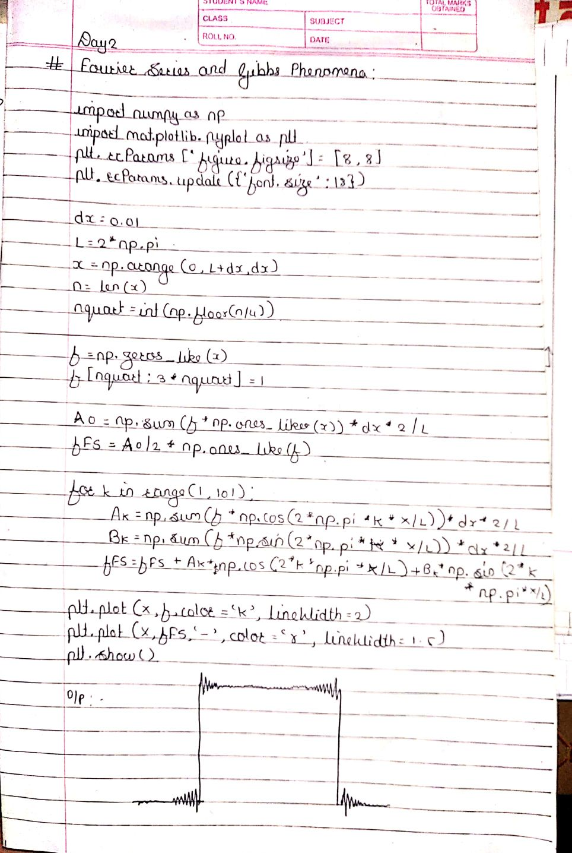

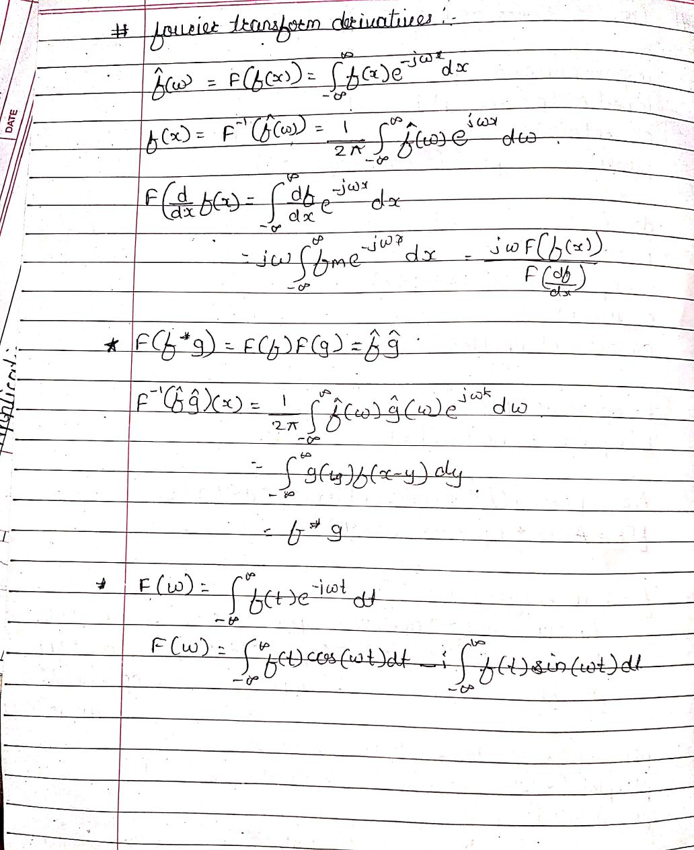

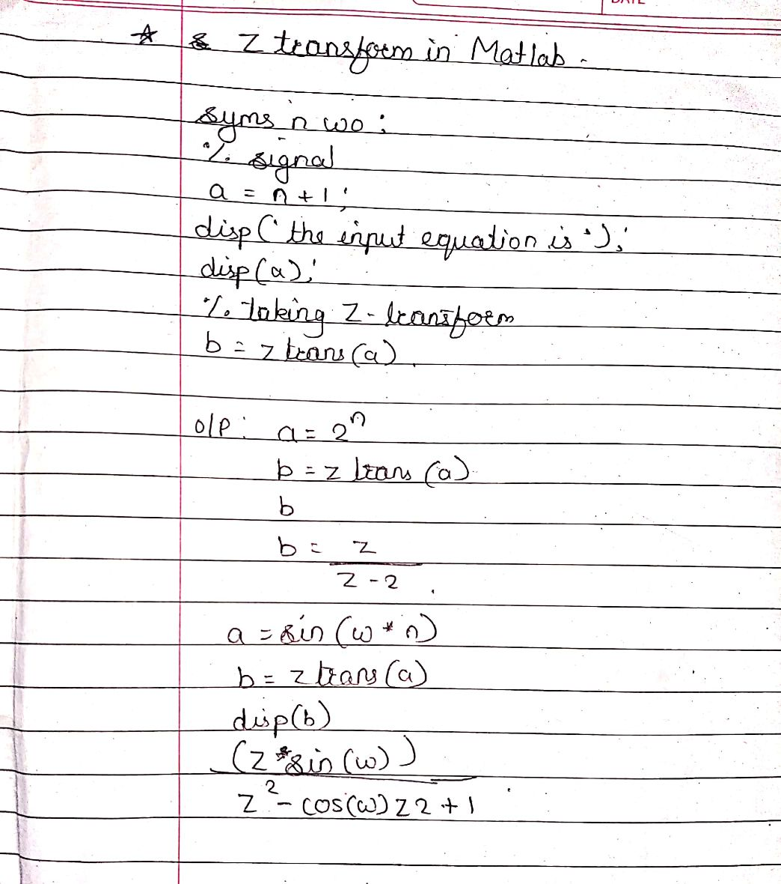

|  |  |  |  |
| --- | --- | --- | --- |
| **Date:** | **26-05-2020** | **Name:** | **Vidul sambhaji chavan** |
| **Course:** | **Python programming** | **USN;** | **4AL17EC095** |
| **Topic:** | **Building a website** | **Semester and section** | **6th sem and B sec** |

