|  |  |  |  |
| --- | --- | --- | --- |
| **Date:** | **27-05-2020** | **Name:** | **Vidul sambhaji chavan** |
| **Course:** | **DSP** | **USN:** | **4AL17EC095** |
| **Topic:** | **Fourier transform,FFT USING matlab,wavelets,FIR IIR,** | **Semester and section:** | **6th sem and B sec** |

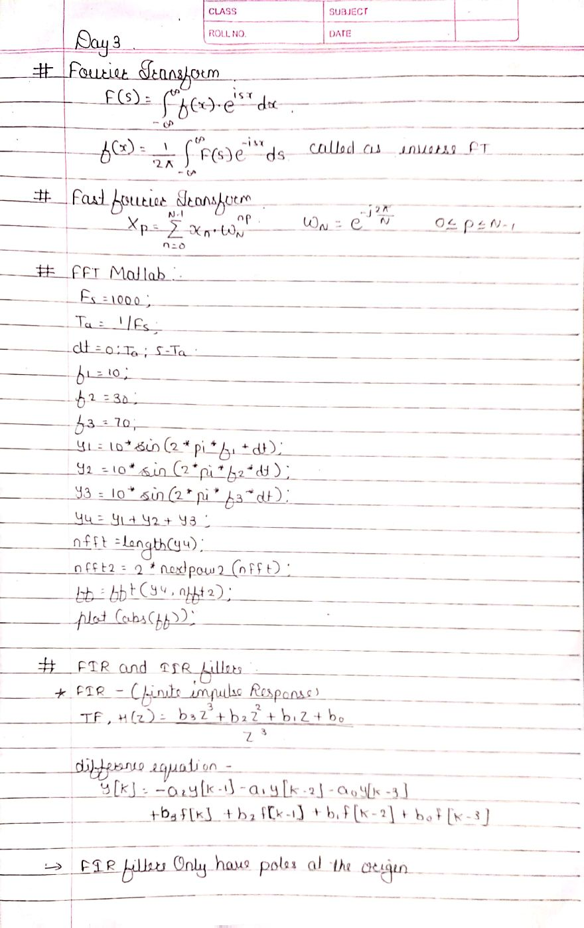

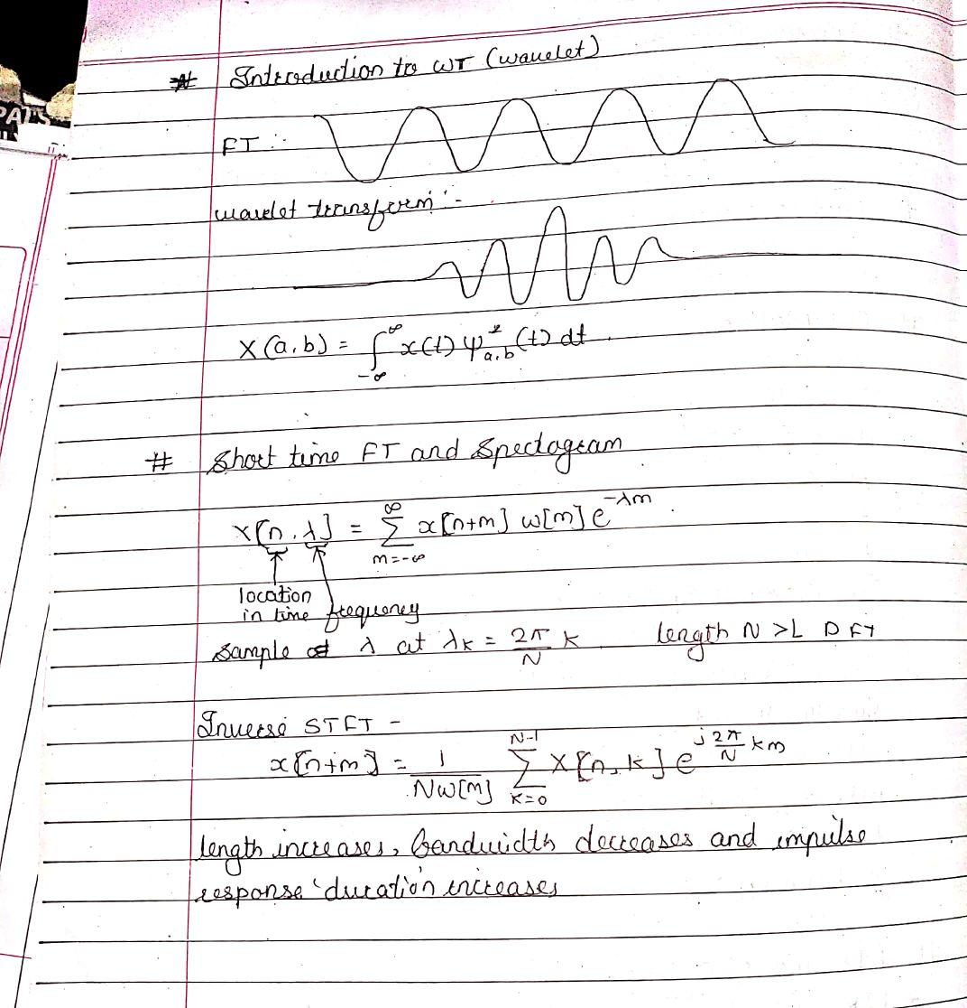

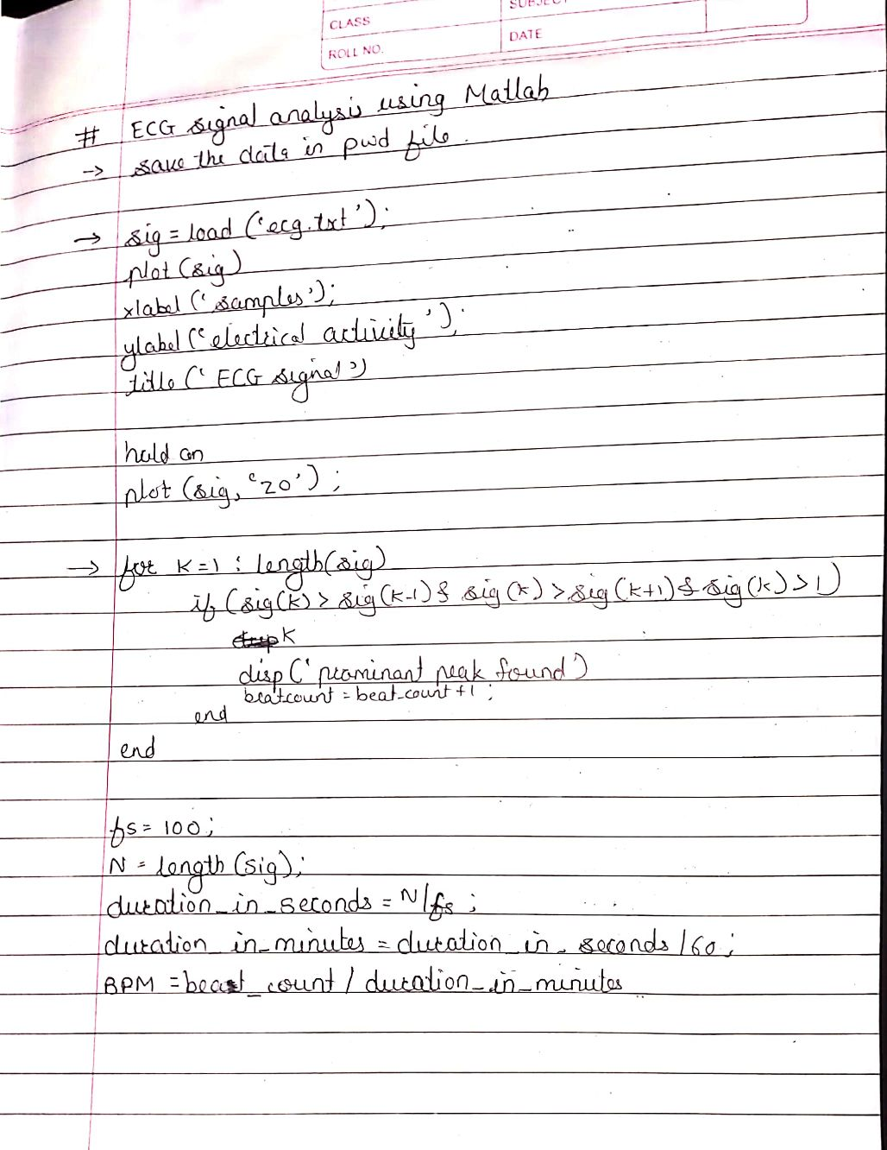

|  |  |  |  |
| --- | --- | --- | --- |
| **Date:** | **27-05-2020** | **Name:** | **Vidul sambhaji chavan** |
| **Course:** | **Python programming** | **USN:** | **4AL17EC095** |
| **Topic:** | **Graphical user interface with tkinter,introduction to python with database.** | **Semester and section:** | **6th sem and B sec** |

