|  |  |  |  |
| --- | --- | --- | --- |
| **Date:** | **28-05-2020** | **Name:** | **Vidul sambhanji chavan** |
| **Course:** | **Logic design** | **USN:** | **4AL17EC095** |
| **Topic:** | **Boolean algebra,MUX.BCD to 7segment display** | **Semester and section** | **6th sem and B sec** |

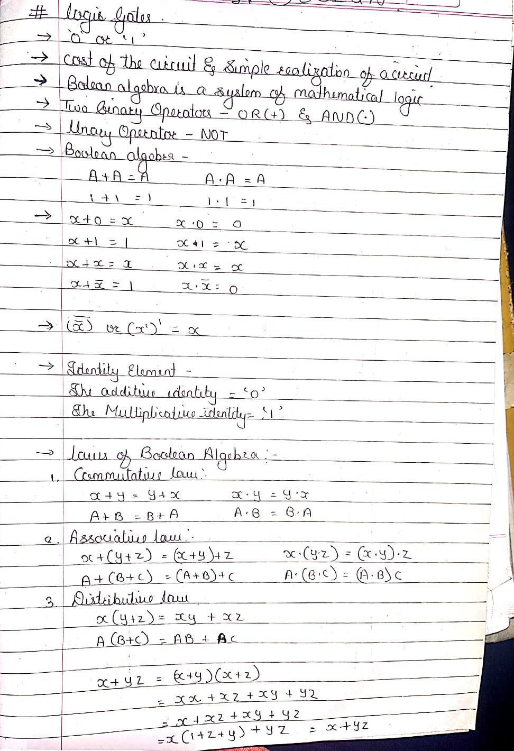

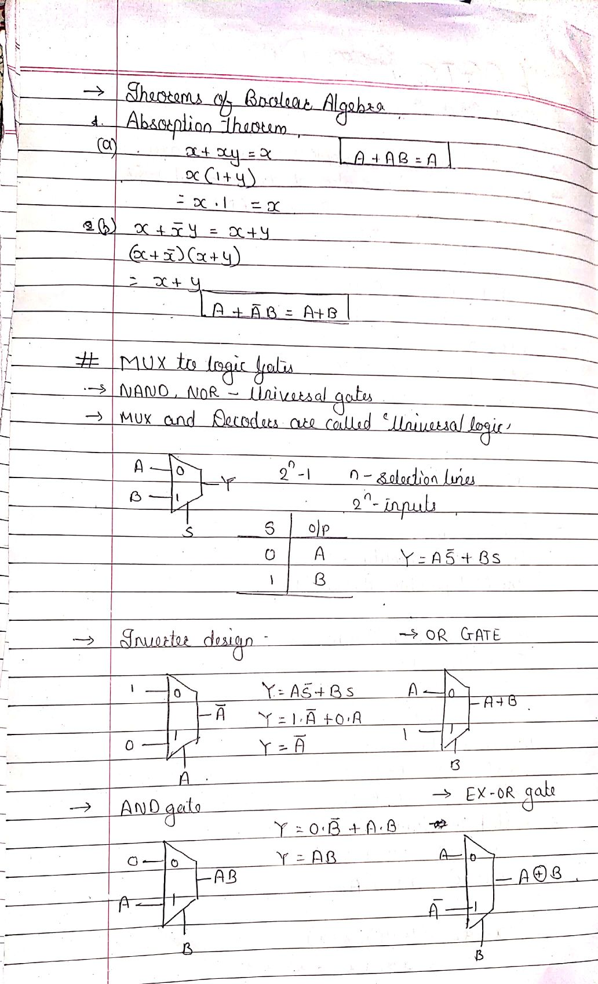

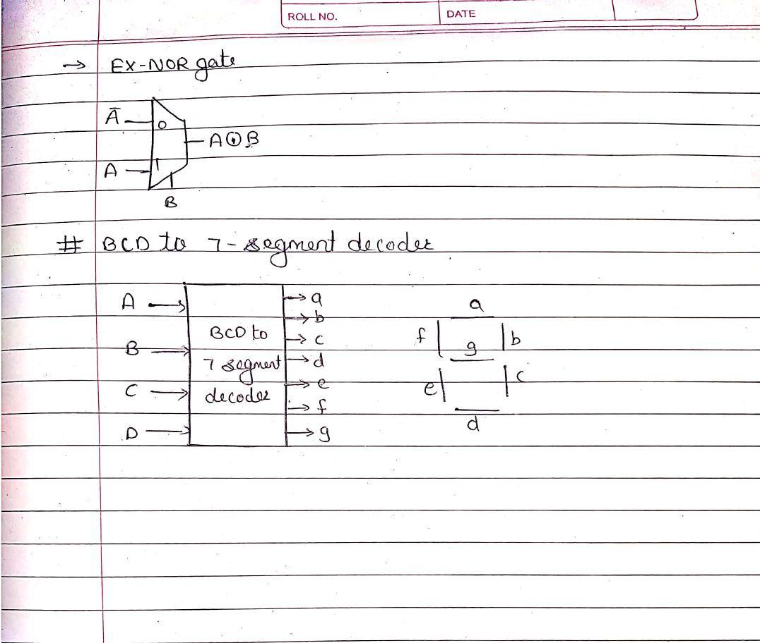

|  |  |  |  |
| --- | --- | --- | --- |
| **Date:** | **28-05-2020** | **Name:** | **Vidul sambhanji chavan** |
| **Course:** | **Python programming** | **USN:** | **4AL17EC095** |
| **Topic:** | **Application 5:build a desktop database application** | **Semester and section** | **6th sem and B sec** |

