**Images:**

 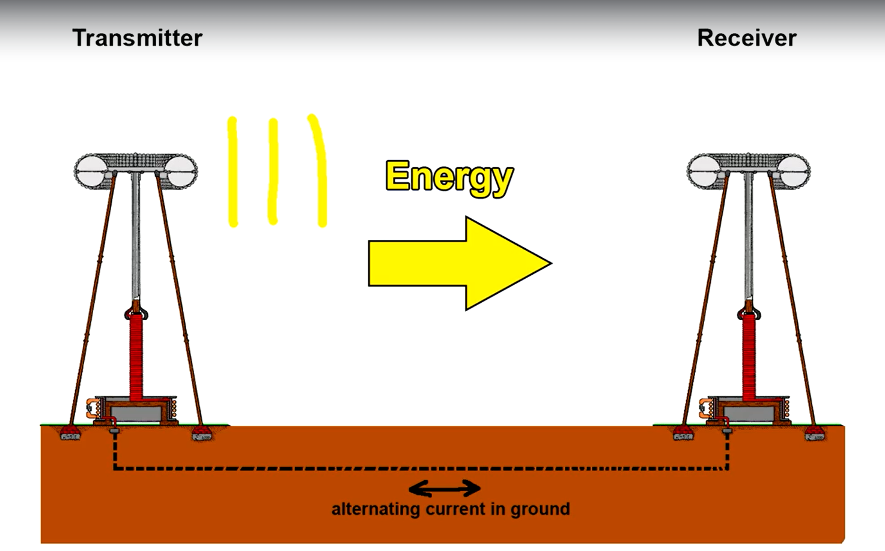

* **A brief introduction:**

We have had wireless power powering electronic devices in the house for nearly 100 years now. A special type of circuit called a crystal radio is able to receive transmissions from high powered AM radio transmitters and convert the received radio waves into music. These crystal radio receivers require no batteries and they're powered entirely by the energy of the radio waves moving through the air. These crystal radios are cheap and easy to build. In fact for decades now there have been kits marketed to children where a seven year old can put one together.

Although wireless power generation is that easy we do not see wireless much around us in our daily lives. This is because of the comparatively lesser amount of power produced by wireless. In reality a crystal radio receives a power in the order of Nano watts. Nano watts is just adequate to produce faintly audible music and is nowhere near power for devices like laptops and phones.

Let us consider the example of charging a phone. A normal phone charger delivers up to 5 volts and 0.5 amps that is 2.5 watts. And for devices like laptops, the typical laptop chargers deliver 40 – 100 watts

For this course we will limit our expectations on wireless power generation to 2.5 watts which in our consideration is enough for a phone to power up. And this is also considered to be commercially viable.

We will walk through the various methods of wireless power that have been attempted throughout history.

* **Tesla Coils:**

A Tesla coil is an electrical resonant transformer circuit designed by inventor Nikola Tesla in 1891. It is used to produce high-voltage, low-current, high frequency alternating-current electricity. Tesla experimented with a number of different configurations consisting of two, or sometimes three, coupled resonant electric circuits. Tesla used these circuits to conduct innovative experiments in electrical lighting, phosphorescence, X-ray generation, high frequency alternating current phenomena, electrotherapy, and the transmission of electrical energy without wires. Tesla coil circuits were used commercially in spark gap radio transmitters for wireless telegraphy until the 1920s, and in medical equipment such as electrotherapy and violet ray devices. Today, their main usage is for entertainment and educational displays, although small coils are still used as leak detectors for high vacuum systems. It takes AC voltage as input, it consists of a special circuitry called the “tank circuitry”, let’s not go into detail. This device could to some extent transmit power through the air.

**Disadvantages:** A. Tesla coils are large. Which means both the transmitting coil and receiving coil would be equally large and would make the circuitry very large.

1. Tesla coils produce lethal amount current in the air and might pose risk to humans.
2. In reality Tesla coils produce massive amounts of electromagnetic interference, which means if it was used in homes, the radio, WIFI and telecommunications would quickly drowned up by radio noise.
3. Tesla coil would draw power even if there were no receiving devices, etc…