* **Concluding with Tesla coils**:

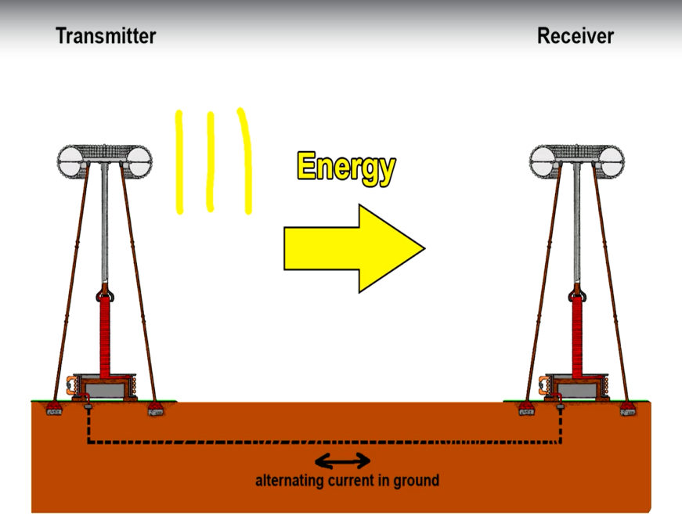Here we see that the Tesla transmitter coil and the Tesla receiver are not entirely what we mean by wireless. There is always high amplitude, high frequency AC current through the ground between the two. Charge carriers or electrons oscillate back and forth at the same frequency as the transmitter.

This creates a return path for the current. This can lead to radio interference, safety and environmental concern if it was implemented in an urban environment. It would be more accurate to describe this as “single conductor power transfer system”. But this is when the concept or idea of wireless power transmission was born and led to the modern wireless power transmission. This was indeed a milestone.

For more clarity refer link - <https://www.spigellab.com/2016/05/27/basic-teslas-experiments-part-1-100w-wireless-transmission-without-ground-connection/>

* 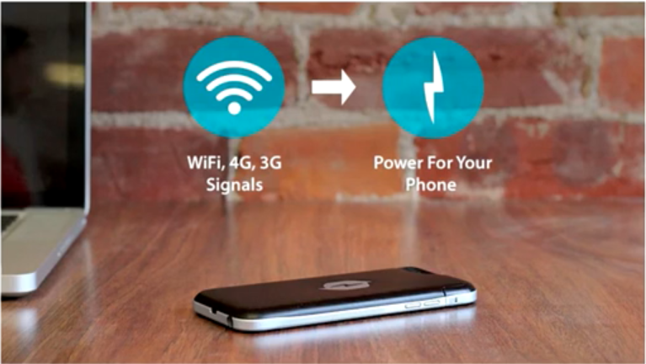**Other technologies that were innovative but not feasible** :

1. A startup called Nicola labs came up with an idea ,that would allow phone charging just with WIFI. So the idea was that a WIFI receiving antenna would harvest radio frequency that could be received by a power conversion circuitry in the phone where in nearly 5V would be produced to charge the phone. But this failed as total wattage of just 16.8mW could be generated which is not enough for phone charging. And added to that the Tx was right next to the Rx to reduce losses and other positive factors.

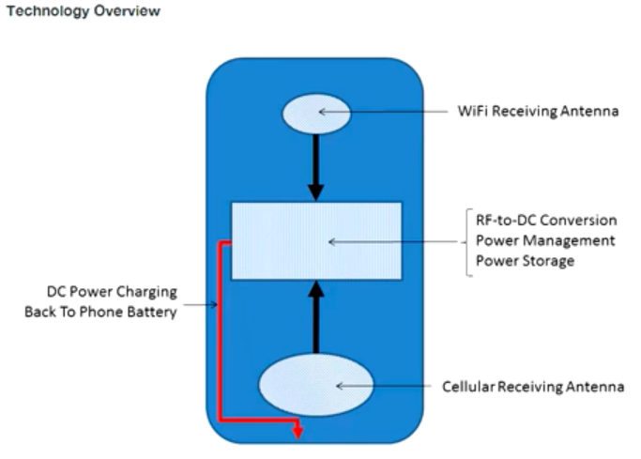

1. Another idea was the RCA airnergy.

This again failed. The product was like a router, it propagated radio waves in all dimensions around it.

As radio waves propagate further away from the transmitting point lesser power can be tapped. That is, closer we go to the transmitting point more power we can tap.

This follows the inverse square law. As we go further away from the center of the sphere

We will be subjected to lesser power. If we doubled the distance away from the center the power that we could tap would become 1/4th or 4 times lesser.

**Friis Transmission Calculator: link -** <https://www.pasternack.com/t-calculator-friis.aspx>

The above link takes us to an online calculator that can calculate the “*Received Power”* for user inputted values for the below parameters in the **equation**:

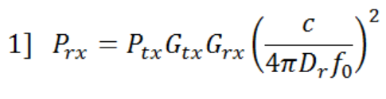

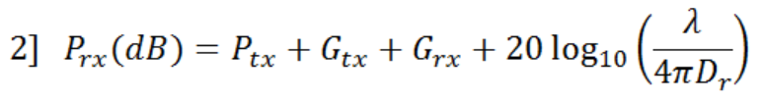

Where, c – speed of light, P – power and G – gain. In the denominator we have the formula for the surface area of a sphere(As we have discussed previously).