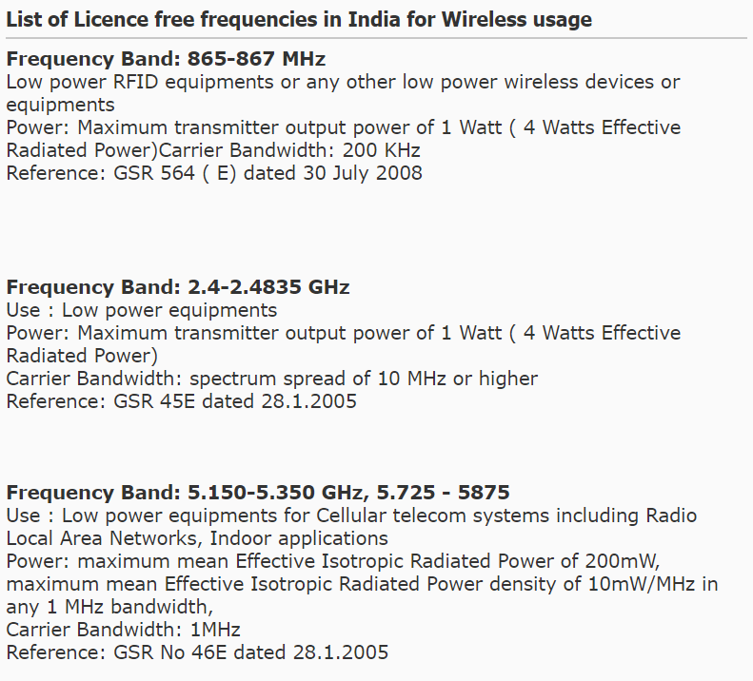**NOTE:** It is a thumb rule from most governments that the maximum power output of any radio transmitter without license must be lesser than or equal to **1 watt**.

Here is a snap from an Indian website.

So by default if we consider the transmitter power to be 1 watt, we observe that we get a very small value of received power.

We have until now considered *isotropic* radio wave transmitter. That is, the radio waves propagate in all directions. And we saw what the drawbacks were. The inverse square law, very minimum amount of received power, etc…

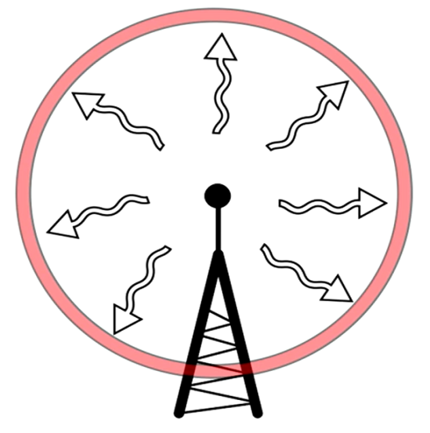 - Isotropic radio wave transmission.

But now we will be considering a *directional antenna* to solve this problem of the wave propagating in all directions, spreading out and being unable to serve for the power requirement.

**Directional Antenna:**

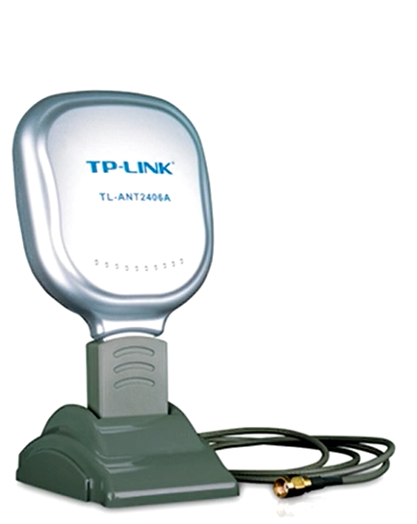 - This is usually how it looks like. And can be easily bought online.

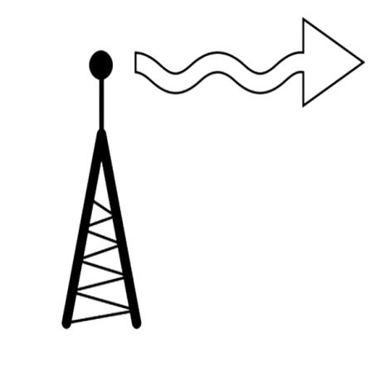 - This is what they do, make the radio wave propagate out in a specific direction.

* **What is the GAIN (dB) of an antenna**:

Gain of an antenna is a way of describing how much a directional antenna increases the strength of a signal. Gain is measured in dBi which is a logarithmic scale.

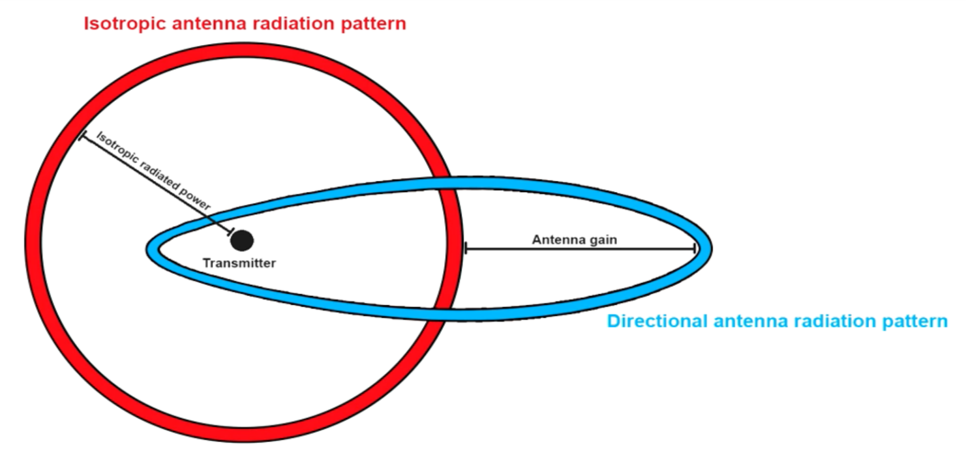

Directional antennas transmit and receive signals in a particular direction. And for now we could just gain the ability of our directional antenna to do this.

In the United States the FCC (Federal communication commission) decides the maximum power output of a radio transmitter. In India we have the TRAI (Telecom Regulatory Authority Of India). The FCC limits the ability of the American locals to use high gain antennas on their transmitters to 6 dBi.