**Moving on to the next innovation:** We now have two innovations to consider under the concept of charging phones wirelessly:

1. With nothing more than **tiny vibration(Piezoelectric):**

**The idea is that we could use piezoelectric effect to generate electricity to charge batteries. Like charging the phone while we type with the pressure we apply on the screen. Pressure causes polarization in the piezoelectric material used.**

* **What is a piezoelectric device?**

Basically, a piezoelectric material produces a change in potential across it when it is squeezed. Also, if you apply a potential difference across it you can get it to expand a little bit. When pressure is applied to the material, the material becomes polarized. This polarization creates in internal electric field and thus a change in electric potential across the two sides. Take references from - <https://www.wired.com/2011/07/can-you-charge-your-phone-by-typing/>

1. With nothing more than **ambient noise:**

**The idea here is to be able to charge phone with just sound. Like charging the phone while we take calls. Let us understand more:**

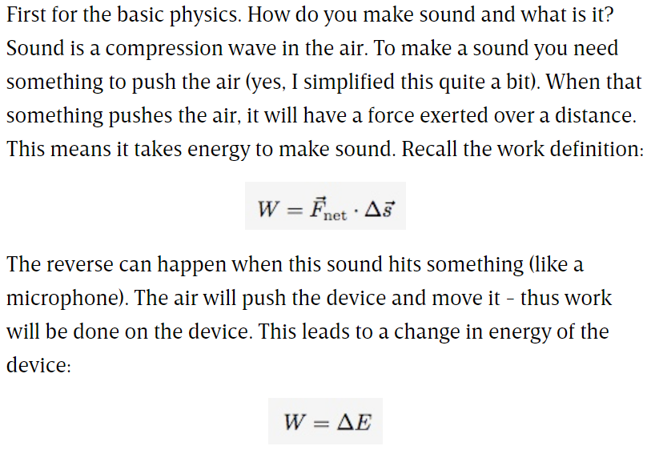

So, it takes energy to make sound and you can get energy from sound. So this much understanding is enough about the innovation because this again has failed to cater to efficient wireless charging. Take references from - <https://www.wired.com/2008/12/charging-a-cell-phone-with-sound-possible/>

For both these innovations we have seen above. There are factors that the outputs depend on. In the first case it is the pressure. Is the pressure we apply on the screen enough to charge it?

And in the second case it is the intensity of sound we create while we speak on phone. Is this intensity of sound that we create enough to charge the phone?

And if we do little research about the above ideas on the internet, we find that only the voltages that we can generate using the above methods are mentioned everywhere. It is not the voltage that charges our phones. It is the power. Power and voltage are not the same. There is always a little amount of current that is required with the produced voltage to cater to our power requirement.

**To make it more understandable**: We know that the voltage we get from a static shock can be of thousands of volts. But yet we cannot charge phones with static electricity because there is not enough current to cause the power.

**To conclude: When we cut through all the hype, both the above ideas, that the piezoelectric chargers and the ambient noise chargers simply do not have enough energy to support viable phone charging.**

**Why we are looking into failed innovations is that, we still find these on the market and we need to understand their limitations so that we will not be victims to scams.**

1. With **conductive charging pads (Conductive wireless chargers)**:

How this works is, we have a grid of electrically conductive squares. And we insert a special sticker into the charging port of our phones, adding two electrical contacts to the back of phones. (See images below)

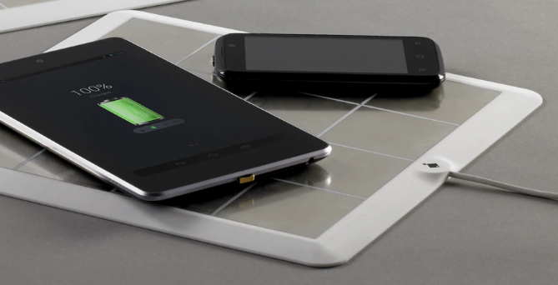This is how the charging looks over a conductive pad.

And the next image shows the conductive strip on the back of phones. This method is known for delivering fast charging.

Take references - <https://www.kickstarter.com/projects/700146891/energysquare-always-stay-charged?ref=most_funded>

Let’s give it another thought. Is this truly the wireless we want? Though we do not have the conventional wires (wires of the USB cable), we still have conducting strips and pads. Below are the pros and cons:

