* **Types of Oscilloscopes:**

1. **Analog Oscilloscopes**
2. **Modern Digital Oscilloscopes**
3. **Modern PC/USB Oscilloscopes**

* **What factors to keep in mind while buying an Oscilloscope?**

1. 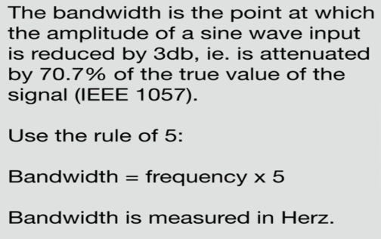**Bandwidth:**
2. 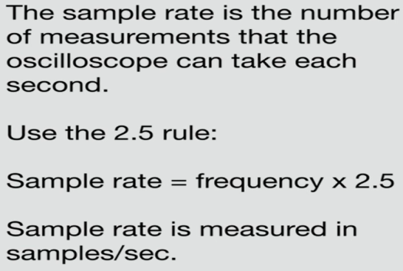**Sample Rate:**
3. 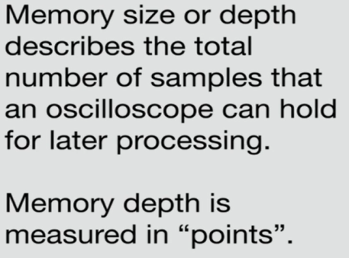**Memory size or Memory depth:**
4. 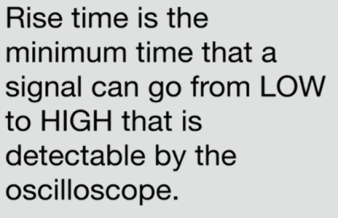**Rise time:**
5. 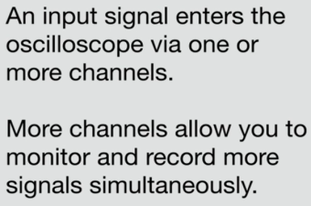**Channels:**

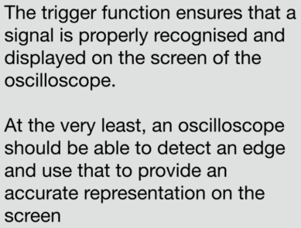

1. **Trigger:**