* EAGLE, an acronym for Easily Applicable Graphical Layout Editor. It is a design software by Cadsoft Computers. It is widely used by educationalists, students, hobbyists and professionals because of its rich yet simple interface with large component library cross-platform support on Windows, Mac and Linux too.
* There is a trial version on Autodesk website which we use throughout this course.
* After the download of Eagle software, we found out that the library search was not that user friendly and good in the Eagle software. So we downloaded the ZIP folder of Adafruit library for Eagle from - <https://github.com/adafruit/Adafruit-Eagle-Library>
* And we placed the Adafruit library folder inside the directory of Eagle library location.

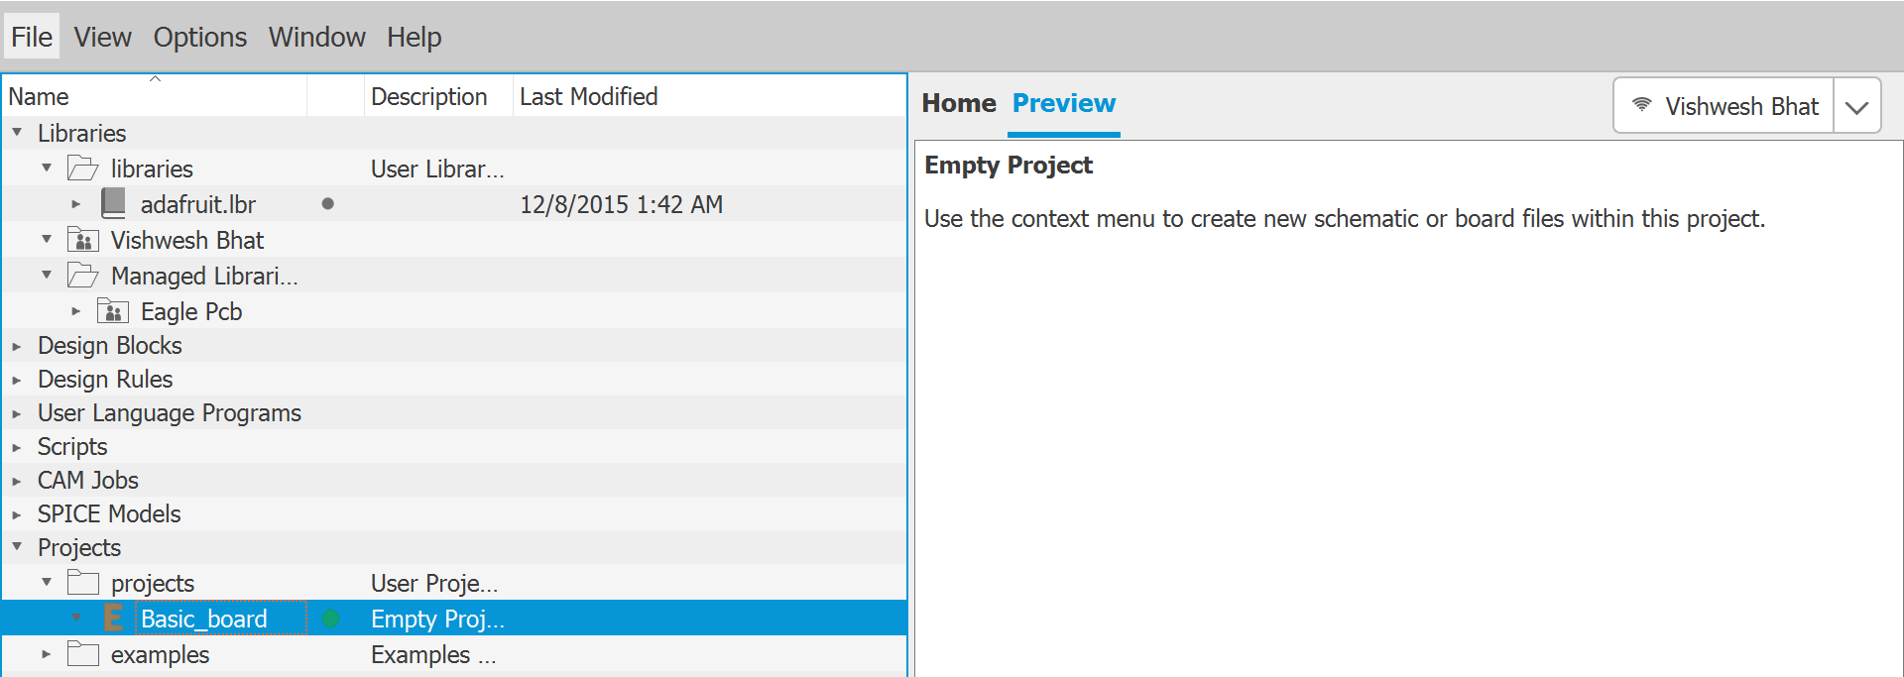

* We can see the Adafruit library in the above image. And we click on file, open a new project, and as we can see in the image above we have named it Basic_board. We further right click on our project and open schematic.

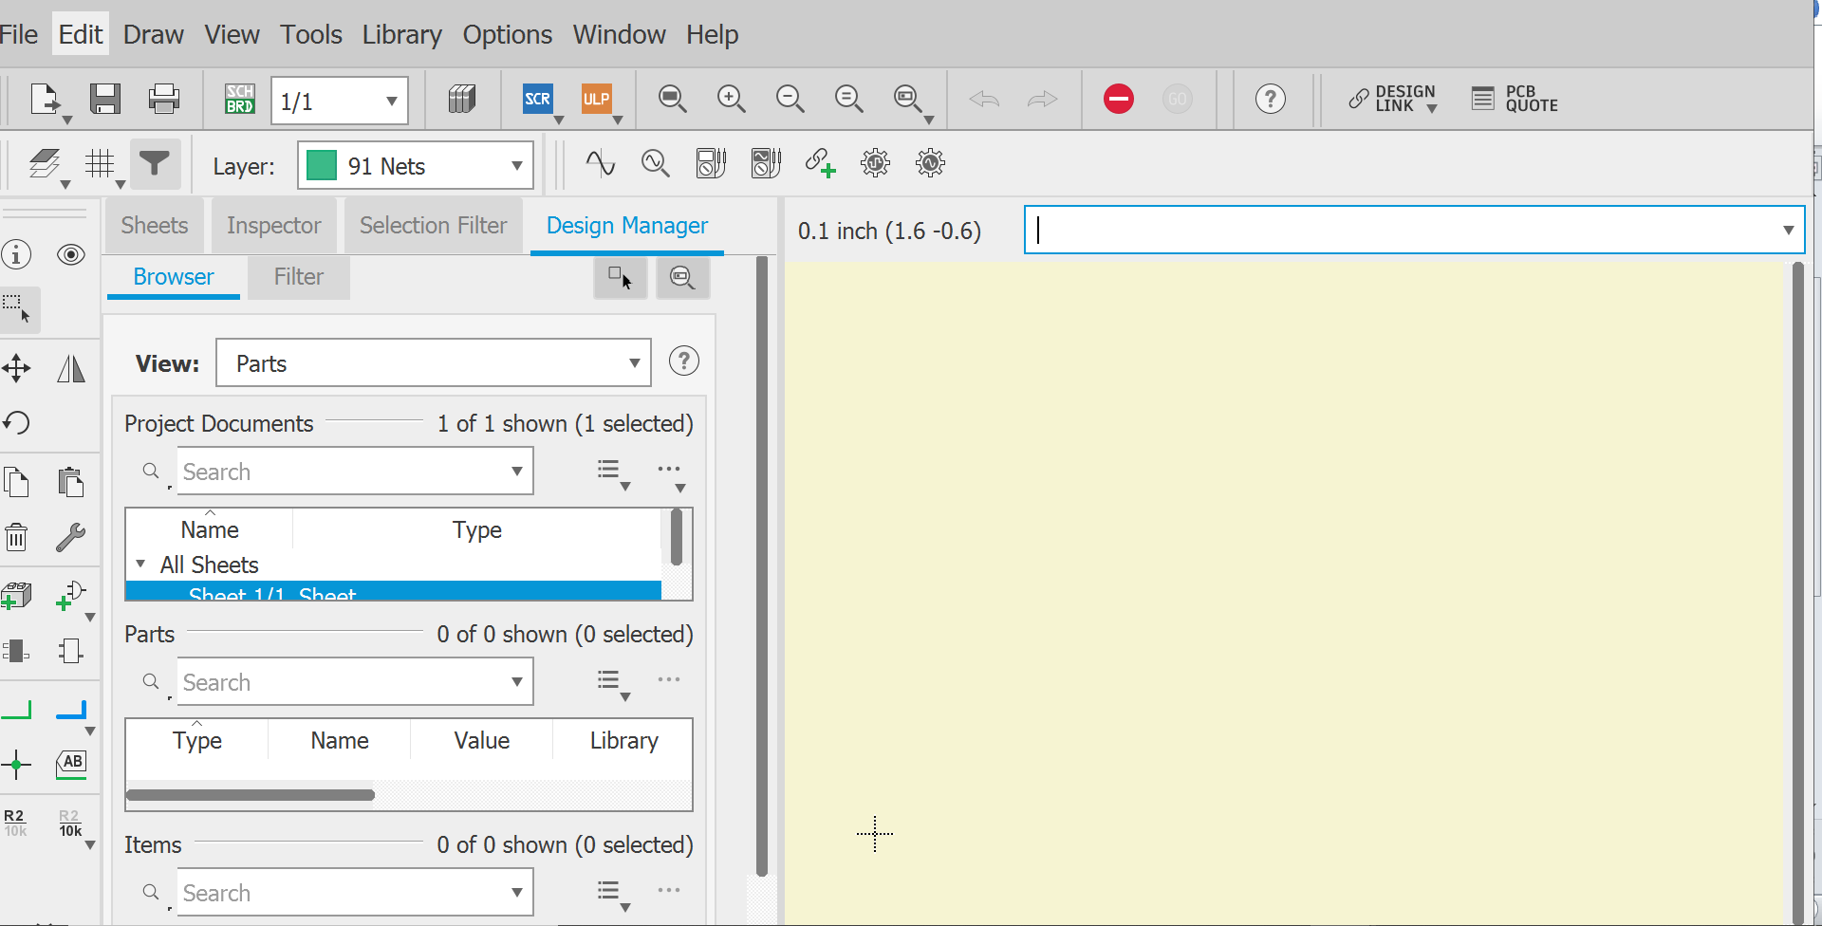

* The above image shows us our working window in Eagle. We enable the grid option which is under the save option in the image above. We use a 0.1 inch grid:

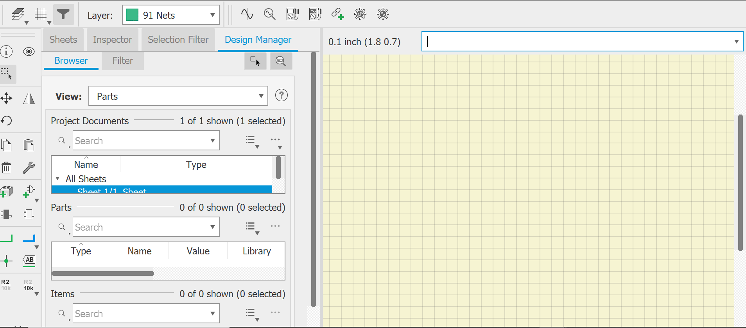

And now, we can go on adding the required parts of our circuitry using the add part option.

And this is when we realize that the Eagle builtin library search is not up to mark. Even if we miss a single letter for the part we are searching, we will not be able to find the part.

This is why we downloaded the Adafruit library from Github.

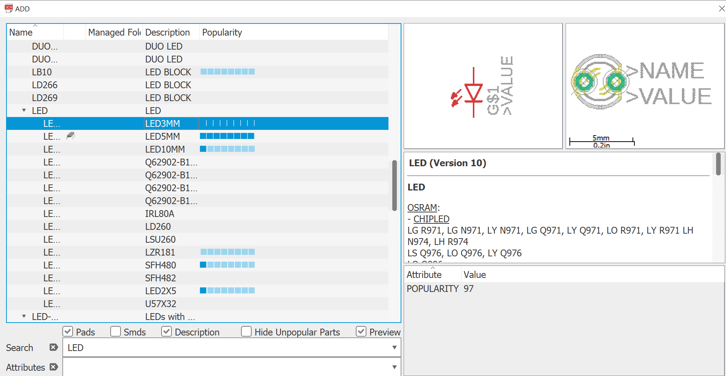

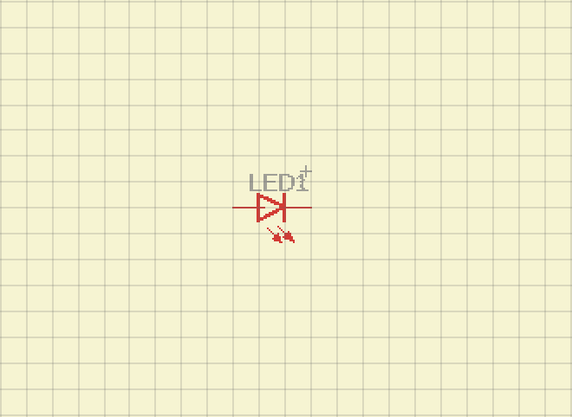 - A Generic 3mm LED