* Steps followed for designing PCB circuitry on **EAGLE**:

1. Open schematic panel under the saved new file. And after the schematic panel is opened, enable the grid option. The grid helps for reference of position.
2. The command **ADD** will take us to the component library. We have already downloaded the adafruit and sparkfun libraries from Github. Or we could also go to the Add part option on the tool bar.
3. For ever circuit that we build, we require a power supply(POW) and ground(GND). We call these as flags in KiCAD and in EAGLE we call them PAD. Go to the component library and search for **PAD.**

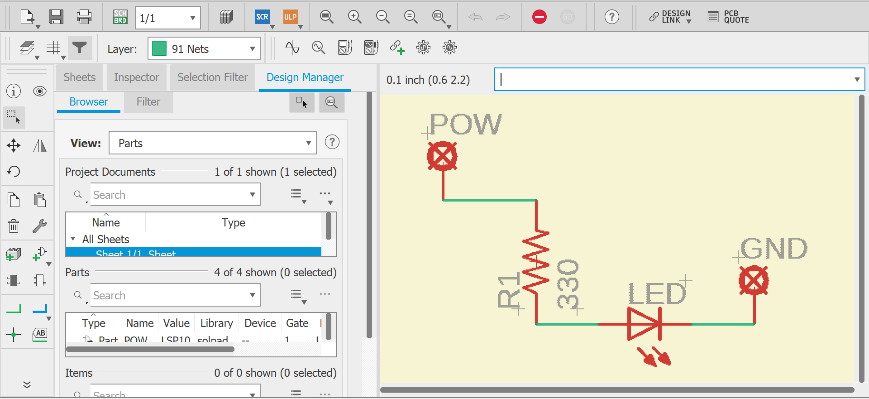

1. We add the required components/parts, and to draw conducting lines between the components **we need not manually draw the wires. Instead we can use the command RIPUP in the command bar.**
2. **IMPORTANT:** If we input **RIPUP;** - The software will automatically draw wires without posing the user with any queries.

If we input **RIPUP –** The software will ask the user some questions, providing some work to be manually done by the user.

1. And after the wiring is done. We can re-plan the boundary by using the boundary layer and drawing it around our circuitry.
2. We can then go for **BRD(Board)** option

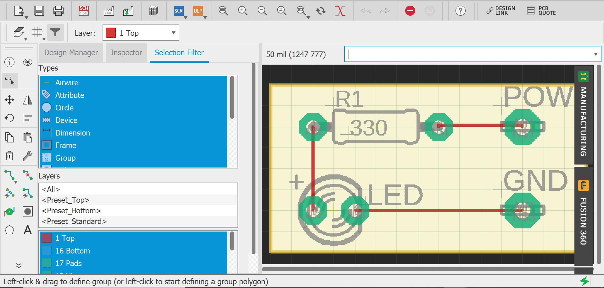

1. And then we click on the manufacture tab to see how our board looks.

