The course started off with a brief introduction on C language that said C is a general-purpose programming language that has been around for nearly 50 years.C has been used to write everything from operating systems (including Windows and many others) to complex programs like the Python interpreter, Git, Oracle database, and more.The versatility of C is by design. It is a low-level language that relates closely to the way machines work while still being easy to learn.

And small programming examples with small exercise questions were posed to the learner to demonstrate the uses of data types and to show how to input/ output in C language.

Using Operators and commenting were also covered in the 1st module that is the basic concepts.

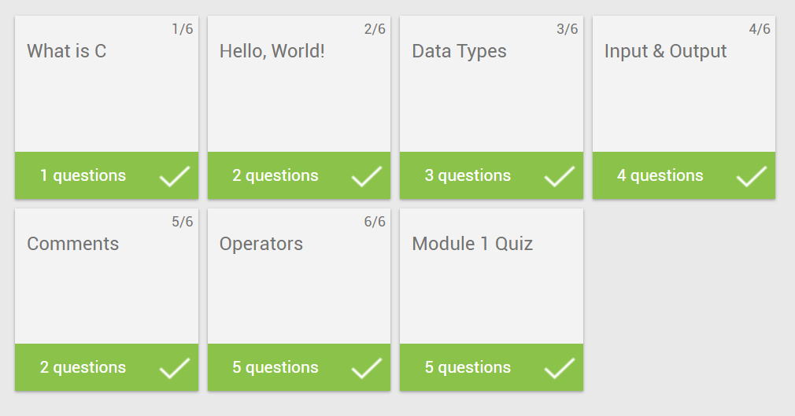

And then the 2nd module was on conditionals and looping. There were again small programming examples demonstrating the usage of looping in programming like for loop and while loop,and conditionals like if statements. Using break and continue and also using return statements were covered.

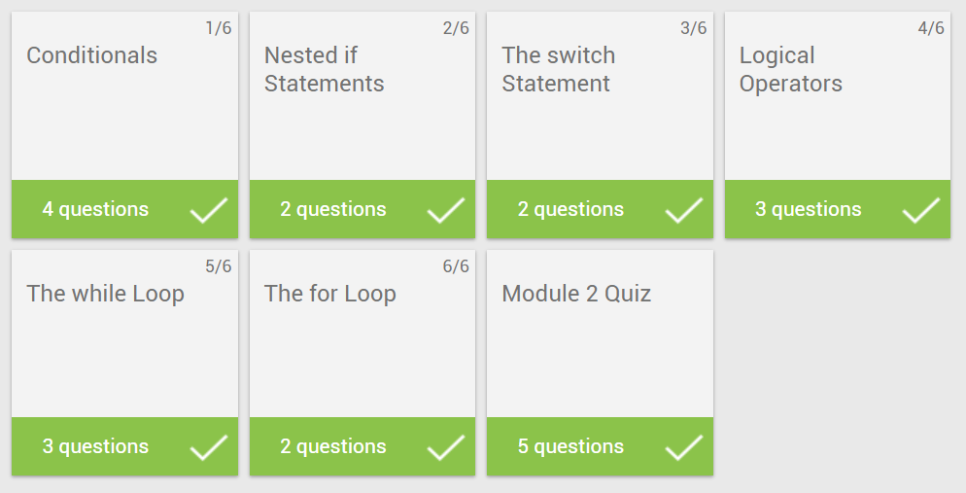

And then the 3rd module was on Functions, arrays and pointers.

